Cancellation of Certificates of Title and 100% eConveyancing

The Registrar General announced a major step in the transition away from paper-based registration of land titles in NSW.

From 11 October 2021, changes to the land titles system in NSW included:

- Cancellation of Certificates of Title (CTs) and the control of the right to deal (CoRD) framework
- Mandate of 100% of Real Property Act dealings (excluding Determination of Title Boundary) for electronic lodgment through an ELNO by a subscriber

These changes have been made under the Real Property Amendment (Certificates of Title) Act 2021. Please note, Water Access Licence dealings and Certificates remain unaffected under this Act.

We have prepared a list of Frequently Asked Questions to assist our customers with conducting online transactions with NSW LRS.

This document is a replacement for the ‘COVID-19 Residual Document FAQ’. As this document provides all current information, the old FAQ will be removed from the NSW LRS website.

Contents

Cancellation of Certificates of Title and 100% eConveyancing 1
Cancellation of Certificates of Title 5
- Do surveyors need to conduct Verification of Identity for lodging via ePlan after the cancellation of Certificates of Title? 5
- How do I lodge dealings affecting multiple ownership situations or dual entitlement titles? .5
- When is a mortgagee’s consent required to be lodged with a plan? 5
- Can a mortgagee consent to a plan by providing a letter of consent in lieu of signing the Administration Sheet or s88B Instrument? 5
- Am I able to lodge an Application for Replacement of Certificate of Title after 11 October 2021? 5
- What do I do with my old Certificate of Title? 5
100% eConveyancing 6
- How do I lodge a Real Property Act dealing in NSW from 11 October 2021? 6
- How do I lodge multiple related dealings via an ELNO where at least one of the dealings must be lodged as a Dealing with Exception? 6
- Do I need to attach a copy of the paper dealing form when lodging a structured electronic dealing? 6
- How do I lodge a dealing affecting Lease Folio (LF) titles? 6
- How do I lodge a dealing that does not have a Lease Folio (LF) created? 7
- In view of the cancellation of Certificates of Title, when is a mortgagee’s consent required to be lodged with a dealing? 7
- Does dual entitlement exist after the cancellation of Certificates of Title? 7
- How do I lodge a dealing affecting part of a lot or whole of a lot within an Auto Consol? .7
- How can I lodge a dealing which affects more than 20 titles electronically? 8
- When do I provide a Lodgment Rules Exception Form with a dealing? 8
- Can I lodge a Real Property Act dealing with NSW LRS without using an ELNO Subscriber? 8
- What documents can be lodged in paper at NSW LRS Lodgment Office from 11 October 2021? 8
- Where can I find all information on the requirements for lodging electronically with NSW LRS? 8
- How do I ensure my transaction is compliant prior to lodging electronically with NSW LRS via an ELNO? 9
- Can I still lodge my Real Property Act dealings by attending the NSW LRS Lodgment Office? 9
- Can I still lodge my plans by attending the NSW LRS Lodgment Office? 9
- When can I lodge a Miscellaneous Dealing via an ELNO? 9
- How do I lodge a Request to amend a plan with NSW LRS? 10
- Will I receive a requisition if I don’t provide a Lodgment Rules Exception form? 10
- Can I still provide a Conveyancing Rules Exemption Form if my dealing was requisitioned prior to 11 October 2021? 10
- Do I need to provide more than one Lodgment Rules Exception form if the exception items apply to more than one dealing in the case? 10
- Regarding Lodgment Rules exception item 1.3 – where can I find the information on whether a dealing is a residual or mainstream? 11
- Does the Dealing with Exception (DwE) coversheet need to be completed correctly? 11
- Does the document name on the Dealing with Exception (DwE) coversheet need to match the paper dealing form? 11
- Does the title reference on the Dealing with Exception (DwE) coversheet need to match the paper dealing form? 11
- Where can I find the information on how to lodge a Dealing with Exception (DwE)? 12
- Are there any changes to how I would normally complete the dealing in paper if I utilise Dealing with Exception (DwE)? 12
- How do I lodge a Transfer or Resumption affecting part of the land in the folio of the Register? 12
- Is there a difference between the examination timeframe for electronic and paper dealings which require referral to the Complex Dealings department? 12
- Can I lodge Powers of Attorney and Old System Deeds electronically? 12
- How do you lodge a dealing affecting a manual Volume and Folio title (no electronically tradeable title reference) from 11 October 2021? 13
- I act on behalf of the same client who needs to lodge several dealings affecting different land. Should I lodge dealings in the same ELNO workspace if there are no common title references between the dealings? 13
- Where can I find the list of authorised ELNOs in NSW and eligibility to lodge electronically? 13
- What should not be attached to Mainstream and Residual eDealings? 13
- What should be attached to a Dealing with Exception (DwE)? 13
- What quality standards should I satisfy when scanning my documents for lodgment with NSW LRS? 14
- What happens if I attach an encrypted or corrupted file when I lodge with NSW LRS? 15
- How do I request a Dealing is registered urgently? 15
- If I’m lodging as a Dealing with Exception (DWE) am I still required to provide evidence related to that document? 15
- What will happen if I attach evidence documents to the relevant Dealing with Exception documents after 8 August 2022? 16
Electronic Powers of Attorney and Old System Deeds 16
- Do I need to complete a Deeds Index Particulars form when lodging a Power of Attorney or Old System Deed? 16
- For lodgment of Old System Deeds and Power of Attorney, how do I get my original document marked with a registration stamp with the Book and Number? 17
- Will LRS send me a certified copy of the registered deed after lodgment and registration? 17
- Can Power of Attorney and Old System deeds be electronically signed? 17
- Do I need to retain the Registration Copy and the original Power of Attorney or Old System Deed? 17
Dealing Requisitions 17
- How do I satisfy a requisition raised against a structured electronic dealing? 17
- How do I satisfy a requisition raised against a Dealing with Exception (DwE)? 18
- How do I amend a dealing that has been requisitioned for a minor alteration? 18
- How do I amend a dealing that has been requisitioned for a major alteration? 19
- Do you have a guide for online submissions and the Secure Upload Portal to increase the chances of a successful transaction? 19
- When can I amend an electronic dealing to satisfy my requisition? 19
- Am I able to submit a substitute paper dealing form where I’m required to amend an electronic dealing? 19
- Am I able to submit a substitute paper dealing form where I’m required to amend the paper dealing form attached to a Dealing with Exception (DwE)? 19
- When I receive a requisition for an error in an Electronic Dealing, will I be charged a requisition fee? 20
- Will I be asked to remove unnecessary or private/confidential information from attachments? 20
- If I have received a requisition to provide LRS with relevant evidence for my Dealing with Exception document, am I still required to provide the evidence after 8 August 2022? 20

Cancellation of Certificates of Title

Do surveyors need to conduct Verification of Identity for lodging via ePlan after the cancellation of Certificates of Title?
There are no changes to the documents required to be retained by surveyors for lodging via ePlan. For more information on lodging plans with NSW LRS via ePlan please visit https://www.nswlrs.com.au/deposited_plans/lodgment/electronic_lodgment_plans.

How do I lodge dealings affecting multiple ownership situations or dual entitlement titles?
With the cancellation of Certificates of Title, dual entitlement situations no longer exist but multiple ownership following registration of a plan of subdivision or consolidation can still occur.

On and from 11 October 2021, where a title is held in dual entitlement, letters of authority instructing the delivery of Certificates of Title are not required to be provided to NSW LRS for the registration of a plan or prior to the lodgment of a dealing resolving the multiple ownership situation via an ELNO. Transactions currently affecting a title held in dual entitlement can be lodged directly via an ELNO as a structured electronic dealing. More information on structured electronic dealings can be
found here.

If less than all parties in the multiple ownership are acting as transferors in the transaction, then the transaction must be lodged via an ELNO as a Dealing with Exception. A correctly completed Lodgment Rules Exception form (Exception Item 50.2) must accompany the Dealing with Exception dealing.

When is a mortgagee’s consent required to be lodged with a plan?
All relevant signatures and consent requirements in place prior to 11 October 2021 will continue to be required for the registration of plans. Please refer to the Plans page for more information.
For information on changes to consents involving Strata Schemes please click here.

Can a mortgagee consent to a plan by providing a letter of consent in lieu of signing the Administration Sheet or s88B Instrument?
No. The consent of the registered proprietor(s) and every mortgagee, chargee or covenant chargee under a mortgage, charge or covenant charge recorded on the affected the title relating to the land in the plan must be endorsed on the Administration Sheet and s88B Instrument prior to lodgment with NSW LRS.

Am I able to lodge an Application for Replacement of Certificate of Title after 11 October 2021?

No. In view of the cessation of CTs, from 11 October 2021, customers will no longer be required or be able to lodge applications for replacement of Certificates of Title with NSW LRS.

What do I do with my old Certificate of Title?
From 11 October 2021, Certificates of Title have ceased to be a legal document. Customers may retain their Certificates of Title for sentimental purposes.

100% eConveyancing

How do I lodge a Real Property Act dealing in NSW from 11 October 2021?
From 11 October 2021, all Real Property Act dealings (excluding Determination of Title Boundary) have been mandated for electronic lodgment via an ELNO by a Subscriber.
There are three avenues for lodging a Real Property Act dealing electronically via an ELNO:
  - Structured electronic dealing
  - Dealing with Exception (Lodgment Rules Exception form required)
  - Miscellaneous Dealing (Lodgment Rules Exception form required)
For information on the appropriate type of electronic lodgment please visit How to Lodge with NSW LRS: Dealings and Documents.

All Determination of Title Boundaries can be lodged by visiting the NSW LRS Lodgment Office. To apply for an appointment please email the details of your transaction to LOSupport@nswlrs.com.au.

How do I lodge multiple related dealings via an ELNO where at least one of the dealings must be lodged as a Dealing with Exception?
Where at least one dealing in a case is required to be lodged as Dealing with Exception, all dealings in the case can be lodged as Dealing with Exception. A correctly completed Lodgment Rules Exception form must accompany the Dealing with Exception dealing which satisfies one of the exception items.

Do I need to attach a copy of the paper dealing form when lodging a structured electronic dealing?
No. When preparing a structured electronic dealing (click here to view the list of structured electronic dealings), any executed paper dealing form is not required to be attached as supporting evidence for lodgment with NSW LRS. Subscribers should continue to retain (not lodge with NSW LRS) necessary documentation for compliance purposes. NSW LRS may raise a requisition if a discrepancy exists between the information stated on the attached paper dealing form and the electronic dealing.

When preparing a Dealing with Exception, the relevant paper dealing form must be attached and lodged with NSW LRS.

How do I lodge a dealing affecting Lease Folio (LF) titles?
From 11 October 2021, dealings affecting Lease Folio titles must be lodged as Dealing with Exception. A correctly completed Lodgment Rules Exception form (Exception Item 1.2) must accompany the Dealing with Exception dealings.
Where the Dealing with Exception affects Lease Folio titles, only the affected LF titles must be entered into the ELNO workspace which will be reflected on the cover sheet. Reference should be made to all head titles and LF titles on the attached paper dealing form.
More information on the preparation of a Dealing with Exception can be found via the following resources:
Registrar General’s Guidelines – Dealing with Exception

How to Lodge with NSW LRS – Out of Scope Transactions

How do I lodge a dealing that does not have a Lease Folio (LF) title created?
Where a Lease Folio has not been created, the head title must be entered into the ELNO workspace which will be reflected on the cover sheet. Reference should be made to all head titles and premises to be leased on the attached paper dealing form. A correctly completed Lodgment Rules Exception form (Exception Item 1.2) must accompany the Dealing with Exception dealings.

More information on the preparation of a Dealing with Exception can be found via the following resources:
Registrar General’s Guidelines – Dealing with Exception How to Lodge with NSW LRS – Out of Scope Transactions

Required uploads as part of the ‘Conditions and Provisions’ for Lease attachment type.

For NSW LRS lodgment purposes, only the terms and conditions of the lease is required to be uploaded for attachment to the dealing. The lease (07L form) and any pages containing execution etc are not required to be uploaded. Please ensure the terms and conditions of the lease, including the lease description i.e., whole or part of the land, are consistent with the details on the electronic Dealing prepared for lodgment.

Please note: The above also applies to other dealing types. Paper dealing forms are only required to form part of a Dealing with Exception attachment and do not need to be uploaded as an attachment to Mainstream or structured Residual Dealings.

Attachments to an electronic Lease which includes the entirety of the Lease (07L form) will be accepted but may incur a fee

The 07L form is not required to be included in the attachment as the examination will be based upon the electronic lease (render pages) however, NSW LRS will not reject the document if it is. It is advised that the 07L form is not attached to avoid confusion and duplicity in information when customers obtain registered copies of the Lease. Please note a fee will be raised on requisitions for Minor alterations. More information on Major/Minor alterations can be found here.

In view of the cancellation of Certificates of Title, when is a mortgagee’s consent required to be lodged with a dealing?
The cancellation of Certificates of Title and CoRD has not changed the requirement for third parties to provide their consent to NSW LRS in certain instances before a dealing can be lodged for registration. Where a consent by a Mortgagee, Lessee or Chargee is required for the registration of a dealing (refer to the Registrar General’s Guidelines for the relevant dealing) then written consent of the relevant Lessee, Mortgagee or Chargee must be provided to NSW LRS with the lodgment of a dealing. Information on dealings which require a consent is available via the reference guide prepared by the Office of the Registrar General: electronic dealings which require written consent.

Information on document and evidence requirements in line with the eConveyancing Subscriber compliance regime can be found here.

Is Mortgagees consent required to be attached to Leases registered with NSW LRS?
NSW LRS don’t require consent of Mortgagees to be provided for Leases lodged via an ELNO. Consent of mortgagee should only be lodged with the Lease if the mortgagee POA agrees to be bound by the terms of the lease.

Does dual entitlement exist after the cancellation of Certificates of Title?
With the cancellation of Certificates of Title, dual entitlement situations no longer exist but multiple ownership following registration of a plan of subdivision or consolidation can still occur.

How do I lodge a dealing affecting part of a lot or whole of a lot within an Auto Consol?
When lodging a dealing affecting part of a lot or whole of lot within an Auto Consol then the dealing must be prepared and lodged as a Dealing with Exception. A correctly completed Lodgment Rules Exception form (Exception Item 1.5) must accompany the Dealing with Exception dealings.

Where all lots within an Auto Consol are affected, the dealing must be lodged as a structured electronic dealing.
More information on preparation of a Dealing with Exception can be found via the following resources:
Registrar General’s Guidelines – Dealing with Exception How to Lodge with NSW LRS – Out of Scope Transactions

How can I lodge a dealing which affects more than 20 titles electronically?
A dealing which affects more than 20 titles may be lodged as a Miscellaneous Dealing using the prescribed Reference to Title NO/REF/99999 in the ELNO workspace. The affected title references are stated in the attached copy of the dealing.

A correctly completed Lodgment Rules Exception Form (Exception Item 75.1) must be lodged with any Miscellaneous Dealing document. More information on the preparation of Miscellaneous Dealings can be found here.

When do I provide a Lodgment Rules Exception Form with a dealing?
A correctly completed Lodgment Rules Exception Form must be lodged with all documents lodged as a Dealing with Exception and Miscellaneous Document via an ELNO. Only one Lodgment Rules Exception Form is required for each ELNO workspace. If a Lodgment Rules Exception Form is not provided or an incorrect exception item is selected, a requisition will be raised by NSW LRS. A copy of the form is available here. Information on Dealing with Exception and Miscellaneous Dealing can be found via How to Lodge with NSW LRS: Out of Scope Transactions.

Populating the Lodgment Rule Exception Form.
When lodging a Lodgment Rule Exception form, it’s important to remember the correct way of populating the Lodgment Rule exception number field. Customers must provide the exact exception number, as provided in the Registrar General’s Guidelines. For example, when lodging an exception for ‘any dealing affecting a lease folio title’, the correct exception number is 1.2. An incorrect exception number is 1, which only refers to the exception category of ‘General Exception’, rather than the specific exception of ‘any dealing affecting a lease folio title’.
The images below demonstrate the correct way to populate this field.
Correct
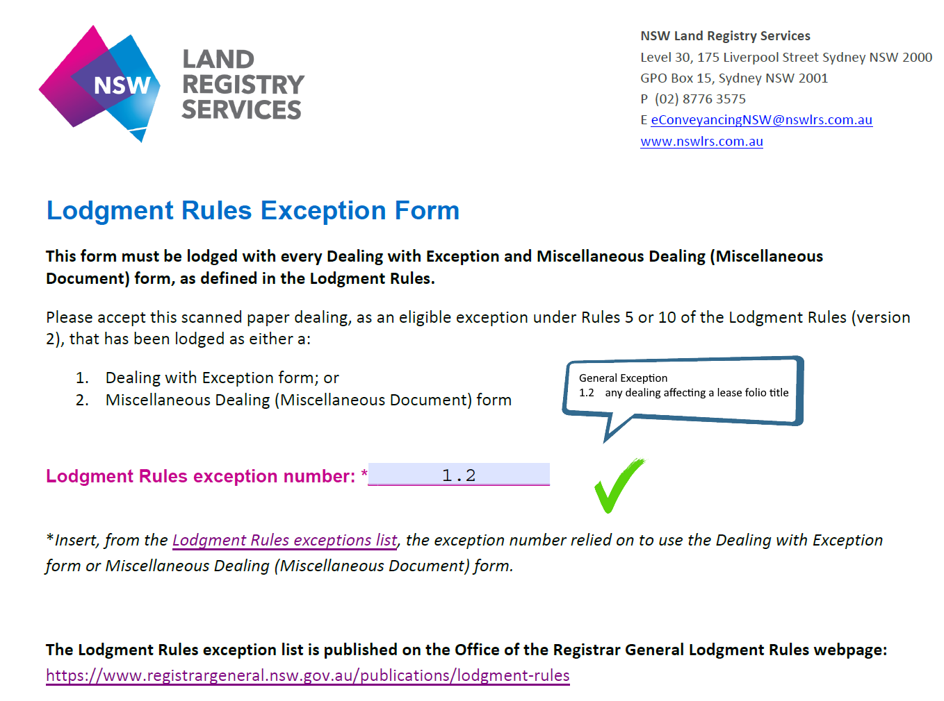
Incorrect
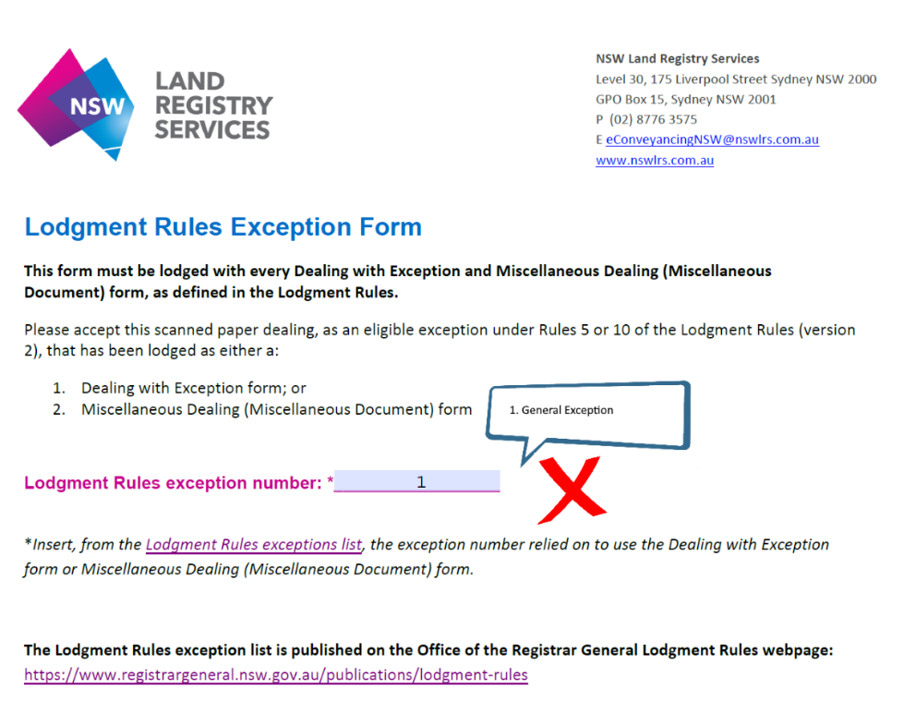

Can I lodge a Real Property Act dealing with NSW LRS without using an ELNO Subscriber?
No. From 11 October 2021, all Real Property Act dealings (excluding Determination of Title Boundary) to be lodged with NSW LRS can only be done electronically by a subscriber (e.g., a lawyer, licensed conveyancer, or financial institutions) through an Electronic Lodgment Network Operator (ELNO). More information on eligibility to lodge electronically can be found here.

What documents can be lodged in paper at NSW LRS Lodgment Office from 11 October 2021?

The following dealings are available for lodgment in paper via our manual lodgment channels. These documents can be lodged by attending the NSW LRS Lodgment Office.

- Water Access Licence dealings (Lodgment via the NSW LRS Lodgment Office only)
- Determination of Title Boundary (Lodgment via the NSW LRS Lodgment Office only)
- Powers of Attorney (Also available for lodgment via an ELNO)
- Old System Deeds (Also available for lodgment via an ELNO)
- Resumption of non-RPA Land/Primary Applications (Also available for lodgment via an ELNO)
- Plans (Also available for lodgment via ePlan)

Information on the lodgment requirements for these dealings can be accessed through the Registrar General’s Guidelines.

Where can I find all information on the requirements for lodging electronically with NSW LRS?
All information relevant to the cancellation of Certificates of Titles, 100% eConveyancing, plan lodgments and satisfaction of requisitions can be found on the How to Lodge with NSW LRS page on the NSW LRS website. To access the How to Lodge with NSW LRS page please visit: https://www.nswlrs.com.au/Lodging-With-NSWLRS

All information on how to prepare Real Property Act dealings for electronic lodgment is available via the Registrar General’s Guidelines.

How do I ensure my transaction is compliant prior to lodging electronically with NSW LRS via an ELNO?
Before lodging a registry instrument electronically via an ELNO, a Subscriber must:

- verify their client’s identity
- establish their client’s right to deal with the land
- have a properly completed and executed Client Authorisation form and
- retain evidence that supports the dealing (Refer to the guide prepared by ARNECC: Model Participation Rules Guidance Notes).
For more information on Subscriber Compliance, please visit the Office of the Registrar General website: https://www.registrargeneral.nsw.gov.au/property-and- conveyancing/eConveyancing/subscriber-compliance

Can I still lodge my Real Property Act dealings by attending the NSW LRS Lodgment Office?

No. The Registrar General has declared under the NSW Conveyancing Rules that 100% Real Property Act dealings (excluding Determination of Title Boundary) are mandated to be lodged electronically on and from 11 October 2021.

This means, on and from 11 October 2021, NSW LRS will not be able to accept Real Property Act dealings presented at the NSW LRS Lodgment Office or via post. All land dealings to be lodged with NSW LRS can only be done electronically by a subscriber (e.g., a lawyer, licensed conveyancer, or financial institutions) through an Electronic Lodgment Network Operator (ELNO).

Transactions which are out-of-scope for lodgment as structured electronic dealings are still mandated and will be dealt with in a slightly different process, which is explained here.

Can I still lodge my plans by attending the NSW LRS Lodgment Office?

Yes. Plans can be lodged via the NSW LRS Lodgment Office. Customers are encouraged to use our electronic channel, ePlan, to submit and manage plans electronically. For more information on ePlan services, obtaining access and the transition from ePlan to NSW LRS Connect, please visit the ePlan page.

NSW LRS is working on the latest instalment of NSW LRS Connect, which will replace ePlan and streamline the plan lodgment process. The phase out of ePlan is one of the key milestones in the NSW Government’s Digital Survey Plans reform. More information on the reform can be found here.

When can I lodge a Miscellaneous Dealing via an ELNO?

This document type is selected in instances where a Real Property Act dealing cannot be lodged as a structured electronic dealing or Dealing with Exception. That is any transaction which:

- affects more than 20 folios of the Register, which cannot be separated

- affects a Special Lease title
- at least one title in the transaction is not electronically tradeable – e.g., a Transfer affecting 20 titles, and one title is not electronically tradeable
- the involved party’s name is (A Minor).
- affects a manual title where there is no computer folio created
- of the Register is partially cancelled

A correctly completed Lodgment Rules Exception Form must be lodged with any Miscellaneous Dealing document. More information on the preparation of Miscellaneous Dealings can be found here.

How do I lodge a Request to amend a plan with NSW LRS?
On and from 11 October 2021, all Real Property Act dealings including Requests (11R) for plan amendments have been mandated for electronic lodgment via an ELNO.
ELNO Subscribers can lodge Requests for a plan amendment as a Dealing with Exception and by completing a Lodgment Rules Exception form (Exception Item 46).
More information on preparation of a Dealing with Exception can be found via the following resources:
Registrar General’s Guidelines – Dealing with Exception How to Lodge with NSW LRS – Out of Scope Transactions

Where a Request for a plan amendment affects more than 20 title references, the Miscellaneous Dealing option can be used. More information on the Miscellaneous Dealing option can be found here: https://www.nswlrs.com.au/Titles-Dealings/Dealings/Lodging-With-NSWLRS/Dealings-and- Documents#out_of_scope_transaction.

A correctly completed Lodgment Rules Exception form (Exception Item 75.1) must accompany the Miscellaneous Dealing.

Will I receive a requisition if I don’t provide a Lodgment Rules Exception form?
Yes. All documents lodged as a Miscellaneous Dealing or Dealing with Exception must be accompanied by a correctly completed Lodgment Rules Exception Form. If a Lodgment Rules Exception Form is not provided or if the correct exception item is not selected, a requisition will be raised by NSW LRS.

Can I still provide a Conveyancing Rules Exemption Form if my dealing was requisitioned prior to 11 October 2021?
Yes. Customers may provide a correctly completed Conveyancing Rules Exemption Form to satisfy requisitions raised prior to 11 October 2021.

Do I need to provide more than one Lodgment Rules Exception form if the exception items apply to more than one dealing in the case?
No. One Lodgment Rules Exception form per document case or ELNO workspace is satisfactory.

Regarding Lodgment Rules exception item 1.3 – where can I find the information on whether a dealing is a residual or mainstream?
The NSW LRS website provides a list of all dealings which fall into the Residual and Mainstream categories together referred to as structured electronic dealings. The list can be viewed here.

Does the Dealing with Exception (DwE) coversheet need to be completed correctly?
Yes. When lodging a Dealing with Exception, all affected land title references and document type stated on the coversheet must be attached on the paper dealing form.

More information on preparation of a Dealing with Exception can be found via the following resources:
Registrar General’s Guidelines – Dealing with Exception How to Lodge with NSW LRS – Out of Scope Transactions

Does the document name on the Dealing with Exception (DwE) coversheet need to match the paper dealing form?
Yes. The document type selected in the ELNO workspace must match the paper dealing form attached.

If a discrepancy exists between the document name stated on the coversheet and the paper dealing form attached, a requisition will be raised by NSW LRS. The Subscriber will be required to attach the correct paper dealing form to rectify the discrepancy or withdraw the dealing and lodge as a new document using the correct document type in the ELNO workspace.

More information on preparation of a Dealing with Exception can be found via the following resources:

Registrar General’s Guidelines – Dealing with Exception How to Lodge with NSW LRS – Out of Scope Transactions

Does the title reference on the Dealing with Exception (DwE) coversheet need to match the paper dealing form?
Yes. All title references stated on the attached paper dealing form must be entered into the ELNO workspace which will be reflected on the coversheet.

If a discrepancy exists between the title references stated on the coversheet and the title references stated on the paper dealing form attached, a requisition will be raised by NSW LRS. The Subscriber will be required to amend the attached paper dealing form to rectify the discrepancy or withdraw the dealing and lodge as a new document using the correct title reference(s) in the ELNO workspace.

Where the dealing affects a servient and dominant tenement, all relevant titles must be entered in the workspace. Where the dealing affects a LF title, only enter the LF title in the workspace.
Reference should be made to all head titles and LF titles on the attached paper dealing form.

More information on preparation of a Dealing with Exception can be found via the following resources:
Registrar General’s Guidelines – Dealing with Exception

How to Lodge with NSW LRS – Out of Scope Transactions

Requisitions for a discrepancy between the electronic dealing and the attachment.

NSW LRS will be evaluating each case and determining whether a case involves Major or
Minor alterations. As a guide, changes to title reference, tenancy, affected interest or Dealing number, interest or share, consideration, name(s) of involved parties(s), land extent (part of land/whole of land)
may be considered as major alterations. In the case of a major alteration, you will be required to withdraw your dealing and relodge after having made the appropriate edits. More information can be found here.

Where can I find the information on how to lodge a Dealing with Exception (DwE)?
All information in relation to the preparation of a Dealing with Exception can be found via the following resources:
Registrar General’s Guidelines – Dealing with Exception How to Lodge with NSW LRS – Out of Scope Transactions

Are there any changes to how I would normally complete the dealing in paper if I utilise Dealing with Exception (DwE)?
No. The paper dealing is to be completed the same way as it normally is. NSW LRS will examine the paper dealing according to the rules for paper dealings as stated in the Registrar General’s Guidelines.
For more information on the paper dealing requirements, please see the Registrar General’s Guidelines.

How do I lodge a Transfer or Resumption affecting part of the land in the folio of the Register?
Where the affected title is electronically tradable, the above scenario may be lodged as a Dealing with Exception.
A correctly completed Lodgment Rules Exception form must accompany the Dealing with Exception dealings.
More information on preparation of a Dealing with Exception can be found via the following resources:
Registrar General’s Guidelines – Dealing with Exception How to Lodge with NSW LRS – Out of Scope Transactions

Is there a difference between the examination timeframe for electronic and paper dealings which require referral to the Complex Dealings department?
No. Where an electronic dealing requires referral to the NSW LRS Complex Dealings department, the same examination timeframes apply as they were lodged prior to 100% eConveyancing.

Can I lodge Powers of Attorney and Old System Deeds electronically?
Yes. Powers of Attorney and Old System Deeds can be lodged electronically via an ELNO by a Subscriber however they are not mandated for electronic lodgment. For more information on the electronic lodgment of Powers of Attorney and other documents please see below:
How to Lodge with NSW LRS – Powers of Attorney and Old System Deeds Information Sheet – Powers of Attorney and Old System Deeds

How do you lodge a dealing affecting a manual Volume and Folio title (no electronically tradeable title reference) from 11 October 2021?
Dealings affecting a manual title (i.e., a Volume Folio for which a computer folio has not been created) need to be lodged using the Miscellaneous Dealing method. A correctly completed Lodgment Rules Exception form (Exception Item 75.5) must accompany the Dealing with Exception dealings.

More information on the Miscellaneous Dealing option can be found here: https://www.nswlrs.com.au/Titles-Dealings/Dealings/Lodging-With-NSWLRS/Dealings-and- Documents#out_of_scope_transaction.

I act on behalf of the same client who needs to lodge several dealings affecting different land. Should I lodge dealings in the same ELNO workspace if there are no common title references between the dealings?
No. All dealings lodged via the same ELNO workspace must affect at least one common title reference. Where multiple dealings each affect different titles, then a separate ELNO workspace should be created for each transaction.

Where can I find the list of authorised ELNOs in NSW and eligibility to lodge electronically?
All information on eligibility to lodge electronically can be found by visiting: How to Lodge with NSW LRS: Eligibility to Lodge Electronically

What should not be attached to Mainstream and Residual eDealings?
In some instances, NSW LRS may require supporting evidence be attached to a Dealing to support the recording of a transaction on the Register.
Documents that should not be presented to NSW LRS with structured electronic dealings include
- Executed Paper Dealing form (unless required as per the Registrar General’s Guidelines)
- Docu Sign certificates and other digital execution extracts
- eNOS extracts
- Identity document numbers e.g. Passport or license numbers in Statutory Declarations
- Certified copies of evidence documents e.g. Probates, change of name or death certificates, etc.
- Minutes of Strata meetings (where dealings are lodged against a Strata Scheme)
- Client Authorisation Forms
- Copies of title or plan searches
- Copies of cancelled certificates of titles

What should be attached to a Dealing with Exception (DwE)?
The Paper Dealing accompanying a Dealing with Exception (DwE) must be completed the same way as it normally is.

Documents that are not required to accompany a Dealing with Exception (DwE) lodged with NSW LRS include
- Docu Sign certificates and other digital execution extracts
- eNOS extracts

- Identity document numbers e.g. Passport or license numbers in Statutory Declarations
- Minutes of Strata meetings (where dealings are lodged against a Strata Scheme)
- Client Authorisation Forms
- Copies of title or plan searches
- Copies of cancelled Certificates of Title
- The following dealings do not require Verification of Identity or Right to Deal Evidence to be presented to NSW LRS. Please note, the Subscriber is still required to verify the identity of their Client, establish their Client’s right to deal and retain evidence to support the dealing in accordance with ARNECC Guidance Note 5:

Dealing | Evidence not required to be presented to NSW LRS
Notice of Change of Address for Service of Notices or Name of Caveator (08CX) | Identity documentation  Evidence where the applicant is not the  caveator e.g. Probate or Letters of Administration
Change of Name (10CN) | Identity documentation
Notice of Death (02ND) | Death Certificate
Transmission Application by Devisee, Beneficiary or Next of Kin (03AD) | Probate or Letters of Administration
Transmission Application by Executor, Administrator or Trustee (03AE) | Probate or Letters of Administration

For more information on the paper dealing requirements, please see the Registrar General’s Guidelines.

What quality standards should I satisfy when scanning my documents for lodgment with NSW LRS?
Following registration, dealings are uploaded to NSW LRS image register for access by customers as information products. NSW LRS customers rely on quality information products so it is important to ensure any scanned documents attached to electronic dealings meet the standards of documents presented to NSW LRS in paper form.
- The text must be clearly printed or written across the width of each sheet of paper used
- All text must be in a font style that is dense black or dense dark blue in colour
- The pages used must have clear margins.
- The scanned document must be legible. Any characters or drawings must not be blurred or skewed.
- The scanned document must consider the format of the original i.e. single or double sided. Any blank pages must be removed.
- Handwriting and any imprint of a seal must be clear and legible and in dense black or dense dark blue ink.
For more information on document quality requirements, please see the Lodgment Rules

What happens if I attach an encrypted or corrupted file when I lodge with NSW LRS?
This issue occurs when an encrypted PDF file is uploaded by a customer as an attachment to a dealing for lodgment via the ELNO workspace. This will cause delays in the availability of the dealing and attachment images to our customers.
This issue occurs when a corrupted PDF file is uploaded by a customer as an attachment to a dealing for lodgment via the ELNO workspace. The corrupted PDF attachment cannot be opened by NSW LRS and a requisition is required to be raised for further remedial action by the Subscriber.
Attaching a corrupted or encrypted file

To ensure your files are not corrupted or encrypted before lodging with NSW LRS:
- Open the relevant PDF file to ensure the file is not inoperable or unusable and the content can be viewed before uploading onto the ELNO workspace.
- Check the security features of the relevant PDF to ensure the following permissions are not selected or defaulted to:
  - No high-quality print
  - No assemble
  - No edit forms
  - No Annotate
  - No copy
  - No edit

How do I request a Dealing is registered urgently?
The following applies to Torrens Title land and Water Access Licences.
A request for urgency as regards registration of a dealing must be supported by a letter stating the Dealing number and detail the reason for the request. The request for urgency must be directed to the Team Leader, Document Registration Services, NSW LRS and lodged via the NSW LRS Contact Us page. To ensure the request is triaged to the appropriate area select ‘Current Lodgment’ and ‘Urgency Request – Dealings’. A request for urgency must be supported by sufficient details on the nature of the urgency for appropriate assessment by the Team Leader.

To avoid unnecessary delays in assessment, a letter requesting urgency should not be lodged via the Secure Upload Portal or presented with a Dealing lodgment.

If I’m lodging as a Dealing with Exception (DWE) am I still required to provide evidence related to that document?
From 8 August 2022, the following dealings do not require Verification of Identity or Right to Deal Evidence to be presented to NSW LRS. Please note, the Subscriber is still required to verify the identity of their Client, establish their Client’s right to deal and retain evidence to support the dealing in accordance with ARNECC Guidance Note 5.

Where evidence for the below documents is provided to NSW LRS after 8 August 2022, the evidence may be removed by NSW LRS or a requisition will be raised for the superfluous evidence to be removed from the dealing.

Dealing | Evidence not required to be presented to NSW LRS
Notice of Change of Address for Service of Notices or Name of Caveator (08CX) | Identity documentation  Evidence where the applicant is not the caveator e.g. Probate or Letters of Administration
Change of Name (10CN) | Identity documentation
Notice of Death (02ND) | Death Certificate
Transmission Application by Devisee, Beneficiary or Next of Kin (03AD) | Probate or Letters of Administration
Transmission Application by Executor, Administrator or Trustee (03AE) | Probate or Letters of Administration

More information about the eConveyancing Subscriber Compliance regime can be found through the Office of the Registrar General’s website.

What will happen if I attach evidence documents to the relevant Dealing with Exception documents after 8 August 2022?
Where evidence for the below documents is provided to NSW LRS after 8 August 2022, the evidence will be removed from the lodged documents by NSW LRS. From 8 August 2022, Subscribers are not required and should not attach supporting evidence when lodging the below dealings as Dealing with Exception.

Dealing | Evidence not required to be presented to NSW LRS
Notice of Change of Address for Service of Notices or Name of Caveator (08CX) | Identity documentation  Evidence where the applicant is not the caveator e.g. Probate or Letters of Administration
Change of Name (10CN) | Identity documentation
Notice of Death (02ND) | Death Certificate
Transmission Application by Devisee, Beneficiary or Next of Kin (03AD) | Probate or Letters of Administration
Transmission Application by Executor, Administrator or Trustee (03AE) | Probate or Letters of Administration

Electronic Powers of Attorney and Old System Deeds

Do I need to complete a Deeds Index Particulars form when lodging a Power of Attorney or Old System Deed?
Yes, a Deeds Index Particulars form is required to be prepared and presented with all Powers of Attorney and Old System deeds to be recorded in the General Register.
For more information, see: https://rg-guidelines.nswlrs.com.au/deeds/deeds_index_particulars_form

For lodgment of Old System Deeds and Power of Attorney, how do I get my original document marked with a registration stamp with the Book and Number?
Upon lodgment, a digital registration seal containing the Book and Number is affixed on the face of the digital copy of the Deed, referred to as the ‘registration copy’. After registration, the registration copy of the deed will be emailed to the subscriber in a PDF format. This copy must be retained with the original wet-signed document at all times.

Will LRS send me a certified copy of the registered deed after lodgment and registration?
Yes. After registration, the digital copy of the deed with the digital registration seal will be emailed to the subscriber in a PDF format.

Can Power of Attorney and Old System deeds be electronically signed?
Regarding Powers of Attorney, Revocation, Renunciation, Appointment of Substitute & any other document related to the Power of Attorney and Guardianship:
- The principal, attorney and witness signatures must be wet signed
- The act of witnessing is currently permissible via audio visual link, see Part 2B Division 1 Electronic Transactions Act 2000 and section 14G Electronic Transactions Act 2000 for more information about how a witness may confirm having witnessed a signature in these circumstances.
All other Old System Deeds can be electronically signed.

Do I need to retain the Registration Copy and the original Power of Attorney or Old System Deed?
Yes, the registration copy, cover sheet and original document must be always retained together.
For more information, please refer to the information sheet on electronic Powers of Attorney and Old System deeds.

Dealing Requisitions

How do I satisfy a requisition raised against a structured electronic dealing?

If an electronic dealing does not require a major alteration, then the requisition may be satisfied by amending the electronic dealing provided to you in the initial requisition email. Please consider the following when making alterations:

If an electronic dealing requires a major alteration, the dealing cannot be amended. The dealing must be withdrawn, and a new dealing must be lodged through an Electronic Lodgment Network Operator (ELNO).

NSW LRS will be evaluating each case and determining whether a case involves major or minor alterations. As a guide, changes to title reference, tenancy, affected interest or dealing number, interest or share, consideration, name(s) of involved parties(s), land extent (part of land/ whole of land) may be considered as major alterations. More information can be found here.

Please note the following when making any alterations:

- a dealing, caveat or instrument that requires a minor alteration after a requisition has been received will be required to be altered and re-submitted
- alterations must be made by striking through the matter intended to be altered and not by rubbing, scraping, or cutting the surface of the paper or by using correction fluid
- signatures or initials noting alterations by interlineation or the striking through of matter must be placed in the margin as near as practicable to the alteration
- in addition, the name of the person noting the alteration must be printed in cases where:
  - the person initials an alteration, or
  - the person notes an alteration by signature, but the person’s name cannot be clearly ascertained
- the date of the alteration must be included.

Please note, if a required amendment alters the nature of the electronic dealing it will be considered a major alteration and will require new certification by the Subscriber. If an electronic dealing requires a major alteration, the dealing cannot be amended. The dealing will have to be withdrawn, and a new dealing must be lodged through an Electronic Network Operator (ELNO).

How do I satisfy a requisition raised against a Dealing with Exception (DwE)?

If the attached paper dealing form requires an alteration, then the requisition may be satisfied by amending/substituting the attached paper dealing form. Please consider the following when making any alterations:

- a dealing, caveat or instrument that requires a minor alteration after a requisition has been received will be required to be altered and re-submitted
- alterations must be made by striking through the matter intended to be altered and not by rubbing, scraping, or cutting the surface of the paper or by using correction fluid
- signatures or initials noting alterations by interlineation or the striking through of matter must be placed in the margin as near as practicable to the alteration
- in addition, the name of the person noting the alteration must be printed in cases where:
  - the person initials an alteration, or
  - the person notes an alteration by signature, but the person’s name cannot be clearly ascertained
- the date of the alteration must be included.

If the electronic dealing requires a major alteration, the dealing cannot be amended. The dealing must be withdrawn, and a new dealing must be lodged through an Electronic Lodgment Network Operator (ELNO). As a guide, changes to the title reference and document name will be considered major alterations.

How do I amend a dealing that has been requisitioned for a minor alteration?
If an electronic dealing only requires a minor alteration, then the requisition may be satisfied by amending the electronic dealing provided to you in the initial requisition email.
The electronic dealing maybe printed, and the alteration may be made via ink on the surface of the electronic dealing and scanned for submission via the Secure Upload Portal. Alternatively, the amendment can be made digitally pursuant to the Guidance Note provided by the Office of the Registrar General.
More information on the Secure Upload Portal can be found here.

How do I amend a dealing that has been requisitioned for a major alteration?

If a required amendment to an electronic dealing alters the nature of the electronic dealing it will be considered a major alteration and will require new certification by the Subscriber. If an electronic dealing requires a major alteration, the dealing cannot be amended. The dealing will have to be withdrawn, and a new dealing must be lodged through an Electronic Network Operator (ELNO).

Do you have a guide for online submissions and the Secure Upload Portal to increase the chances of a successful transaction?
Yes. NSW LRS have prepared a guide to online lodgment at NSW LRS to resolve common questions we see during the online dealing lodgment process. Following the steps in this guide will help NSW LRS attend to your transaction efficiently and minimise requisitions and delays. Please click here to view the guide to successful online submission.

When can I amend an electronic dealing to satisfy my requisition?
NSW LRS will be evaluating each case and determining if a case involves a major or minor alteration. If a case requires a minor alteration, the requisition letter sent to the email associated with the dealing case will notify you that the dealings may be amended.
The amended dealings will need to be submitted to NSW LRS using the Secure Upload Portal link included in the initial requisition email. More information on the Secure Upload Portal can be found here.

Am I able to submit a substitute paper dealing form where I’m required to amend an electronic dealing?
No. Where a ‘minor’ alteration is required to satisfy a requisition, customers are able to amend the surface of the electronic dealing. Where a dealing requires a ‘major’ alteration, the dealing will need to be withdrawn and the corrected version must be via an ELNO.

More information is available via the NSW LRS website.

Am I able to submit a substitute paper dealing form where I’m required to amend the paper dealing form attached to a Dealing with Exception (DwE)?

Yes. If the attached paper dealing form requires an alteration, then the requisition may be satisfied by amending/substituting the attached paper dealing form. Please consider the following when making any alterations:

- a dealing, caveat or instrument that requires a minor alteration after a requisition has been received will be required to be altered and re-submitted
- alterations must be made by striking through the matter intended to be altered and not by rubbing, scraping, or cutting the surface of the paper or by using correction fluid
- signatures or initials noting alterations by interlineation or the striking through of matter must be placed in the margin as near as practicable to the alteration
- in addition, the name of the person noting the alteration must be printed in cases where:
  - the person initials an alteration, or
  - the person notes an alteration by signature, but the person’s name cannot be clearly ascertained
- the date of the alteration must be included.

When I receive a requisition for an error in an Electronic Dealing, will I be charged a requisition fee?
No fee will be raised on requisitions for Major alterations where:
- All the dealings in a case have been requisitioned and require a Major alteration.
- A dealing within a case has been requisitioned and requires a Major alteration and no other dealing within the case requires a Minor alteration.

If an electronic dealing requires a major alteration, the dealing cannot be amended. The dealing must be withdrawn, and a new dealing must be lodged through an Electronic Lodgment Network Operator (ELNO).

A fee will be raised on requisitions for Minor alterations where:
- A dealings in a case has been requisitioned and requires a Minor alteration.
- A dealing within a case has been requisitioned and requires a Major alteration and other dealings within the case require a Minor alteration.

If an electronic dealing does not require a major alteration, then the requisition may be satisfied by amending the electronic dealing provided to you in the initial requisition email.

Will I be asked to remove unnecessary or private/confidential information from attachments?
Yes. If private/confidential information is provided such as passport and Driver’s licence numbers on statutory declarations, NSWLRS will raise a requisition advising to redact or reupload the attachments without containing private or confidential information.

If I have received a requisition to provide LRS with relevant evidence for my Dealing with Exception document, am I still required to provide the evidence after 8 August 2022?
Yes. The relevant Dealing with Exception documents lodged prior to 8 August 2022 must be accompanied with the required evidence when lodging with NSW LRS. Where the dealing has been lodged prior to 8 August and has been requisitioned for the required evidence, the evidence must be provided to NSW LRS in order to satisfy the requisition.

