

**NSW LandXML Recipe**

**Specifications for preparation of Deposited Plans and Strata Plans in LandXML format for lodgment at NSW Land Registry Services**

|  |  |
| --- | --- |
| **Document information** | |
| Title | *NSW LandXML Recipe* |
| Author | *Mark Deal, Hwan Choi* |
| Version | *9.1* |
| Date issued | *June 2019* |

**Amendment History**

|  |  |  |  |
| --- | --- | --- | --- |
| Version | Date | Author | Comments |
| 4.0 | 15-10-2010 | Mark Deal | Complete rewrite of NSW Recipe to align with ICSM ePlan Protocol LandXML Mapping .doc |
| 4.01 | 3-11-2010 | Mark Deal  Feedback from:  Mike Elfick and  Landmark | * Removed Author element * Removed Amendment and AmendmentItem elements * Removed PlanFeatures and PlanFeature elements * Removed IrregularLine element * Removed PntList2D element * Removed PntList3D element * Removed PurposeOfSurvey element * Removed Personnel element * Removed SurveyHeader@surveyorReference attribute * Changed description column for CgPoint@state attribute * Changed description column for Parcel@state attribute * Changed ReducedObservation@azimuth attribute to “R” (required) * Changed wording of description for the following attributes::   + ReducedObservation@distanceType   + ReducedObservation@azimuthType   + ReducedArcObservation@arcType   + ReducedObservation@adoptedDistanceSurvey   + ReducedArcObservation@adoptedSurvey * Included easements in Parcel@name and Parcel@desc descriptions. * Added new Section 4 Complex Scenario Descriptions. Including Section 4.1 multipart lots * Changed Parcel@pclRef description |
| 4.02 | 15-11-2010 | Mark Deal  (ICSM WG) | * Change to use of ReducedObservation@desc and ReducedArcObservation@desc attribute |
| 4.03 | 16-11-2010 | Mark Deal  Landmark | * Removed following attributes   + LandXML@xmlns:xsi   + LandXML@xsi:schemaLocation * Added ReducedObservation@distanceAdoptionFactor * Changed wording of description of Parcel@state * Sample LXML for part lots (sec 4.1) Parcel@state changed to “proposed” * Added Section 1.2 – References |

|  |  |  |  |
| --- | --- | --- | --- |
| Version | Date | Author | Comments |
| 4.04 | December 2010 | Mark Deal | * Added attributes Line@note and Curve@note * Amended description of   + ReducedObservation@azimuth   + ReducedObservation@azimuthType   + ReducedArcObservation@arcType   + ObservationGroup@id   + InstrumentSetup@id * Added new links in Section 1.2 – References * Added attributes   + LandXML@xmlns:xsi   + LandXML@xsi:schemaLocation * Changed attribute LandXML@xmlns:xsi from CR to R (Required) |
| 4.04.01 | January 2011 | Mark Deal | * Change to Note 2d on page 8 and description of Parcel@parcelType * SurveyHeader@jurisdiction value changed from NSW to New South Wales * DocFileRef@location amended file name in location address |
| 4.04.02 | February 2011 | Mark Deal | * A number of elements and attributes that were previously omitted from the NSW recipe have now been included to accommodate some administrative data. The following is a list of the additional Elements@attributes that have been added:   + PurposeOfSurvey   + AdministrativeDate   + Personnel   + SurveyHeader@surveyorFirm   + SurveyHeader@surveyorReference   + Amended Child Element references in SurveyHeader   + Amended element tree diagram   + Added information in Section1.5 * Amended example LXML for Centre, Curve, Start and End elements * Change to Note 2d on page 8 all NSW enumeration now capital * Changed cardinality of ReducedObservation to1-* * Changed element tree diagram to show ReducedObservation as required * Added FieldNote element and changed element tree diagram * Added ReducedObservation@coordGeomRefs and ReducedArcObservation@coordGeomRefs * Added Note 2g page 8 |
| 5.0 | March 2011 | ICSM ePlan WG | * CgPoint@pntSurv value for parcel and curve centre now “sideshot” for both |
| 6.0 | September 2011 | Mark Deal | * Removed 'AdminArea' from description of Parcel@parcelType * Amended example LXML for multipart lots section 4.1 * Amended Administrative Date element to describe use for date of survey. ”office use only” classification has been removed for this element. * CoordinateSystem@datum attribute changed to “R” (required) * Reinstated IrregularLine element * Reinstated PntList2D element * Reinstated PntList3D element * Reinstated PlanFeatures and PlanFeature elements * Changed Personnel@attributes to “optional” * SurveyHeader@desc changed to “required” * Amended description of Monument@desc * CoordGeom@name changed to “optional” * Added AdministrativeArea Element as optional element * Added LocationAddress and its Child Elements as optional for future use |
| 6.01 | October  2011 | Mark Deal | * Added to complex scenarios. * Change CgPoint@desc to R |
| 6.02 | November  2011 | Mark Deal | * Change CgPoint@desc to CR * Changed cardinality for AdministrativeDate under SurveyHeader to 1-*. This is to mandate the date of survey. * Changed Parcel@name description |
| 6.03 | Dec 2011 | Mark Deal | * Added additional LXML enumeration (i.e.” traverse”) to the subset used in NSW for CgPoint@pntSurv * Changed cardinality for FieldNote element * Completed complex scenarios for Control Mark used as RM and boundary corner not marked. |
| 6.04 | Feb 2012 | Mark Deal | * Added complex scenario for recording “plans used” * Update reference files addresses from LPMA to LPI * Update description of CgPoint@pntSurv for “sideshot” * Added irregular lines and occupations to complex scenarios section * Change personnel element to mandatory * Changed SurveyHeader@surveyorReference to required |
| 6.05 | April 2012 | Mark Deal | * Added occupations and irregular line definition to complex scenarios |
| 6.06 | May 2012 | Mark Deal | * Added to complex scenarios   + easements over track in use   + easement defined by centreline traverse   + Admin area boundaries |
| 6.07 | June 2012 | Mark Deal | * Added to complex scenarios for occupations * Changed monumentType to CR |
| 6.08 | July 2012 | MD | * Added Subdivision Number to complex scenarios * Change to SurveyHeader@name description |
| 6.09 | Nov 2012 | MD | * “desc” attribute info added to Line element and complex scenarios “Occupations” section * Added details of User defined diagrams for rendering- complex scenario section |
| 6.10 | Feb 2013 | MD | * Added CoordGeom@desc * Added more info on user defined diagrams |
| 6.11 | Mar 2013  Apr 2013  May 2013 | MD  MD  MD | * Amended definition for transmission line easements Sec 4.12 * Re write of Irregular line section * Changed ReducedObservation@azimuth to CR * Added adminArea@adminAreaType “Terrain” to record terrain info * name & note attributes removed from Line ,Curve and IrregularLine elements |
| 7.0 | July 2013 | MD | * added scenario for Boundary Mark found – RM gone on same corner * minor rewording to Introduction, Sections 1.4 and 1.5 * updated web numerous address hyperlinks |
| 7.1 | 4 Sept2013 | MD  &  Hwan Choi (HC) | * reinstated Amendment and AmendmentItem elements * fixed typos * customise numerous element /attribute descriptions to NSW specific |
| 7.2 | 12 Sep 2013 | MD | * added appendix A * edit re Occupation use of Monument@state |
| 7.3 | 22 Oct 2013 | MD | * added info on direction of flow arrow for water courses Sec 4.17 * edited AnnotationType list in appendix A |
| 7.4 | 20 Nov 2013 | MD | * edited Plan Feature@name description and Occupations scenarios to accommodate walls, buildings ,fences ,Kerbs and offsets from Kerbs and other plan feature types |
| 7.5 | 31 Mar 2014 | MD | changed horzOrderType list in Appendix A |
| 7.5.1 | 30 Jun 2014 | MD | edited section 4.13 transmission line easement definition |
| 7.5.2 | Oct 2014 | MD | Added Parcel@class = “Reserved Road” and Section 4.18 Defining Reserved Roads |
| 7.5.3 | April 2015 | MD | Amended description of how to define extremity boundary of easement for transmission line sec 4.13 |
| 8.0 | Nov 2014 | HC | * Added ”Reference” in the NSW enumerated list for purposeType * Added Annotation@type = “Combined Scale Factor” |
| Mar 2015 | HC | * Added “Unspecified” in the NSW enumerated list for monumentState * Added 4.19 Defining Reference Mark (RM) and modified 4.6 Control marks used as reference marks * Added ReducedObservation@distanceAccClass and changed its type from enum:horzClassType to enum:distanceAccType * Removed ReducedObservation@adoptedAzimuthSurvey attribute |
| Nov 2015 | HC | * Added Annotation@type = “LPI File Ref” * Updated all the examples used * Major review and updates on the Complex Scenario sections * Added “Designated Area” in the NSW enumerated list for parcelClass |
| Dec 2015 | HC | * Added 4.20 Defining the area ‘Benefited to the Part’ using Designated Area * Added “BM” in the NSW enumerated list for monumentType * Removed “Unspecified” in the NSW enumerated list for monumentState |
|  | Feb 2016 | HC | * Added "Staged Strata Plan" and "Staged Strata Plan Of Subdivision" in the NSW enumerated list for PurposeOfSurvey@name |
|  | Mar 2016 | HC | * Changed requirement of PlanFeature@desc from required to conditionally required and updated Section 4.13 * Changed the NSW enumerated list for adminDateType and updated Section 3.33 AdministrativeDate * Removed “Lodgment Date”, “Registration Date” and “Image Date” * Added “Date Of Compilation” * Changed the Cardinality of ReducedObservation element from 1 - * to 0 - * |
|  | Apr 2016 | HC | * Updated section 4.10.1 under ‘Traverse’: Changed ReducedObservation@desc=“Boundary” to “Connection” * Added 4.20 Defining the Line PEG * NSW enumerated list for monumentState and distanceAccType have been modified * Section 4.19 have been modified to include all Reference Marks |
|  | May 2016 | HC | * Added “Boardwalk” and “Passage” in the NSW enumerated list for RoadName@ roadNameType to support the latest Rural and Urban addressing standard, AS/NZS 4819:2011 |
| 8.0.1 | June 2016 | HC | * Amended section 4.11.1 Occupations * Changed requirement of PlanFeature@desc back to required and updated Section 4.13 * Reinstated “natural boundary” as a valid enumeration for CgPoint@pntSurv and updated Section 4.10.1 |
| 8.0.2 | Feb 2017 | MD/HC | * Change to description of ReducedObservation and ReducedArcObservation@desc |
| Mar 2017 | HC | * added "LPICalculated" to observationType for distanceType, azimuthType and arcType attributes in ReducedObservation and ReducedArcObservation |
| July 2017 | MD | * Changed naming convention for Hydrographic Parcels see Section 3.14 and 4.10.3 * Removed "GPS" and replaced with "Policy 3" horzFixType enumeration list |
| 9.0 | July 2018 | MD/HC | * Changed Annotation@type = “LPI File Ref” to “LRS File Ref” and observationType of “LPICalculated” to “LRSCalculated” * Updated the hyperlinks from LPI to LRS * Edited 4.14 parcel definition for New and existing easements * Changed section 4.11.1 Occupations, for occupation offset state from “Existing” to “Found” * Edited 4.14 parcel definition for New and existing easements * Added Author@createdBy Element@attribute to record source of the file ( Section 3.7) * 3.21 CoordGeom@name changed from optional to required * Added new ReducedObservation/ReducedArcObservation@desc enumeration=”Road Extent” (Section 3.40,3.41 and Appendix A3 and Section 4.23) * Added 3 additional AdminDate Types - Appendix A3 * Edited Monument@condition attribute to only apply to Control Marks. Section 3.13 and Appendix A3 – and updated enumeration list * ~~Updated reference data and schema address in section 1.2 and 3.9~~ Item below negates this * Removed DocFileRef element and changed FeatureDictionary element definition Section 3.8 * Changes for S&SI Reg 2017 * Edit description Sec 3.42 re: established mark >= Class D * Removed “Found Now Gone” added “Not Marked Obstructed” to Monument@state –-Appendix A3 and Section 4.22 * Added additional enumerations for Monument@type in Appendix A3 * Added 4.24 for Height Difference Schedule data requirements (Cl 69 SSI Reg 2017) and ReducedObservation attributes to Secs 3.39 * @vertDistance (Height Difference) * @MSLDistance (Method) * Added 4.24 for Height Schedule data requirements ( Cl 71 SSI Reg 2017) and RedVerticalObservation attributes to Secs 3.43 * @verticalFix (Height Datum Validation) * @date (AHD SCIMS date) * Added 4.25 – GNSS Schedule data requirements * Changed ReducedObservation@distanceType/azimuthType enumerations - Appendix A3 * Added NA to enums for RedVerticalObservation and RedHorizontalPosition@Order * Added SP elements * CgPoint@code (Section 3.10) * Parcel@buildingNo (Section 3.14) * Parcel@buildingLevelNo (Section 3.14) * Parcel@state=”affected” (Section 3.14 & Appendix A2) * Line@note, Curve@note , IrregularLine@note (Section 3.21,3.22,3.23) * ReducedObservation@azimuth are optional for strata boundaries (Section 3.39) * Annotation@type=”Scale” (Section 3.36 & Appendix A3) * New Section 5 mapping SP elements to LXML |
| 9.1 | May 2019 | HC | * Added enumerations “MGA94” and “MGA2020” replacing “MGA” at surveyBgDatumType and horzDatumType * Added new attributes ‘locationalUncertainty’ and ‘positionalUncertainty’ to RedHorizontalPosition and RedVerticalObservation elements @ObservationGroup * Added new enumerations “Policy 4” and “Policy 5” to horzFixType |
| June 2019 | HC | * Removed ‘locationalUncertainty’ from RedHorizontalPosition and RedVerticalObservation elements @ObservationGroup * Added “58” to enumeration (zoneNumberType) for CgPoints@zoneNumber attribute * Added “Height Difference” to enumeration (purposeType) for ReducedObservation@desc attribute * Updated sections 3.9, 3.39 and 4.24 |
| August 2020 | HC | * Updated section 3.10 @pntSurv |

## Table of Contents

Table of Contents 8

1. Introduction 10

1.1 Purpose 10

1.2 References 11

1.3 How the data will be used 11

1.4 Exception 11

1.5 Using this document 12

2. File Definition – Element Tree 15

3. Elements and attributes 17

3.1 XML Prolog 17

3.2 LandXML 17

3.3 Units 18

3.4 Metric 18

3.5 CoordinateSystem 19

3.6 Application 19

3.7 Author 20

3.8 FeatureDictionary 20

3.9 CgPoints 21

3.10 CgPoint 22

3.11 Monuments 23

3.12 Monument 23

3.13 Parcels 24

3.14 Parcel 25

3.15 LocationAddress 28

3.16 ComplexName 29

3.17 RoadName 29

3.18 AddressPoint 30

3.19 Center 30

3.20 CoordGeom 31

3.21 Line 32

3.22 Curve 32

3.23 IrregularLine 33

3.24 Start 34

3.25 End 34

3.26 PntList2D 35

3.27 PntList3D 35

3.28 PlanFeatures 36

3.29 PlanFeature 36

3.30 Survey 37

3.31 SurveyHeader 37

3.32 AdministrativeArea 38

3.33 AdministrativeDate 39

3.34 PurposeOfSurvey 40

3.35 Personnel 40

3.36 Annotation 41

3.37 FieldNote 43

3.38 ObservationGroup 44

3.39 ReducedObservation 44

3.40 ReducedArcObservation 46

3.41 RedHorizontalPosition 48

3.42 RedVerticalObservation 49

3.43 InstrumentSetup 50

3.44 InstrumentPoint 51

3.45 Amendment 51

3.46 AmendmentItem 52

4. Complex scenario descriptions 53

4.1 Multipart Lots 53

4.2 Subdivision Number 54

4.3 Plan Note 54

4.4 Parcel Note 54

4.5 Line Note 54

4.6 Control marks used as reference marks 55

4.7 “Not Marked” boundary corners 56

4.8 RM gone 56

4.8.1 with boundary mark 56

4.8.2 without boundary mark 56

4.9 Plans Used 57

4.10 Irregular Lines 57

4.10.1 Surveyed plans 57

4.10.2 Compiled plans 59

4.10.3 Defining Adjoining Hydrographic Parcels 59

4.11 PlanFeatures 60

4.11.1 Occupations 60

4.11.2 Other Types of Plan Features 64

4.12 Easements over track in use or line of pipes (Approx. position) 65

4.13 Transmission line easements defined by centre line traverse 66

4.14 Definition of easement segments 69

4.16 Defining diagrams (enlargements) in NSW LXML 71

4.17 Adding Direction of Flow arrow in water course 72

4.18 Defining Reserved Roads 73

4.19 Defining Reference Mark (RM) 74

4.19.1 RM(s) referencing single corner 74

4.19.2 When one mark references multiple corners 77

4.20 Defining the area ‘Benefited to the Part’ using Designated Area 79

4.21 Defining the Line PEG 81

4.22 Defining Obstructed Boundary Corner 82

4.23 New road parcels abutting existing or other new road parcels 82

4.24 Height Schedule and Height Difference Schedule 83

4.25 GNSS Schedule 85

5 Strata Plan specific scenarios 86

5.01 Structural Requirements 86

5.01.1 Lot boundary definition Structural and Non Structural 86

5.01.2 Separating Levels 89

5.02 Location Plan 90

5.02 Floor Plans 93

5.03 Cubic Space Floor Plan 97

Appendix A – Enumeration lists 98

A1. Primitive Data Types 98

A2. LandXML Enumerated Types 98

A3. NSW Enumerated Types 100

# Introduction

NSW Land Registry Services (NSW LRS) is developing a digital plan processing system that includes the preparation and lodgment of land title plans in LandXML format. LandXML (or LXML) has been ratified by the Intergovernmental Committee on Surveying and Mapping (ICSM) as the national standard for digital lodgment of land title plans.

The ICSM has published a document titled “***ePlan Protocol LandXML Mapping***” which fully defines every element within the national LandXML schema. However not every jurisdiction will use all of the elements within the schema. In the initial implementation of digital plan lodgment in NSW, digital plans lodged in NSW will only include the survey component of the plan that is currently represented on the plan drawing sheet together with a subset of the information contained on the Administration Sheet. All of the administrative information (including the subset in the LXML), certification and signatures will continue to be contained in an Administration Sheet in TIFF format which must be lodged in conjunction with the LXML file.

During the first stages of implementation, a TIFF file of the plan drawing sheet will also be lodged to support the LXML file. This will be the case until NSW LRS can satisfactorily produce a formal rendering of the LXML file onto the appropriate plan form, through an online rendering service being developed and enhanced for surveyors in the ePlan lodgment portal. Once the rendering service is in full production, the lodging surveyor will no longer need to prepare a TIFF of the plan drawing sheet. The rendering service will also be available for surveyors to render their plans for use with councils, clients etc. prior to lodgment. The version rendered by NSW LRS at lodgment will then form the legal representation of the plan.

This document specifies the elements that are required to be in the LXML file for a plan submission to NSW LRS as part of the ePlan process. It is a subset of the ICSM LandXML specification.

For information on NSW LRS ePlan please refer to:

<http://www.nswlrs.com.au/plan_and_title_registration/eplan> and <http://www.nswlrs.com.au/plan_and_title_registration/landxml>

## Purpose

This document specifies the requirements for the construction of a digital plan for lodgment with NSW LRS. It is intended for use by survey software vendors and surveyors to assist them in the development of LXML functionality within their software and practices that complies with the NSW specifications and ICSM national standard LXML format.

## 1.2 References

Links to the following documents, schemas and reference data files are provided to assist in the creation of LXML plan files that are compliant with the National (ICSM) and NSW specifications.

|  |
| --- |
| REF1 LandXML 1.2 Schema  [*http://www.landxml.org/schema/LandXML-1.2/LandXML-1.2.xsd*](http://www.landxml.org/schema/LandXML-1.2/LandXML-1.2.xsd) |
| REF2 ICSM ePlan Protocol – LandXML Mapping  [*http://www.icsm.gov.au/eplan/ePlan-Protocol-LandXML-Mapping-v2.1.4.pdf*](http://www.icsm.gov.au/eplan/ePlan-Protocol-LandXML-Mapping-v2.1.4.pdf) |
| REF3 ICSM ePlan Protocol – LandXML Structural Requirements  [*http://www.icsm.gov.au/eplan/ePlan-Protocol-LandXML-Structural-Requirements-v1.0.pdf*](http://www.icsm.gov.au/eplan/ePlan-Protocol-LandXML-Structural-Requirements-v1.0.pdf) |
| REF4 ICSM ePlan Protocol – Schema Architecture  [*http://www.icsm.gov.au/eplan/ePlan-Protocol-Schema-Architecture-v2.1.pdf*](http://www.icsm.gov.au/eplan/ePlan-Protocol-Schema-Architecture-v2.1.pdf) |
| REF5 ICSM ePlan Protocol – Schema  [*http://www.icsm.gov.au/eplan/schema/xml-gov-au-icsm-eplan-cif-protocol-2.0.xsd*](http://www.icsm.gov.au/eplan/schema/xml-gov-au-icsm-eplan-cif-protocol-2.0.xsd) |

For NSW specifications, please find the most upto date schemas through below NSW LRS web site.

[*https://www.nswlrs.com.au/Digital-Plans/LandXML*](https://www.nswlrs.com.au/Digital-Plans/LandXML)

## 1.3 How the data will be used

The digital plan file known as a CIF (Cadastral Information File) which is in LXML format, will only contain data for a single deposited plan.

This file can be used in two situations:

1. Data interchange from a surveyor to NSW LRS as part of an ePlan lodgment of a new plan.

2. Data interchange when receiving existing digital plan data from NSW LRS.

## 1.4 Exception

During initial implementation stage of digital lodgment in NSW, occupations such as walls, fences etc. are not required to form part of the LXML file. Notwithstanding that, this document defines the LXML definitions for occupations in Section 4.11. Initially they will only be required to be displayed on the accompanying TIFF file of the plan drawing sheet.

When the NSW LRS rendering service, described in the Introduction Section of this document, is available and the TIFF of the plan drawing sheet is no longer required the occupation information must be included in the LXML file.

## 1.5 Using this document

**Section 1**

This section contains background information on this document

**Section 2**

This section provides a list of the XML elements that are used for plans being prepared for lodgement in NSW. The elements appear in the order that they appear in the LXML schema.

**Section 3**

This section describes each element and its attributes in detail. Elements are presented in the order that they appear in the LXML schema, and each element's child and parent elements are provided along with an example of use.

In section 3, tables are used to assist formatting information. Most table sections are self-explanatory; however the following have special meaning:

**Cardinality**:

This specifies how many child elements of a particular type an element must have, e.g.:

* 1. **0 - \*** means zero or more (i.e. the child is optional)
  2. **1** means exactly one (i.e. if the parent element is used, it must have this element as a child)
  3. **1 - \*** means at least one and possibly more

**Type:**

This specifies the data type of an attribute. The type can be an XML base type such as "string", or custom type that is defined in the schema. Types used by the Protocol are listed as follows:

* 1. *Base* – a raw value type, e.g. "string".
  2. *LandXML Enumerations* – an enumerated type defined in the LandXML Schema, e.g. "stateType".
  3. *Jurisdictional Enumerations* – an enumerated type defined by the NSW enumerations schema, e.g. "parcelClass". These are defined as skeleton types in the LandXML schema that are extended by the jurisdictional enumerations.
  4. *Custom Jurisdictional Enumerations* – defined as a base type in LandXML but with a custom enumeration type specified by a jurisdictional enumerations schema, e.g."horzDatumType" **-** ‘horizontalDatum’ in LandXML 1.2 is defined as *string* but in NSW jurisdictional schema, it is defined as a *horzDatumType,* which is the custom enumerated type specified by jurisdictional enumeration schemas. Only the enumerated values listed in the enumeration schemas can be used for these attributes.
  5. *Other Defined Types* – explicitly defined in as a type in LandXML but the underlying type is a base type. These are not extended in the jurisdictional schemas. The underlying LandXML base type is used.

For information on all the “type” definitions used by the ePlan Protocol, including LXML and NSW specific enumerated types, please refer to ***Appendix A*** in this document.

**Required:**

This specifies whether an attribute is**:**

* 1. Required (**R**): the attribute must be used when the element is used and must have a value that is not an empty string.

E.g. Parcel elements must have a name attribute.

* 1. Conditionally Required (**CR**): the attribute must be used if some condition is met.

E.g. CoordinateSystem element must have a desc, if the plan is on MM orientation. The value will be the deposited plan to which the survey has been orientated

* 1. Optional (**O**): the attribute may be used

E.g. Amendment elements have an optional comments attribute

**NB**: elements and attributes that are specified as optional in the national specification may be required in this NSW specification

**Section 4**

Complex scenarios section specifies LandXML structural requirements that are to be used in the construction of a CIF where necessary to handle scenarios that require LandXML to be structured in a certain way to correctly capture the data

**All sections - XML examples**

Throughout this document, XML examples use the following formatting:

<Parcel class="Road" ...>

<CoordGeom>

<Line>

<Start pntRef="..."/>

<End pntRef="..."/>

</Line>

<Line>

...

</Line>

</CoordGeom>

</Parcel>

**Notes**

1. Sections of code that are not important to the XML examples are replaced by an ellipsis (…)
2. The following conventions apply to element and attribute names and values:
   1. Element names start with a capital letter
   2. All attribute values defined by a LXML enumeration start with lower case letter.
   3. All attribute values defined in the NSW jurisdictional specific enumerations start with upper case letter.
   4. Where the attribute is a “string” the case is not sensitive.
   5. In LandXML, names reflect the purpose of the element. Capitalisation is used to assist readability, e.g. CoordinateSystem.
   6. All dates shown in the file must be in the format of yyyy-mm-dd (ISO 8601)
3. XPath notation is used to refer to elements in places.

* Full reference to Parcel elements: /LandXML/Parcels/Parcel
* Partial reference to Line elements: //Parcel/Line

1. Where an attribute value says "set to…" the value in the CIF must be the stated value matching exactly.

# File Definition – Element Tree

A LXML file for use in the NSW ePlan process will contain the elements that are listed below in the order they appear in the LandXML schema:

LandXML Element Tree - Part 1





LandXML Element Tree - Part 2



# Elements and attributes

## 3.1 XML Prolog

|  |  |  |  |
| --- | --- | --- | --- |
| Description | All XML files must start with a prologue that declares the version of XML being used and the character encoding. The XML prologue element is a requirement of the XML specification. (Note: there cannot be Byte Order Mark for it to work with validation service) | | |
| Example | <?xml version="1.0" encoding="utf-8" ?> | | |
| Parent Elements | None | | |
| Child Elements | | | Cardinality |
| None | | |  |
| Attribute | Type | Required | Description |
| version | string | R | Set to: 1.0 |
| encoding | string | R | Set to: utf-8 |

## 3.2 LandXML

|  |  |  |  |  |
| --- | --- | --- | --- | --- |
| Description | The first element in the CIF must be a LandXML root element. All other elements are contained inside this element. A CIF must contain one LandXML element. | | | |
| Example | <LandXML  version="1.0" date="2014-06-13" time="05:43:04" xmlns="http://www.landxml.org/schema/LandXML-1.2" xmlns:xsi="http://www.w3.org/2001/XMLSchema-instance" xsi:schemaLocation="http://www.landxml.org/schema/LandXML-1.2 http://www.landxml.org/schema/LandXML-1.2/LandXML-1.2.xsd">  …  <Units> … </Units>  <CoordinateSystem … ></CoordinateSystem>  <Application … ></Application>  <FeatureDictionary … > … </FeatureDictionary>  <CgPoints … > … </CgPoints>  <Parcels … > … </Parcels>  <PlanFeatures … > … </PlanFeatures>  <Survey> … </Survey>  <Monuments> … </Monuments>  <Amendment … > … </Amendment>  …  </LandXML> | | | |
| Parent Elements | None | | | |
| Child Elements | | | | Cardinality |
| *Units* | | | | 1 |
| *CoordinateSystem* | | | | 1 |
| *Application* | | | | 1 |
| *FeatureDictionary* | | | | 1 |
| *CgPoints* | | | | 1 |
| *Parcels* | | | | 1 |
| *PlanFeatures* | | | | 0 - * |
| *Survey* | | | | 1 |
| *Monuments* | | | | 0 - 1 |
| *Amendment* | | | | 0 - * |
| Attribute | | Type | Required | Description |
| version | | string | R | Version number of this CIF.  e.g. "1.0" |
| date | | date | R | Date that this version of the CIF was created in ISO 8601 format (yyyy-mm-dd).  e.g. "2014-06-13" |
| time | | time | R | Time that this version of the CIF was created. ISO 8601 format (hh:mm:ss).  e.g. "05:43:04" |
| xmlns | | string | R | XML namespace, set to: [http://www.landxml.org/schema/LandXML-1.2](http://www.landxml.org/schema/LandXML-1.2/documentation/LandXML-1.2Doc.html) |
| xmlns:xsi | | string | R | XML schema instance, set to: <http://www.w3.org/2001/XMLSchema-instance> |
| xsi:schemaLocation | | string | R | LandXML Schema Location for validation, set to: [http://www.landxml.org/schema/LandXML-1.2](http://www.landxml.org/schema/LandXML-1.2/documentation/LandXML-1.2Doc.html)  <http://www.landxml.org/schema/LandXML-1.2/LandXML-1.2.xsd> |

## 3.3 Units

|  |  |  |  |
| --- | --- | --- | --- |
| Description | This element defines the measurement units used by the CIF. | | |
| Example | <LandXML … >  …  <Units>  <Metric … > </Metric>  </Units>  …  </LandXML> | | |
| Parent Elements | *LandXML* | | |
| Child Elements | | | Cardinality |
| *Metric* | | | 1 |
| Attribute | Type | Required | Description |
|  |  |  | None |

## 3.4 Metric

|  |  |  |  |
| --- | --- | --- | --- |
| Description | This element specifies the metric units used in the file. | | |
| Example | …  <Units>  <Metric  areaUnit="squareMeter" linearUnit="meter"  volumeUnit="cubicMeter" angularUnit="decimal dd.mm.ss"  temperatureUnit="celsius" pressureUnit="milliBars"  directionUnit="decimal dd.mm.ss">  </Metric>  </Units>  … | | |
| Parent Elements | *Units* | | |
| Child Elements | | | Cardinality |
| None | | |  |
| Attribute | Type | Required | Description |
| areaUnit | metArea | R | Set to: squareMeter |
| linearUnit | metLinear | R | Set to: meter |
| volumeUnit | metVolume | R | Set to: cubicMeter |
| angularUnit | angularType | CR | Required if an angle is shown on the plan and set to: decimal dd.mm.ss |
| temperatureUnit | metTemperature | R | Set to: celsius |
| pressureUnit | metPressure | R | Set to: milliBars |
| directionUnit | angularType | R | Set to: decimal dd.mm.ss  e.g. "45.3025" represent 45°30’25”. Both the minutes and seconds must be two characters ranging between ‘00’ to ‘60’. |

## 3.5 CoordinateSystem

|  |  |  |  |
| --- | --- | --- | --- |
| Description | The CoordinateSystem element defines the coordinate system used for CgPoint coordinates and the orientation information of the CIF. | | |
| Example | <LandXML … >  …  <CoordinateSystem  datum="MM" desc="Oriented to DP54565"  horizontalDatum="Local" verticalDatum="AHD">  </CoordinateSystem>  …  </LandXML> | | |
| Parent Elements | *LandXML* | | |
| Child Elements | | | Cardinality |
| None | | |  |
| Attribute | Type | Required | Description |
| datum | *surveyBgDatumType* | R | This is the datum for the plan orientation e.g. "MGA94", “MGA2020", "MM", etc.  If datum="MM", then plan of orientation must be recorded in desc attribute.  See *surveyBgDatumType* list in NSW enumerations schema for allowed values. |
| desc | string | CR | Required if the datum="MM".  Defines the plan of orientation of the survey.  e.g. "Oriented to DP54565" |
| horizontalDatum | *horzDatumType* | R | Datum of CgPoint horizontal coordinates. Although *horzDatumType* is a list in NSW enumerations schema, it is set to: Local for NSW plans |
| verticalDatum | *vertDatumType* | CR | Required if 3D points are used.  *The* *vertDatumType* is in NSW enumerations schema. This value should be set to: AHD for NSW plans |

## 3.6 Application

|  |  |  |  |
| --- | --- | --- | --- |
| Description | The Application element records information about the surveying software application used to create the CIF. | | |
| Example | <LandXML … >  ...  <Application  name="AcmeCAD" version="1.1.11">  </Application>  …  </LandXML> | | |
| Parent Elements | *LandXML* | | |
| Child Elements | | | Cardinality |
| *Author* | | | 0-1 |
| Attribute | Type | Required | Description |
| name | string | R | The name of the application that created the CIF.  e.g. "AcmeCAD" |
| version | string | R | The version of the application  e.g. "1.1.11" |

## 3.7 Author

|  |  |  |  |
| --- | --- | --- | --- |
| Description | The Author element records the details the sourse of the file | | |
| Example | <LandXML … >  ...  <Application … >  <Author createdBy="NSWLRS" />  </Application>  …  </LandXML> | | |
| Parent Elements | 3.6 Application | | |
| Child Elements | | | Cardinality |
| None | | |  |
| Attribute | Type | Required | Description |
| createdBy | string | R | The source of the file.  Set to: Lodged for surveyors lodged LXML  Other values will be:   * “NSWLRS” * “Back Capture Project” * “Spatial Services” * “Capture on Demand - Registered” * “Capture on Demand - Lodgement” * “Capture on Demand - Proposed” |

## 3.8 FeatureDictionary

|  |  |  |  |
| --- | --- | --- | --- |
| Description | The FeatureDictionary element specifies the name and version of the Schema used to create the file. | | |
| Example | <LandXML>  …  <FeatureDictionary  name="xml-gov-au-nsw-icsm-eplan-cif-protocol" version="4.0"/>  …  </LandXML> | | |
| Parent Elements | *LandXML* | | |
| Child Elements | | | Cardinality |
| None | | |  |
| Attribute | Type | Required | Description |
| name | string | R | The name of the NSW protocol schema used for this file.  Set to: xml-gov-au-nsw-icsm-eplan-cif-protocol |
| version | string | R | The version of the NSW protocol schema used for this file. |

## 3.9 CgPoints

|  |  |  |  |
| --- | --- | --- | --- |
| Description | The CgPoints element is a container for all the points created as CgPoint in the file. | | |
| Example | <LandXML … >  ...  <CgPoints  zoneNumber="56">  ...  <CgPoint … > … </CgPoint>  ...  </CgPoints>  …  </LandXML> | | |
| Parent Elements | *LandXML* | | |
| Child Elements | | | Cardinality |
| *CgPoint* | | | 1 - * |
| Attribute | Type | Required | Description |
| zoneNumber | *zoneNumberType* | R | The MGA Zone No is mandatory for all plans, including plans on MM orientation |

## 3.10 CgPoint

|  |  |  |  |  |
| --- | --- | --- | --- | --- |
| Description | A CgPoint represents a point in the CIF. They may represent boundary points, traverse points, reference marks, permanent survey marks and various administrative points.  The datum for these points is specified by CoordinateSystem@horizontalDatum, which is set to Local for NSW plans. | | | |
| Example | …  <CgPoints … >  <CgPoint  name="822" desc="A" state="existing"  pntSurv="control" oID="22126">  6257928.410000 333988.599000 78.7360  </CgPoint>  </CgPoints>  … | | | |
| Element Content | Coordinate values for the point. Two dimensional coordinates are a coordinate pair of the Northing followed by Easting. Three dimensional coordinates are a coordinate triplet: Northing, Easting and Height. Coordinates are separated by a single space. | | | |
| Parent Elements | *CgPoints* | | | |
| Child Elements | | | | Cardinality |
| None | | | |  |
| Attribute | | Type | Required | Description |
| name | | string | R | Unique ePlan identifier for the point. |
| oID | | string | CR | Required for Survey Control points.  Value is the mark number from SCIMS |
| desc | | string | CR | This is mainly used for labelling the datum terminal points. Two points must have this attribute one must be labelled “A” and the other “B”.  Other alphanumeric starting from “C” can also be used to label specific points for other purposes. |
| state | | *stateType* | R | The state of the CgPoint in the context of other CgPoints in the CIF. "proposed" or "existing" are the only state that can be used in NSW |
| pntSurv | | *survPntType* | R | This is to specify the point type and following types can be used in NSW.   * “**boundary**” for all boundary points of all parcels   (regardless of Parcel@state)   * “**natural boundary**” points are used for the intermediate points traversed along the natural feature such as a creek between the two boundary points. * “**control**” points for control marks * “**reference**” points for reference marks * “**sideshot**” points for parcel centre, curve centre, occupation points and diagram only points. * “**traverse**” for all other points |
| code | | string | R for SP’s | Location Plan or Floor Plan Level on which the point exists – see Section 5 for instructions on code value requirements  Will be the same as the Parcel@BuildingLevelNo attribute for boundary points. |

## 3.11 Monuments

|  |  |  |  |  |
| --- | --- | --- | --- | --- |
| Description | The Monuments element is a container Monument element, which contains details for boundary, reference and control marks as well as offsets of occupations. | | | |
| Example | <LandXML … >  ...  <Monuments>  ...  <Monument … ></Monument>  ...  </Monuments>  …  </LandXML> | | | |
| Parent Elements | *LandXML* | | | |
| Child Elements | | | | Cardinality |
| *Monument* | | | | 1 - * |
| Attribute | | Type | Required | Description |
|  | |  |  | None |

## 3.12 Monument

|  |  |  |  |  |
| --- | --- | --- | --- | --- |
| Description | | The Monument element defines the physical attributes of all survey marks on the plan including boundary, reference and control marks as well as offsets of occupations. A Monument must be linked to a CgPoint using the pntRef attribute. The CgPoint defines the survey mark's relational position against all other points and identification. | | |
| Example | | …  <Monuments>  ...  <Monument  name="1" pntRef="5" type="Peg" state="Found"  desc="Original lot peg" condition="Remains"  originSurvey="DP654321"  </Monument>  ...  </Monuments>  … | | |
| Parent Elements | | *Monuments* | | |
| Child Elements | | | | Cardinality |
| None | | | |  |
| Attribute | Type | | Required | Description |
| name | string | | R | Unique ePlan identifier for the point. Can be a sequence starting at “1” |
| pntRef | pointNameRef  (string) | | R | Reference to the name attribute of the linked CgPoint. |
| type | *monumentType* | | CR | Jurisdictional list of monument types – see *monumentType* list in NSW enumerations schema  e.g. "Peg", "GIP", "DH&amp;W", etc.  Required for all marks except for marks with a state of "Gone" or "Not Found" |
| state | *monumentState* | | R | Jurisdictional list of monument states – see *monumentState* list in NSW enumerations schema  This is the state of the mark itself and required for all marks  e.g. "Found", "Placed", etc. |
| desc | string | | CR | Surveyor's description of the monument.  Required if the monumentType does not fully describe the monument. |
| condition | *monumentCondition* | | O | Only used for Control Marks if applicable. Jurisdictional list of monument condition – see *monumentCondition* list in NSW enumerations schema  e.g. "Destroyed", "Subsidence Area", etc.  Note:For Bounday and Reference Marks use the desc attribute |
| originSurvey | string | | CR | This is the plan number that physically placed the mark and required for all found marks with exception of SCIMS and boundary marks.  e.g. "DP1145678", "16.789", "Origin unknown", etc. |

## 3.13 Parcels

|  |  |  |  |
| --- | --- | --- | --- |
| Description | The Parcels element is a container for individual Parcel elements. Parcels containers can be nested within Parcel elements to capture parcel relationships. | | |
| Example | <LandXML … >  ...  <Parcels>  ...  <Parcel … > … </Parcel>  ...  </Parcels>  …  </LandXML> | | |
| Parent Elements | *LandXML* | | |
| Child Elements | | | Cardinality |
| *Parcel* | | | 1 - * |
| Attribute | Type | Required | Description |
|  |  |  | None |

## 3.14 Parcel

|  |  |  |  |
| --- | --- | --- | --- |
| Description | The Parcel element provides a basic unit to describe a spatial area. A Parcel element can contain a nested Parcels element that has Parcel child elements. There are fewer required attributes for these "sub" parcels, generally only requiring a name and pclRef. | | |
| Example | …  <Parcels>  ...  <Parcel  name="1" area="3225.6" parcelType="Single"  state="proposed" class="Lot"  useOfParcel="Public Reserve" parcelFormat="Standard">  <Center … />  <CoordGeom … > … </CoordGeom>  <LocationAddress … > … </LocationAddress>  </Parcel>  <Parcel  name="2" parcelType="Multipart" … >  <Parcels>  <Parcel name="A" pclRef="2A"/>  <Parcel name="B" pclRef="2B"/>  </Parcels>  </Parcel>  <Parcel name="2A" parcelType="Part" … > … </Parcel>  <Parcel name="2B" parcelType="Part" … > … </Parcel>  <Parcel  name="E1" class="Easement"  desc="Right of Carriageway Variable Width" … >  <CoordGeom … > … </CoordGeom>  </Parcel>  <Parcel  name="R1" class="Road"  desc="NICHOLSONS LANE (20.115 WIDE)" … >  <Center … />  <CoordGeom … > … </CoordGeom>  </Parcel>  …  </ Parcels>  … | | |
| Parent Elements | *Parcels* | | |
| Child Elements | | | Cardinality |
| *Center* | | | 0 - 1 |
| *CoordGeom* | | | 0 - 1 |
| *Parcels* | | | 0 - 1 |
| *LocationAddress* | | | 0 - * |
| Attribute | Type | Required | Description |
| name | string | R | * Lot number for new lots e.g. "1", "2", etc. * Lot/plan for adjoining lots. e.g. "1/DP123456",   "A/DP235", etc.  *Note: any string combination of alpha/numeric characters can be used for adjoining parcels*   * All Road ,Secondary Interest (including Easement) and Hydrography parcels must start with prefix ’R’ ,‘E’ and “H” respectively followed by integers. i.e. * "R1", "R2", etc. for Roads * "E1", "E2", etc. for Secondary Interests * "H1", "H2", etc. for Hydrography parcels * For actual Road, Easement and water body names please refer to desc attribute |
| area | double | CR | The legal area. Required for new lots.  Must be in units as specified in Units element. *(set to m2 in NSW)* |
| parcelType | *parcelTypeType* | R | Jurisdictional list of the parcel construction type – see *parcelTypeType* list in NSW enumerations schema  e.g. "Single", "Multipart", etc.  *Note: First letter must be upper case.* |
| state | *parcelStateType* | R | The state of the parcel in the context of other parcels on the plan and only the following three states can be used.   * "proposed" - for all subject parcels * "adjoining" - for all other parcels outside the subject parcels * "existing" - for all existing parcels within the boundaries of subject parcels   e.g. an existing easement within a new lot   * “affected” for SP base parcel |
| class | *parcelClass* | R | In the context of the survey plan, the class that a parcel belongs to i.e. its grouping.  See *parcelClass* list in NSW enumerations schema  e.g. "Lot", "Road", "Easement", etc. |
| desc | string | CR | Required, if the parcel class="Road", "Easement" , any secondary interest or Hydrography parcels.Also required for Common Property Parcels in a Strata Plan   * For a Road, it should have Road name, type, width and/or alignment details * For a new Easement, it should be easement name and/or width as per 88B instrument.   e.g. "Easement to Drain Water 0.5 wide"   * For an existing Easement, it should also contain the creating instrument as well as easement name and/or width.   e.g. "Easement for Drainage 1 wide - vide DP13"   * All Secondary Interest parcels should have appropriate description/name in this attribute * For Hydrography parcels this attribute records the name of the water body e.g. “Pioneer River * For CP Parcels this is the description of the CP eg Visitor Parking, Lift etc |
| useOfParcel | *useOfParcelType* | O | Jurisdictional list of the use of a parcel that further defines the specific use – see *useOfParcelType* list in NSW enumerations schema  e.g. "Public Reserve", etc. |
| parcelFormat | *parcelFormat* | R | Jurisdictional list of the physical format of a parcel – see *parcelFormat* list in NSW enumerations schema  e.g. "Standard", "Stratum", etc. |
| buildingNo | string | CR | Required for the parcel defining the Building(s) with the Street No(s) on the location plan  This is the street No for the strata scheme |
| buildingLevelNo | string | CR | Required where parcelFormat="Strata"  This is used to indicate the level on which the strata lot or CP parcels exist. It is also used to indicate the base parcel that is on the Location Plan |
| pclRef | parcelNameRef  (string) | CR | Reference identifier used to link the parts of multipart lots – see *section 4.1* of this document |

## 3.15 LocationAddress

|  |  |  |  |  |
| --- | --- | --- | --- | --- |
| Description | The LocationAddress element contains street address information for its parent element. | | | |
| Example | …  <Parcel … >  ...  <LocationAddress  addressType=" … " flatType=" … " flatNumber=" … " floorLevelType=" … " floorLevelNumber=" … " numberFirst=" … " numberSuffixFirst=" … " numberLast=" … "  numberSuffixLast=" … ">  <ComplexName … ><ComplexName/>  <RoadName … ><RoadName/>  <AdministrativeArea … ><AdministrativeArea/>  <AddressPoint … ><AddressPoint >  </LocationAddress>  ...  </Parcel>  … | | | |
| Parent Elements | *Parcel* | | | |
| Child Elements | | | | Cardinality |
| *ComplexName* | | | | 0 - * |
| *RoadName* | | | | 1 - * |
| *AdministrativeArea* | | | | 1 - * |
| *AddressPoint* | | | | 0 - * |
| Attribute | | Type | Required | Description |
| addressType | | *addressTypeType* | R | The type of the address. A Parcel could have many addresses as it could have several frontages and be used for different purposes. For example it may have a primary address and several aliases. |
| flatType | | *flatTypeType* | O | Jurisdictional list of the flat type – see *flatTypeType* list in NSW enumerations schema  e.g. "Unit", "Townhouse", etc. |
| flatNumber | | string | O | The number of the flat |
| floorLevelType | | *floorLevelTypeType* | O | Jurisdictional list of the floor level type – see *floorLevelTypeType*list in NSW enumerations schema  e.g. "Basement", "Ground", etc. |
| floorLevelNumber | | string | O | The number of the floor level |
| numberFirst | | int | O | The street address number or the first street address number in a range of numbers |
| numberSuffixFirst | | string | O | The alpha suffix of the first street address number  e.g. "A" |
| numberLast | | int | O | The last street address number in a range of numbers. |
| numberSuffixLast | | string | O | The alpha suffix of the last street address number  e.g. "B" |

## 3.16 ComplexName

|  |  |  |  |  |
| --- | --- | --- | --- | --- |
| Description | The ComplexName element is used to store the site name and building name. | | | |
| Example | …  <LocationAddress … >  ...  <ComplexName  desc="Riverview" priority="1">  <ComplexName/>  ...  </LocationAddress>  … | | | |
| Parent Elements | *LocationAddress* | | | |
| Child Elements | | | | Cardinality |
| None | | | |  |
| Attribute | | Type | Required | Description |
| desc | | string | R | The site name, building name or other name. |
| priority | | int | R | The priority of the ComplexName is relation to other ComplexName being defined in the LocationAddress. |

## 3.17 RoadName

|  |  |  |  |  |
| --- | --- | --- | --- | --- |
| Description | The RoadName element is used to store the details of the road fronted by the property. | | | |
| Example | …  <LocationAddress … >  ...  <RoadName  roadNameType="Street" roadName="Smith"  roadNameSuffix=" … " roadType="Public Highway" pclRef=" … ">  <RoadName/>  ...  </LocationAddress>  … | | | |
| Parent Elements | *LocationAddress* | | | |
| Child Elements | | | | Cardinality |
| None | | | |  |
| Attribute | | Type | Required | Description |
| roadNameType | | *roadNameTypeType* | R | Jurisdictional list of the road name type – see *roadNameTypeType*list in NSW enumerations schema  e.g. "Street", "Lane", etc. |
| roadName | | string | R | The name of the road  (without Type or Suffix) |
| roadNameSuffix | | *roadNameSuffixType* | O | Jurisdictional list of the suffix type of the road name – see *roadNameSuffixType*list in NSW enumerations schema  e.g. "East", "West", etc.  Any prefix is also recorded in this attribute |
| roadType | | *roadTypeType* | R | Jurisdictional list of the road type – see *roadTypeType*list in NSW enumerations schema  e.g. "Public" or "Private" |
| pclRef | | parcelNameRefs  (string) | O | Reference to physical road parcel. |

## 3.18 AddressPoint

|  |  |  |  |
| --- | --- | --- | --- |
| Description | The AddressPoint element describes the geographic location of an address using coordinates either contained in a linked CgPoint element or as a space delimited list inside the element. | | |
| Example | …  <LocationAddress … >  ...  <AddressPoint  addressPointType="Access Point" pntRef="1004">  < AddressPoint/>  ...  </LocationAddress>  … | | |
| Parent Elements | *LocationAddress* | | |
| Child Elements | | | Cardinality |
| None | | |  |
| Attribute | Type | Required | Description |
| addressPointType | *addressPointTypeType* | R | Jurisdictional list of address point type – see *addressPointTypeType*list in NSW enumerations schema  e.g. "Access Point" or "Centroid of Parcel" |
| pntRef | pointNameRef  (string) | R | The CgPoint representing the location of the address point.  Value must be a CgPoint@name attribute in the CIF. |

## 3.19 Center

|  |  |  |  |
| --- | --- | --- | --- |
| Description | The Center element represents either:   * A nominal centre point for a Parcel element, or * The centre point of the Curve element   The pntRef attribute references the CgPoint@name attribute. | | |
| Example | …  <Parcel … >  <Center pntRef="108"/>  …  <CoordGeom … >  …  <Curve … >  …  <Center pntRef="23"/>  …  </Curve>  …  </CoordGeom>  </Parcel>  … | | |
| Parent Element | *Parcel**,* *Curve* | | |
| Child Elements | | | Cardinality |
| None | | |  |
| Attribute | Type | Required | Description |
| pntRef | pointNameRef  (string) | R | Value must be a CgPoint@name attribute in the CIF. |

## 3.20 CoordGeom

|  |  |  |  |  |
| --- | --- | --- | --- | --- |
| Description | The CoordGeom element is a container for the spatial components of its parent element.  This section defines the lines that form each parcel or a feature in a clockwise sequence. | | | |
| Example | …  <Parcel … >  …  <CoordGeom  name="189857-1-60" desc=" …">  …  <Line … > … </Line>  <Curve … > … </Curve>  <IrregularLine … > … </IrregularLine>  …  </CoordGeom>  …  </Parcel>  …  <PlanFeature … >  …  <CoordGeom  name="Building-1" desc="DBL BK HOUSE">  …  <Line … > … </Line>  <Curve … > … </Curve>  <IrregularLine … > … </IrregularLine>  …  </CoordGeom>  …  </PlanFeature>  … | | | |
| Parent Elements | *Parcel**,* *PlanFeature* | | | |
| Child Elements | | | | Cardinality |
| *Line* | | | | 0 - * |
| *Curve* | | | | 0 - * |
| *IrregularLine* | | | | 0 - * |
| Attribute | | Type | Required | Description |
| name | | string | R | Unique ePlan identifier. |
| desc | | string | O | Free text description of the CoordGeom element.  e.g. description of occupation such as, "DBL BK HOUSE", etc. |

## 3.21 Line

|  |  |  |  |  |
| --- | --- | --- | --- | --- |
| Description | The Line element represents a straight line between two points. The line may be used to construct a 2D or 3D object. | | | |
| Example | …  <CoordGeom … >  …  <Line  desc=" … " note=" … ">  <Start … />  <End … />  </Line>  …  </CoordGeom>  … | | | |
| Parent Elements | *CoordGeom* | | | |
| Child Elements | | | | Cardinality |
| *Start* | | | | 1 |
| *End* | | | | 1 |
| Attribute | | Type | Required | Description |
| desc | | string | O | Free text description of the line. |
| note | | string | O | For annotation purposes- used to annotate what a structural boundary in a SP is defined by e.g. Edge of concrete. Would usually be noted with an designation such as C with an Annotation@type= Plan Note to identify what the designation represents e.g. “C-EDGE OF CONCRETE” |

## 3.22 Curve

|  |  |  |  |  |  |  |
| --- | --- | --- | --- | --- | --- | --- |
| Description | A Curve is a specific type of regular line between two points. It is defined by its start and end points, its radius, direction of rotation and centre point (i.e. radius point). | | | | | |
| Example | …  <CoordGeom … >  …  <Curve  rot="ccw" radius="122.900" note=" … ">  <Start … />  <Center … />  <End … />  </Curve>  …  </CoordGeom>  … | | | | | |
| Parent Elements | *CoordGeom* | | | | | |
| Child Elements | | | | | | Cardinality |
| *Start* | | | | | | 1 |
| *End* | | | | | | 1 |
| *Center* | | | | | | 1 |
| Attribute | | Type | | Required | | Description |
| radius | | double | | R | | The radius of the curve |
| rot | | *clockwise* | | R | | Direction from Start to End  Value will be either "cw" for clockwise or "ccw" for counter clockwise |
| note | | string | O | | For annotation purposes- used to annotate what a structural boundary in a SP is defined by e.g. Edge of concrete. Would usually be noted with an designation such as C with an Annotation@type= Plan Note to identify what the designation represents e.g. “C-EDGE OF CONCRETE” | |

## 3.23 IrregularLine

|  |  |  |  |  |
| --- | --- | --- | --- | --- |
| Description | Irregular lines are used to capture non-surveyed lines (e.g. river boundary). An IrregularLine must have a CgPoint as its start and end point and a point list to define the line between the start and end points. | | | |
| Example | …  <CoordGeom … >  …  <IrregularLine  desc="Left Bank of Darling River" source="DP1234" note=" … ">  <Start … />  <End … />  <PntList2D> … </PntList2D>  </IrregularLine>  …  <IrregularLine  desc=" … " >  <Start … />  <End … />  <PntList3D> … </PntList3D>  </IrregularLine>  …  </CoordGeom>  … | | | |
| Parent Elements | *CoordGeom* | | | |
| Child Elements | | | | Cardinality |
| *Start* | | | | 1 |
| *End* | | | | 1 |
| *PntList2D* or *PntList3D* | | | | 1 |
| Attribute | | Type | Required | Description |
| desc | | string | R | Free text description of the irregular line.  e.g. "Left Bank of Darling River" |
| source | | string | O | Required if the line has been adopted from another source.  e.g. "DP1234" |
| note | | string | O | For annotation purposes- used to annotate what a structural boundary in a SP is defined by e.g. Edge of concrete. Would usually be noted with an designation such as C with an Annotation@type= Plan Note to identify what the designation represents e.g. “C-EDGE OF CONCRETE” |

## 3.24 Start

|  |  |  |  |
| --- | --- | --- | --- |
| Description | The Start element represents the ‘from’ point of linear elements such as Curve, Line, IrregularLine (*cf*. *End*). | | |
| Example | …  <Line … >  …  <Start pntRef="214"/>  …  </Line>  <Curve … >  …  <Start pntRef="224"/>  …  </Curve>  <IrregularLine … >  …  <Start pntRef="234"/>  …  </IrregularLine>  … | | |
| Parent Elements | *Line**,* *Curve**,* *IrregularLine* | | |
| Child Elements | | | Cardinality |
| None | | |  |
| Attribute | Type | Required | Description |
| pntRef | pointNameRef  (string) | R | Value must be a CgPoint@name attribute in the CIF. |

## 3.25 End

|  |  |  |  |
| --- | --- | --- | --- |
| Description | The End element represents the ‘to’ point of linear elements such as Curve, Line, IrregularLine (*cf*. *Start*). | | |
| Example | …  <Line … >  …  <End pntRef=" 215"/>  …  </Line>  <Curve … >  …  <End pntRef="225"/>  …  </Curve>  <IrregularLine … >  …  <End pntRef="235"/>  …  </IrregularLine>  … | | |
| Parent Elements | *Line**,* *Curve**,* *IrregularLine* | | |
| Child Elements | | | Cardinality |
| None | | |  |
| Attribute | Type | Required | Description |
| pntRef | pointNameRef  (string) | R | Value must be a CgPoint@name attribute in the CIF. |

## 3.26 PntList2D

|  |  |  |  |  |
| --- | --- | --- | --- | --- |
| Description | The PntList2D element is used with associated Start and End elements to define a two dimensional line using a sequence of space separated (y, x) or (northing, easting) coordinate pairs that are the content of the element.  The first and last coordinate pair must match the associated Start and End points coordinate pairs respectively (therefore the element must contain at least two coordinate pairs). | | | |
| Example | …  <IrregularLine … >  …  <PntList2D>  6263281.740730 287046.916070  6263280.340620 287047.461040  …  6263260.670370 287028.817030  6263257.385810 287025.211110  </PntList2D>  </IrregularLine>  … | | | |
| Element Content | A space delimited list of coordinate values in Northing Easting pairing.  <PntList2D>N0 E0 N1 E1 ... Nn En</PntList2D> | | | |
| Parent Elements | *IrregularLine* | | | |
| Child Elements | | | | Cardinality |
| None | | | |  |
| Attribute | | Type | Required | Description |
|  | |  |  | None |

## 3.27 PntList3D

|  |  |  |  |  |
| --- | --- | --- | --- | --- |
| Description | The PntList3D element is used with associated Start and End elements to define a three dimensional line using a sequence of space separated (y, x, z) or (northing, easting, height) coordinate sets that are the content of the element.  The first and last coordinate set must match the associated Start and End points coordinate sets respectively (therefore the element must contain at least two coordinate sets). | | | |
| Example | …  <IrregularLine … >  …  <PntList3D>  6263281.740730 287046.916070 27.780  6263280.340620 287047.461040 26.880  …  6263260.670370 287028.817030 28.489  6263257.385810 287025.211110 28.597  </PntList3D>  </IrregularLine>  … | | | |
| Element Content | A space delimited list of coordinate values in Northing Easting Height.  <PntList3D>N0 E0 H0 N1 E1 H1 ... Nn En Hn</PntList3D> | | | |
| Parent Elements | *IrregularLine* | | | |
| Child Elements | | | | Cardinality |
| None | | | |  |
| Attribute | | Type | Required | Description |
|  | |  |  | None |

## 3.28 PlanFeatures

|  |  |  |  |
| --- | --- | --- | --- |
| Description | A container for PlanFeature elements. In NSW this element is used for occupations being walls, fences, buildings, etc. or extremity of transmission line easements. | | |
| Example | <LandXML … >  …  <PlanFeatures  name="Occupation">  …  <PlanFeature … > … </PlanFeature>  …  </PlanFeatures>  …  </LandXML> | | |
| Parent Elements | *LandXML* | | |
| Child Elements | | | Cardinality |
| *PlanFeature* | | | 1 - * |
| Attribute | Type | Required | Description |
| name | string | R | Set to: Occupation |

## 3.29 PlanFeature

|  |  |  |  |  |
| --- | --- | --- | --- | --- |
| Description | The PlanFeature element is used to define and facilitate rendering of occupations on the plan including walls, fences, buildings, kerbs, etc. as well as extremity of transmission line easements. | | | |
| Example | …  <PlanFeatures … >  …  <PlanFeature  name="Wall-1" desc="Retaining Wall">  …  <CoordGeom … > … </CoordGeom>  <FieldNote> … </FieldNote>  …  </PlanFeature>  …  </PlanFeatures>  … | | | |
| Parent Elements | *PlanFeatures* | | | |
| Child Elements | | | | Cardinality |
| *CoordGeom* | | | | 0-1 |
| *FieldNote* | | | | 0 - * |
| Attribute | | Type | Required | Description |
| name | | string | R | Must have a prefix of "Building", "Wall", "Fence", "Kerb" or "Offset" to facilitate the correct line style for the rendering |
| desc | | string | R | Free text description of the PlanFeature element is required. *Note:* *Where this element is used for the perimeter boundary of transmission line easements the “desc” attribute should have a prefix of “DNR”– see* *Section 4.13* *of this document* |

## 3.30 Survey

|  |  |  |  |  |
| --- | --- | --- | --- | --- |
| Description | The Survey element contains the survey components of the ePlan. | | | |
| Example | <LandXML … >  …  <Survey>  …  <SurveyHeader … > … </SurveyHeader>  <InstrumentSetup … > … </InstrumentSetup>  <ObservationGroup … > … </ObservationGroup>  …  </Survey>  …  </LandXML> | | | |
| Parent Elements | *LandXML* | | | |
| Child Elements | | | | Cardinality |
| *SurveyHeader* | | | | 1 |
| *InstrumentSetup* | | | | 1 - * |
| *ObservationGroup* | | | | 1 |
| Attribute | | Type | Required | Description |
|  | |  |  | None |

## 3.31 SurveyHeader

|  |  |  |  |
| --- | --- | --- | --- |
| Description | The SurveyHeader element contains administrative information about the survey. | | |
| Example | …  <Survey>  …  <SurveyHeader  name="1189857"  desc="Plan of SUBDIVISION OF LOT 1343 DP1171493"  jurisdiction="New South Wales" surveyFormat="Standard"  type="surveyed" surveyorFirm="CRAIG &amp; RHODES"  surveyorReference="72-10-1343">  …  <Personnel … />  <PurposeOfSurvey … />  <Annotation … />  <AdministrativeArea … />  <AdministrativeDate … />  <FieldNote> … </FieldNote>  …  </SurveyHeader>  …  </Survey>  … | | |
| Parent Elements | *Survey* | | |
| Child Elements | | | Cardinality |
| *Personnel* | | | 1 |
| *PurposeOfSurvey* | | | 1 |
| *Annotation* | | | 1 - * |
| *AdministrativeArea* | | | 0 - * |
| *AdministrativeDate* | | | 1 - * |
| *FieldNote* | | | 0 - * |
| Attribute | Type | Required | Description |
| name | string | R | Should be the DP No. without the DP” prefix.  e.g. "DP12345" to be recorded as "12345" |
| desc | string | R | This is the plan heading  e.g. "Plan of subdivision of … " |
| jurisdiction | *jurisdictionType* | R | Set to: New South Wales |
| surveyorFirm | string | O | The name of the surveying firm |
| surveyorReference | string | R | Surveying firms internal reference ID |
| surveyFormat | *surveyFormatType* | R | Jurisdictional list of the survey format type – see *surveyFormatType* list in NSW enumerations schema  e.g. "Standard", "Stratum", "Strata", etc. |
| type | *surveyType* | R | This is plan survey type, which is either "compiled" or "surveyed" for NSW plans.  If the plan is partially surveyed then it should be "surveyed" |

## 3.32 AdministrativeArea

|  |  |  |  |
| --- | --- | --- | --- |
| Description | The AdministrativeArea element contains the administrative areas relevant to this survey. It defines a number of different types of administrative areas such as local government and locality. Each entry can link to a parcel element that defines the boundaries of the administrative area. | | |
| Example | …  <SurveyHeader … >  …  <AdministrativeArea  adminAreaType="Locality" adminAreaName="PENRITH"  adminAreaCode="2750" pclRef="PENRITH"/>  <AdministrativeArea  adminAreaType="Local Government Area" adminAreaName="PENRITH"/>  <AdministrativeArea  adminAreaType="Parish" adminAreaName="CASTLEREAGH"/>  <AdministrativeArea  adminAreaType="County" adminAreaName="CUMBERLAND"/>  <AdministrativeArea  adminAreaType="Survey Region" adminAreaName="Urban"/>  <AdministrativeArea  adminAreaType="Terrain" adminAreaName="Level-Undulating"/>  …  </SurveyHeader>  … | | |
| Parent Elements | *SurveyHeader**,* *LocationAddress* | | |
| Child Elements | | | Cardinality |
| None | | |  |
| Attribute | Type | Required | Description |
| adminAreaType | *adminAreaTypeType* | R | Jurisdictional list of administrative area types – see *adminAreaTypeType* list in NSW enumerations schema  e.g. "Locality", "Parish", "County", etc. |
| CR | **This will also be used;**   * to identify if the surveyed area is "Urban" or "Rural" area, adminAreaType is set to "Survey Region" – Not required for compiled plan |
| CR | * to identify if the terrain type of surveyed area is "Level-Undulating" or "Steep-Mountainous", adminAreaType is set to "Terrain" – Required for partially compiled plan |

|  |  |  |  |
| --- | --- | --- | --- |
| adminAreaName | string | R | The full name of the administrative area (County, Parish, Locality, LGA).  e.g. "PENRITH", "CUMBERLAND"  or |
| CR | If adminAreaType="Survey Region", it should be populated with either "Urban" or "Rural"  or |
| CR | If adminAreaType="Terrain", it should be populated with either "Level-Undulating" or "Steep-Mountainous" |
| adminAreaCode | string | O | The code or identifier of the administrative area.  e.g. "2750" (Post Code for a Locality) |
| pclRef | parcelNameRefs  (string) | O | A reference to the name of a parcel element representing the corresponding administrative area. |

## 3.33 AdministrativeDate

|  |  |  |  |  |
| --- | --- | --- | --- | --- |
| Description | The AdministrativeDate element captures a list of relevant administrative dates used in the jurisdictions’ plan lodgement process.  This element is used to record the date of survey for lodged plans in NSW. Plans disseminated from LRS may have another instance of this element, such as recording the date of registration of the plan. | | | |
| Example | …  <SurveyHeader … >  …  <AdministrativeDate  adminDateType="Date Of Survey" adminDate="2013-10-02"/>  …  </SurveyHeader>  … | | | |
| Parent Elements | *SurveyHeader* | | | |
| Child Elements | | | | Cardinality |
| None | | | |  |
| Attribute | | Type | Required | Description |
| adminDateType | | *adminDateTypeType* | R | Jurisdictional list of the date types – see *adminDateTypeType*list in NSW enumerations schema  "Date of Survey" is required for all surveyed plans  "Date of Compilation" is required for all compiled plans |
| adminDate | | date | R | Date according to the adminDateType in ISO 8601 format (yyyy-mm-dd).  e.g. "2013-10-02" |

## 3.34 PurposeOfSurvey

|  |  |  |  |  |
| --- | --- | --- | --- | --- |
| Description | The PurposeOfSurvey element describes the purpose of the survey. | | | |
| Example | …  <SurveyHeader … >  …  <PurposeOfSurvey  name="Subdivision"/>  …  </SurveyHeader>  … | | | |
| Parent Elements | *SurveyHeader* | | | |
| Child Elements | | | | Cardinality |
| None | | | |  |
| Attribute | | Type | Required | Description |
| name | | *purpSurvType* | R | Jurisdictional list of purpose of survey types – see *purpSurvType* list in NSW enumerations schema  e.g. "Subdivision", "Easement", etc. |

## 3.35 Personnel

|  |  |  |  |  |
| --- | --- | --- | --- | --- |
| Description | | The Personnel element captures information about the personnel who participated in the survey and the surveyor who endorsed the survey. | | |
| Example | | …  <SurveyHeader … >  …  <Personnel  name="JOHN DOE" role="Signing Surveyor" regType="Registered" regNumber="1004"/>  …  </SurveyHeader>  … | | |
| Parent Elements | | *SurveyHeader* | | |
| Child Elements | | | | Cardinality |
| None | | | |  |
| Attribute | Type | | Required | Description |
| name | string | | R | Full name of the surveyor as registered. |
| role | *surveyorRoleType* | | O | Set to: "Signing Surveyor" |
| regType | *registrationType* | | O | Set to: "Registered" |
| regNumber | string | | O | Surveyor's board registration number |

## 3.36 Annotation

|  |  |  |  |  |
| --- | --- | --- | --- | --- |
| Description | | The Annotation element is used for rendering purposes in NSW and type of “Plans Used” is the only type that is compulsory. | | |
| Example | | …  <SurveyHeader … >  …  <Annotation  type="Plans Used" name="1"  desc="DP12345, DP378910, DP524789, C5697.2103"/>  <Annotation  type="Subdivision Number" name="s1" desc="015/14"/>  <Annotation  type="Plan Note" name="n1" desc="All areas shown are approximate"/>  <Annotation  type="Parcel Note" name="n2" desc="Limited to 20.195m in depth" pclRef="1, 2, 3"/>  <Annotation  type="Diagram Lots" name="d1" desc="25, 43, 62, 85"/>  <Annotation  type="Diagram Occupations " name="d2" desc="25, 43, 62, 85"/>  <Annotation  type="Direction of Flow Non Tidal" name="f1" desc="58, 69"/>  <Annotation  type="Combined Scale Factor" name="c1" desc="0.999978"/>  <Annotation  type="LRS File Ref" name="r1" desc="2015M7100 (1404)Comp"/>  …  </SurveyHeader>  … | | |
| Parent Elements | | *SurveyHeader* | | |
| Child Elements | | | | Cardinality |
| None | | | |  |
| Attribute | Type | | Required | Description |
| type | *annotationType* | | R | This is a category of annotations that are used in NSW – see *annotationType*list in NSW enumerations schema for full list of types that can be used in NSW.  An Annotation could be based on the plan as a general statement, or specific to a parcel or number of parcels.  e.g.  1. AnnotationType "Plans Used" is used to record the plans used by the surveyor in preparing the plan and this is the only mandatory Annotation Type in NSW  2. AnnotationType "Diagram", "Diagram Lots", "Diagram Secondary Interests", "Diagram Occupations" can be used to define the area to be in the sub-diagram on the rendering of the file  3. AnnotationType "Subdivision Number” is used to record the subdivision certificate number for plan of subdivision, etc.  4. AnnotationType "Plan Note" can be used to give information relating to whole of the plan, such as desc="All areas shown are approximate"  5. AnnotationType "Parcel Note" can be used for specific parcel(s) to give information relating to particular parcel(s), such as desc="Limited to 20.195m in depth" |
|  |  | |  | 6. AnnotationType "Direction of Flow Tidal" and "Direction of Flow Non Tidal" are used in rendering of ‘flow direction arrow’ in water course(s)  7. AnnotationType "Combined Scale Factor" is used to render combined scale factor in the schedule of control (SCIMS) marks  8. AnnotationType "LRS File Ref" is used to render LRS file (M-file) reference.  9. AnnotationType “Scale” use in SP’s |
| name | string | | R | This is the unique identifier for the Annotation and is used to cross reference and track the amendments. |
| desc | string | | R | This can be textual description or related CgPoint@name depends on Annotation@type.  e.g.  1. Annotation@type="Parcel Note" will have textual description such as "Limited to 20.195m in depth"  where as  2. Annotation@type=" Diagram" will have comma separated CgPoint@name such as "25, 43, 62, 85" |
| pclRef | parcelNameRefs  (string) | | CR | Required if the annotation refers to the parcel(s).  The pclRef attribute allows referencing the annotation(s) to a specific parcel(s). A list of one or more comma separated Parcel@name are used. e.g. Annotation@type="Parcel Note" is likely to refer to particular parcel(s). For example, with desc="Limited to 20.195m in depth" and pclRef="1, 2, 3" can be used to inform that the depth limitation only applies to parcels 1, 2 and 3. |

## 3.37 FieldNote

|  |  |  |  |  |
| --- | --- | --- | --- | --- |
| Description | Notes are added as content of the FieldNote element. Plain text or any valid XML structure may be placed inside this element. | | | |
| Example | …  <Survey>  …  <SurveyHeader … >  …  <FieldNote> This is a field note </FieldNote>  …  </SurveyHeader>  …  <ObservationGroup … >  …  <ReducedObservation … >  <FieldNote>This is a field note</FieldNote>  </ReducedObservation>  <ReducedArcObservation … >  <FieldNote>This is a field note</FieldNote>  </ReducedArcObservation>  <RedHorizontalPosition … >  <FieldNote>This is a field note</FieldNote>  </RedHorizontalPosition>  <RedVerticalObservation … >  <FieldNote>This is a field note</FieldNote>  </RedVerticalObservation>  …  </ObservationGroup>  …  </Survey>  …  <PlanFeatures… >  …  <PlanFeature … >  …  <FieldNote> This is a field note </FieldNote>  …  </PlanFeature>  …  </PlanFeatures>  … | | | |
| Element Content | Free text or any valid XML structure representing the field note information. | | | |
| Parent Elements | *SurveyHeader* | | | |
| *PlanFeature* | | | |
| *ReducedObservation* | | | |
| *ReducedArcObservation* | | | |
| *RedHorizontalPosition* | | | |
| *RedVerticalObservation* | | | |
| Child Elements | | | | Cardinality |
| None  (If custom XML is used, child elements of the custom XML will be shown.) | | | |  |
| Attribute | | Type | Required | Description |
| None | |  |  |  |

## 3.38 ObservationGroup

|  |  |  |  |  |
| --- | --- | --- | --- | --- |
| Description | | The ObservationGroup element is a container element for all types of observation elements. | | |
| Example | | …  <Survey>  …  <ObservationGroup  id="OG-1">  …  <ReducedObservation … />  <ReducedArcObservation … />  <RedHorizontalPosition … />  <RedVerticalObservation … />  </ObservationGroup>  …  </Survey>  … | | |
| Parent Elements | | *Survey* | | |
| Child Elements | | | | Cardinality |
| *ReducedObservation* | | | | 0 - * |
| *ReducedArcObservation* | | | | 0 - * |
| *RedHorizontalPosition* | | | | 0 - * |
| *RedVerticalObservation* | | | | 0 - * |
| Attribute | Type | | Required | Description |
| id | ID  (string) | | R | As LandXML allows multiple observation groups, each observation group has an “id”.  For ePlan there will be only one observation group per file.  ID value should be unique within the file and must start with an alpha character and may not contain spaces. |

## 3.39 ReducedObservation

|  |  |  |  |  |
| --- | --- | --- | --- | --- |
| Description | The ReducedObservation element contains a reduced horizontal measurement being the bearing and distance. The measurement is related to CgPoint elements using references to InstrumentSetup elements for the setupID and targetSetupID attributes. (See *InstrumentSetup* for details.) | | | |
| Example | …  <ObservationGroup …>  …  <ReducedObservation  name="15" desc="Connection"  setupID="IS14" targetSetupID="IS15"  azimuth="59.3032" horizDistance="324.525" distanceType="Measured"  azimuthType="Measured"  distanceAdoptionFactor="1.00024000"  coordGeomRefs="LOT-103">  <FieldNote> … </FieldNote>  <ReducedObservation />  …  </ObservationGroup>  … | | | |
| Parent Elements | *ObservationGroup* | | | |
| Child Elements | | | | Cardinality |
| *FieldNote* | | | | 0 - * |
| Attribute | | Type | Required | Description |
| name | | string | R | Unique ePlan identifier. |
| desc | | *purposeType* | R | Jurisdictional list of the purpose types – see *purposeType* in NSW enumerations schema.  This is the equivalent of a line type in NSW and values to be set as follows:  **Boundary:** all boundaries of new parcels with the exception of boundaries of new lots that abut a road and boundaries of new road parcels that abut a lot parcel of any state.  **Road:** boundaries of new lots that abut a road and boundaries of new road that abut a lot parcel of any state.  **Road Extent:** Boundaries of new road abutting other road parcels of any state  **Reference:** Reference Mark connections from marks to the referencing corner  **Connection:** all other measured lines in the plan  **Height Difference:** These are only used to give height differences between the marks without horizontal observations |
| coordGeomRefs | | coordGeomNameRefs  (string) | O | A space delimited list of the CoordGeom @ name values this measurement is used in |
| setupID | | IDREF  (string) | R | A reference to the InstrumentSetup @ id that this measurement is made from |
| targetSetupID | | IDREF  (string) | R | A reference to the InstrumentSetup @ id that this measurement is made to |
| azimuth | | direction  (double) | CR | This is the bearing of ReducedObservation and required for all observations with exception of compiled residue parcel boundaries where bearing is optional and boundaries in Strata Plans |
| horizDistance | | double | CR | This is the horizontal distance of ReducedObservation and required for all observations with exception of connections to Trig. stations |
| distanceType | | *observationType* | CR | Jurisdictional list of the observation types – see *observationType*in NSW enumerations schema.  It is required if the method of observation is other than measured. |
| azimuthType | | *observationType* | CR | Jurisdictional list of the observation types – see *observationType*in NSW enumerations schema.  It is required if the method of observation is other than measured. |
| distanceAccClass | | *distanceAccType* | CR | Jurisdictional list of states for reference lines from survey marks– see *distanceAccType* in NSW enumerations schema.  This is the state of the reference line and It is required if the ReducedObservation@desc="Reference" |
| adoptedDistanceSurvey | | string | CR | Required if the observation is adopted from a previous survey or for found marks (reference lines). Value is the plan number it was adopted from.  “Origin unknown” may be the value where applicable. |
| distanceAdoptionFactor | | double | CR | This is the scale factor used for conversion between grid and ground distance. Ground distance should be given in the horizDistance.  It is required for connections between survey control marks. |
| vertDistance | | double | CR | Used to record the height difference between Control Marks for the Height Difference Schedule required in Cl 69 SSI Reg 2017 |
| MSLDistance | | *HeightMethodType* | CR | Used to record the surevy “Method” used to determine the Height difference between Control Marks for the Height Difference Schedule required in Cl 69 SSI Reg 2017 |

## 3.40 ReducedArcObservation

|  |  |  |  |  |
| --- | --- | --- | --- | --- |
| Description | The ReducedArcObservation element contains a horizontal arc measurement. There can be multiple ReducedArcObservation over same two points as long as radii are different. | | | |
| Example | …  <ObservationGroup …>  …  <ReducedArcObservation  name="329" desc="Boundary"  setupID="S-132" targetSetupID="S-130"  chordAzimuth="124.3035" radius="930.570"  length="47.145" rot="cw"  arcType="Compiled" coordGeomRefs="XSTG12-1-1260">  <FieldNote> … </FieldNote>  <ReducedArcObservation />  …  </ObservationGroup>  … | | | |
| Parent Elements | *ObservationGroup* | | | |
| Child Elements | | | | Cardinality |
| *FieldNote* | | | | 0 - * |
| Attribute | | Type | Required | Description |
| name | | string | R | Unique ePlan identifier |
| desc | | *purposeType* | R | Jurisdictional list of the purpose types – see *purposeType* in NSW enumerations schema.  This is the equivalent of a line type in NSW and values to be set as follows:  **Boundary:** all boundaries of new parcels with the exception of boundaries of new lots that abut a road and boundaries of new road parcels that abut a lot parcel of any state.  **Road:** boundaries of new lots that abut a road and boundaries of new road that abut a lot parcel of any state.  **Road Extent:** Boundaries of new road abutting other road parcels of any state  **Connection:** all other measured lines in the plan  **Reference:** Not used for arcs |
| coordGeomRefs | | coordGeomNameRefs  (string) | O | A space delimited list of the CoordGeom @ name values this measurement is used in |
| setupID | | IDREF  (string) | R | A reference to the InstrumentSetup @ id that this measurement is made from |
| targetSetupID | | IDREF  (string) | R | A reference to the InstrumentSetup @ id that this measurement is made to |
| chordAzimuth | | direction  (double) | R | The chord bearing of the arc and it is required for all observations including compiled parcels |
| radius | | double | R | Radius of the arc and it is required for all observations including compiled parcels |
| length | | double | R | Length of the arc and it is required for all observations including compiled parcels |
| rot | | *clockwise* | R | Direction of the arc from the setupID to the targetSetupID.  Value will be either "cw" for clockwise or "ccw" for counter clockwise |
| arcType | | *observationType* | CR | Jurisdictional list of the observation types – see *observationType*in NSW enumerations schema.  It is required if the method of observation is other than measured. |
| adoptedSurvey | | string | CR | Required if the observation is adopted from a previous survey, this is the identity (e.g. plan number) of the survey it was adopted from |

## 3.41 RedHorizontalPosition

|  |  |  |  |  |
| --- | --- | --- | --- | --- |
| Description | The RedHorizontalPosition element contains horizontal details of the survey control marks in the plan. For all established control marks (with class=”D” or better & order=”3” or better), details must match SCIMS database. | | | |
| Example | …  <ObservationGroup …>  …  <RedHorizontalPosition  name="172475" setupID="S-31"  latitude="6363006.080" longitude="373418.490"  class="U" order="U" currencyDate="2015-07-27" horizontalFix="Traverse" horizontalDatum="MGA94">  <FieldNote> … </FieldNote>  <RedHorizontalPosition/>  …  </ObservationGroup>  … | | | |
| Parent Elements | *ObservationGroup* | | | |
| Child Elements | | | | Cardinality |
| *FieldNote* | | | | 0 - * |
| Attribute | | Type | Required | Description |
| name | | string | R | Unique ePlan identifier. |
| setupID | | IDREF  (string) | R | A reference to the InstrumentSetup @ id where the point is a survey control point.  There must be at least one ReducedObservation associated with same id. |
| horizontalDatum | | *horzDatumType* | R | Jurisdictional list of the horizontal datum types – see *horzDatumType*in NSW enumerations schema. |
| latitude | | string | R | SCIMS northing coordinate for the control mark |
| longitude | | string | R | SCIMS easting coordinate for the control mark. |
| horizontalFix | | *horzFixType* | R | Jurisdictional list of the horizontal fix types – see *horzFixType* in NSW enumerations schema.  This is the method used to determine the position of the mark and it should be "SCIMS" for all established marks. Different methods can be used for unestablished marks.  Policy 3, 4 & 5 plans will record “Policy 3”, “Policy 4” & “Policy 5” accordingly |
| currencyDate | | string | R | This is the date the survey control mark information was obtained from SCIMS or by other method in ISO 8601 format (yyyy-mm-dd).  e.g. "2014-06-13" |
| class | | *horzClassType* | R | Jurisdictional list of the horizontal class types – see *horzClassType*in NSW enumerations schema.  This must match order in SCIMS database for found established marks. |
| order | | *horzOrderType* | CR | Jurisdictional list of the horizontal order types – see *horzOrderType*in NSW enumerations schema. Required if datum is in MGA94.  This must match order in SCIMS database for found marks. |
| positionalUncertainty | | double | CR | Required if datum is in MGA2020 and available in SCIMS.  This must match positionalUncertainty in SCIMS database for found marks and if available in SCIMS. |

## 3.42 RedVerticalObservation

|  |  |  |  |  |
| --- | --- | --- | --- | --- |
| Description | The RedVerticalObservation element contains vertical information of the survey control marks in the plan. For all established control marks, details must match SCIMS database.  These are in additional information to the details provided for the control mark in the RedHorizontalPosition Section above.  **The additional information is only mandatory for plans defining stratum boundaries that use a survey control mark as one of the required bench marks** | | | |
| Example | …  <ObservationGroup …>  …  <RedVerticalObservation  name="172475" setupID="S-31"  height="20.200" verticalDatum="AHD"  class="LC" order="L3">  <FieldNote> … </FieldNote>  <RedVerticalObservation/>  …  </ObservationGroup>  … | | | |
| Parent | *ObservationGroup* | | | |
| Child elements | | | | Cardinality |
| *FieldNote* | | | | 0 - * |
| Attribute | | Type | Required | Description |
| name | | string | R | Unique ePlan identifier |
| setupID | | IDREF  (string) | R | A reference to the InstrumentSetup @ id where the point is a survey control point.  There must be a RedHorizontalPosition with same setupID. |
| height | | double | R | This is the reduced level value for the control mark. |
| verticalDatum | | *vertDatumType* | R | Jurisdictional list of the vertical datum types – see *vertDatumType*in NSW enumerations schema.  This is the vertical datum used for the height and it is set to: AHD in NSW. |
| class | | *vertClassType* | R | Jurisdictional list of the vertical class types – see *vertClassType*in NSW enumerations schema.  This must match class in SCIMS database for found established marks |
| order | | *vertOrderType* | CR | Jurisdictional list of the vertical order types – see *vertOrderType*in NSW enumerations schema. Required if horizontal datum is in MGA94.  This must match order in SCIMS database for found marks. |
| positionalUncertainty | | double | CR | Required if horizontal datum is in MGA2020 and available in SCIMS.  This must match positionalUncertainty in SCIMS database for found marks and if available in SCIMS. |
| verticalFix | | *vertFixType* | CR | Height Datum Validation for Height Schedule for marks that have an accurate AHD value,  ***Notes****.*  *- The single mark adopted to define the height datum for the survey is to be described as “SCIMS adopted” and the mark or marks used to validate the height datum adopted are to be described as “from SCIMS-datum validation*”.  *- Enumeration of “Null” will provide blank in the Height Datum Validation table next to heights determined for marks placed/found by the survey.* |
| date | | date | CR | The date on which the AHD values were obtained from SCIMS- ***Note*** *can only be one date* |

## 3.43 InstrumentSetup

|  |  |  |  |  |
| --- | --- | --- | --- | --- |
| Description | The InstrumentSetup element links observation setup points to a CgPoint. This is purely a structural requirement of LandXML to link observation start and end points to a physical location. See example below. | | | |
| Example | …  <Survey>  …  <InstrumentSetup  id="S-4" stationName="4" instrumentHeight="0">  <InstrumentPoint … />  </InstrumentSetup>  …  </Survey>  … | | | |
| Parent Elements | *Survey* | | | |
| Child Elements | | | | Cardinality |
| *InstrumentPoint* | | | | 1 |
| Attribute | | Type | Required | Description |
| id | | ID | R | ID value should be unique within the document.  Must start with an alpha character and may not contain spaces. |
| stationName | | string | R | Required by LandXML but optional for ePlan. |
| instrumentHeight | | double | R | Required by LandXML but optional for ePlan. If not needed should be Set to: 0 |

## 3.44 InstrumentPoint

|  |  |  |  |  |
| --- | --- | --- | --- | --- |
| Description | The InstrumentPoint element contains the reference to the CgPoint for the InstrumentSetup. | | | |
| Example | …  <InstrumentSetup … >  <InstrumentPoint pntRef="4"/>  </InstrumentSetup>  … | | | |
| Parent Elements | *InstrumentSetup* | | | |
| Child Elements | | | | Cardinality |
| None | | | |  |
| Attribute | | Type | Required | Description |
| pntRef | | pointNameRef | R | Reference to the CgPoint for this InstrumentPoint. |

## 3.45 Amendment

|  |  |  |  |
| --- | --- | --- | --- |
| Description | The Amendment element is used to record amendments made to the file. This element would not normally be used by the surveyor creating the file, but by LRS to record a post registration amendment requested by the surveyor or required by LRS. The information recorded in this element will be shown on the rendering of the LXML done by LRS. | | |
| Example | < LandXML … >  …  <Amendment  dealingNumber="Amendment File 2013-1174"  amendmentDate="2013-08-26"  comments="Connections to easement E5 in lot 6 amended from 0.5 to 0.6">  <AmendmentItem … />  …  </Amendment>  …  </LandXML> | | |
| Parent Elements | *LandXML* | | |
| Child Elements | | | Cardinality |
| *AmendmentItem* | | | 1 - * |
| Attribute | Type | Required | Description |
| dealingNumber | string | CR | This is the LRS amendment file No |
| amendmentDate | date | R | The date that the amendment was made. |
| comments | string | R | Description of the amendment  e.g. "Connections to easement E5 in lot 6 amended from 0.5 to 0.6" |

## 3.46 AmendmentItem

|  |  |  |  |
| --- | --- | --- | --- |
| Description | The AmendmentItem element contains name of each element that has been amended. It is only recorded in the LXML file and will not be shown on the plan when rendered. | | |
| Example | …  <Amendment … >  <AmendmentItem  elementName=" ReducedObservation 244"/>  …  </Amendment>  … | | |
| Parent Elements | *Amendment* | | |
| Child Elements | | | Cardinality |
| None | | |  |
| Attribute | Type | Required | Description |
| elementName | string | R | The name of the element being amended.  e.g. If a ReducedObservation element is amended then the value of elementName is ReducedObservation @ name in the file. |

# Complex scenario descriptions

This section of the document specifies LandXML structural requirements that are to be used in the construction of a CIF where necessary to handle scenarios that require LandXML to be structured in a certain way to correctly capture the data. It also explains in NSW specific terms some of the scenarios described in the ICSM National level document titled – “*ePlan Protocol LandXML Structural Requirements*”

## 4.1 Multipart Lots

Multipart lots consist of multiple parts linked to form a single cadastral entity. This is achieved using one parcel with a parcelType of "multipart" with linkages to several parcels with a parcelType of "part".

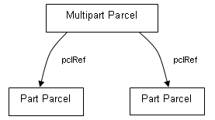

Figure 1 – Multipart parcel structure

A multipart lot has the following structural features:

* The "multipart" parcel contains parcel linkages to all the "part" parcels.
* The "multipart" parcel does not contain the CoordGeom and Center elements. Only the "part" parcels contain coordinate geometry.
* The "multipart" parcel specifies the total area in its area attribute. All part parcels must specify their respective area in their area attribute.
* For a lot with multiple parts, the “multipart” parcel name is the lot number and the “part” lot parcel name is the lot number followed by a an alpha suffix starting with “A”.

For example, if Lot 101 has two parts the parcel name of the multipart parcel is “101” and two part parcels are “101A” and “101B”.

**NB**: the suffix is required in LandXML file as each name should be unique, however the lot number is rendered as Pt 101.

The following is an example implementation of a multipart parcel in LandXML file. The element names are arbitrary and used for demonstration purposes only.

<Parcel name="**101**" class="Lot" state="proposed" parcelType="Multipart" parcelFormat="Standard" area="6685">

<! -- Linkage to parts -->

<Parcels>

<Parcel name="A" pclRef="101A"/>

<Parcel name="B" pclRef="101B"/>

</Parcels>

</Parcel>

<Parcel name="**101A**" class="Lot" state="proposed" parcelType="Part" parcelFormat="Standard" area="1206">

<Center … />

<CoordGeom … >

…

</CoordGeom>

</Parcel>

<Parcel name="**101B**" class="Lot" state="proposed" parcelType="Part" parcelFormat="Standard" area="5479">

<Center … />

<CoordGeom … >

…

</CoordGeom>

</Parcel>

## 4.2 Subdivision Number

The Subdivision Number issued by the Council in the Subdivision Certificate is also recorded on the plan drawing sheet. This is recorded in the LXML file by the use of the Annotation element.

<SurveyHeader … >

<Annotation type="Subdivision Number" name="s1" desc="SC/14/2010/529/1"/>

…

</SurveyHeader>

## 4.3 Plan Note

To apply a note (annotation) to a plan that is about the whole plan you use the Annotation Element as a child of the SurveyHeader element with Annotation@type="Plan Note". See example below.

<SurveyHeader … >

<Annotation type="Plan Note" name="n1" desc="All areas are approximate"/>

…

</SurveyHeader>

## 4.4 Parcel Note

To apply a note (annotation) to a specific parcel or number of parcels you use the Annotation Element as a child of the SurveyHeader element with Annotation@type="Parcel Note". See example below.

<SurveyHeader … >

<Annotation type="Parcel Note" name="n2" desc="Unformed Road" pclRef="R1, R2"/>

…

</SurveyHeader>

## 4.5 Line Note

To apply a note to a specific line you use the FieldNote element as a child of the ReducedObservation element. See following examples:

* Showing a dimension as “by me”

<ReducedObservation name="75" desc="Connection" setupID="IS84" targetSetupID="IS83" azimuth="189.04" horizDistance="6.320">

<FieldNote>by me</FieldNote>

</ReducedObservation>

* Showing measurements between occupations

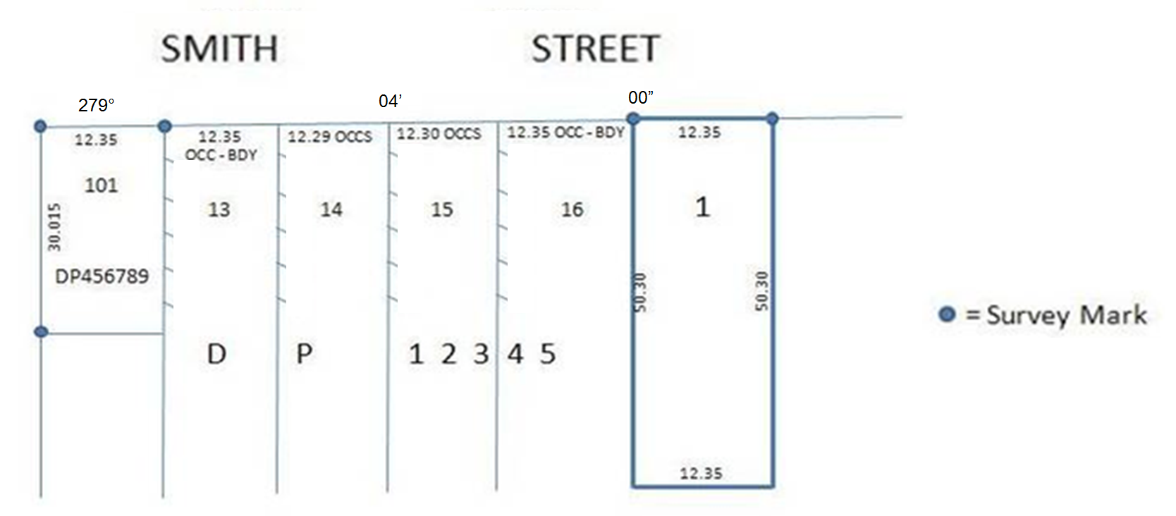

…

<ReducedObservation name="75" desc="Connection" setupID="IS84" targetSetupID="IS83" azimuth="279.04" horizDistance="12.35">

<FieldNote>OCC-BDY</FieldNote>

</ReducedObservation>

<ReducedObservation name="76" desc="Connection" setupID="IS83" targetSetupID="IS82" azimuth="279.04" horizDistance="12.30">

<FieldNote>OCCS</FieldNote>

</ReducedObservation>

…

## 4.6 Control marks used as reference marks

A Control Mark (PM, SSM, etc.) can also be used as a reference mark. This is recorded by using following convention in Land XML:

*At CgPoint;*

<CgPoint name="3" state="existing" pntSurv="control" oID=”168718”>6110668.110000

534471.312000</CgPoint>

*At ReducedObservation;*

<ReducedObservation name="30" desc="Reference" setupID="IS3" targetSetupID="IS2" azimuth="265.3700" horizDistance="3.945" distanceAccClass="Placed"/>

*At RedHorizontalPosition;*

<RedHorizontalPosition name="61" setupID="IS3" latitude="6263432.521" longitude="287064.951" class="C" order="3" currencyDate="2014-01-29" horizontalFix="SCIMS" horizontalDatum="MGA"/>

*At Monument;*

<Monument name="10" pntRef="3" type="SSM" state="Found"/>

## 4.7 “Not Marked” boundary corners

Where a surveyor does not place a boundary mark (such as a peg) at the corner of a new lot, they are required to record the corner as "Not Marked" and place a reference mark in a suitable location remote from the corner.

In order to record a corner which is "Not Marked", CgPoint and Monument elements should be populated as per below example.

*At CgPoint;*

<CgPoint state="proposed" pntSurv="boundary" name="79">6390231.696689 741645.430913</CgPoint>

*At Monument;*

<Monument name="27" pntRef="79" type="Not Marked" state="Not Marked" />

## 4.8 RM gone

### 4.8.1 with boundary mark

Where a surveyor finds or places a boundary mark (such as a peg) on a corner of an adjoining or proposed parcel and there was a RM that was connected to the same corner which is now gone, they are required to record boundary mark information as well as RM gone.

In order to record this information, CgPoint and Monument elements should be populated as per below example.

*At CgPoint;*

<CgPoint state="existing" pntSurv="boundary" name="79">6390231.696689 741645.430913</CgPoint>

*At Monument;*

<Monument name="2" pntRef="16" type="Peg" state="Found" desc="RM Gone (DP220102)"/>

### 4.8.2 without boundary mark

**New lot corners**

Where surveyor cannot place a boundary mark on a new lot corner and there was a RM that was connected to the same corner which is now gone, they must record the corner as "Not Marked" and place a reference mark in a suitable location remote from the corner as per section 4.7 of this document. They must also record RM gone in the file.

In order to record this information, CgPoint and Monument elements should be populated as per below example.

*At CgPoint;*

<CgPoint state="proposed" pntSurv="boundary" name="79">6390231.696689

741645.430913</CgPoint>

*At Monument;*

<Monument name="2" pntRef="16" type="Not Marked" state="Not Marked" desc="RM Gone (DP220102)"/>

**Adjoining lot corners**

Where there is no boundary mark on an adjoining lot corner and there was a RM that was connected to the same corner which is now gone, they must record RM gone detail on the corner it was referencing.

In order to record this information, CgPoint and Monument elements should be populated as per below example.

*At CgPoint;*

<CgPoint state="existing" pntSurv="boundary" name="79">6390231.696689

741645.430913</CgPoint>

*At Monument;*

<Monument name="2" pntRef="16" state="Gone" desc="RM Gone (DP220102)"/>

## 4.9 Plans Used

The list of plans used by the surveyor in the preparation of the plan is recorded using the Annotation@type of “Plans Used” in the NSW enumerations schema. Plan numbers or names are recorded in a comma delimited list in the Annotation@desc attribute. See example below.

<SurveyHeader ...>

<Annotation type="Plans Used" name="1" desc="DP378910, DP524789, 5697.2103"/>

…

</SurveyHeader>

**NB**: This is a mandatory element required for all plans.

## 4.10 Irregular Lines

Irregular line boundaries such as creeks, etc. are defined differently depending on if the plan is surveyed or compiled.

### 4.10.1 Surveyed plans

For surveyed plans, the irregular line boundary (e.g. natural boundary) of a lot is to be defined using IrregularLine element and the traverse information in LandXML. The IrregularLine element is for the rendering of the legal boundary together with the description of the feature (e.g. Right bank of Pioneer River) and the traverse information is for mathematical closure of the lot and will be rendered separately in a short right lines table to represent a traverse along the boundary.

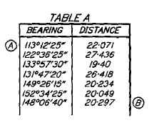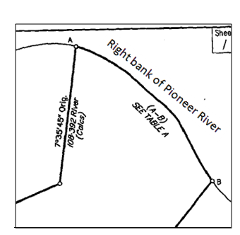

Diag. Surveyed Irregular line boundary

**IrregularLine element**

The shape of the irregular line is visualized using the PntList2d element under IrregularLine element in LandXML using a set of northing and easting coordinate pairs

The information used to render the irregular line and description of the boundary is as follows:

* 1. IrregularLine@desc records the location of the legal boundary (e.g. “Right bank of Pioneer Creek”
  2. The Start and End points (pntRefs) of the irregular line should be from CgPoints
  3. The coordinate pairs of the points representing the irregular line between the Start and End points. The first and last pairs of coordinates in the list must match the CgPoint coordinates of Start and End points.

**NB**: Some of the coordinate pairs in the list can be same as the CgPoint coordinates that are used in traverse

<IrregularLine desc="Right bank of Pioneer River" >

<Start pntRef="217"/>

<End pntRef="234"/>

<PntList2D>1322.137070 897.047360 1315.916630 896.467670 1310.226980 897.991240 1303.757680 903.401480 1294.458130 911.729520 1206.212380 967.435920 1195.584230 974.819390 1188.710850 975.722460 1183.368710 976.036190 1177.116210 974.874520 1170.836800 971.127850 1162.738330 965.201400 1157.406840 961.661120 1153.054100 958.694270 1289.443320 915.970390 1274.394860 931.130970 1268.003170 937.445250</PntList2D>

</IrregularLine>

**Traverse**

Bearings and distances of traverses are recorded using ReducedObservation element under the ObservationGroup element and all points used in the traverse must be in the CgPoints element and have corresponding InstrumentSetup elements. The start and end point of the traverse must match the Start@pntRef and End@pntRef of the corresponding IrregularLine and have CgPoint@pntSurv of “boundary”. All other intermediate points in the traverse must have CgPoint@pntSurv of “natural boundary”. See example below:

*At CgPoints;*

<CgPoints zoneNumber="56">

…

<CgPoint name="217" state="proposed" pntSurv="boundary">1322.137070 897.047360</CgPoint>

<CgPoint name="234" state="proposed" pntSurv="boundary">1268.003170 937.445250</CgPoint>

…

<CgPoint name="221" state="proposed" pntSurv="natural boundary">1310.226980 897.991240</CgPoint>

<CgPoint name="222" state="proposed" pntSurv="natural boundary">1188.710850 975.722460</CgPoint>

<CgPoint name="223" state="proposed" pntSurv="natural boundary">1183.368710 976.036190</CgPoint>

<CgPoint name="224" state="proposed" pntSurv="natural boundary">1177.116210 974.874520</CgPoint>

…

</CgPoints>

*At InstrumentSetup;*

…

<InstrumentSetup id="S-217" stationName="217" instrumentHeight="0">

<InstrumentPoint pntRef="217" />

</InstrumentSetup>

<InstrumentSetup id="S-221" stationName="221" instrumentHeight="0">

<InstrumentPoint pntRef="221" />

</InstrumentSetup>

…

<InstrumentSetup id="S-224" stationName="226" instrumentHeight="0">

<InstrumentPoint pntRef="226" />

</InstrumentSetup>

<InstrumentSetup id="S-234" stationName="234" instrumentHeight="0">

<InstrumentPoint pntRef="234" />

</InstrumentSetup>

…

All traverse observations should have ReducedObservation@desc of “Connection”

*At ObservationGroup;*

<ObservationGroup id="OG-1">

…

<ReducedObservation name="11" setupID="S-217" targetSetupID="S-221" azimuth="234.5140" horizDistance="13.235" desc="Connection"></ReducedObservation>

<ReducedObservation name="12" setupID="S-221" targetSetupID="S-222" azimuth="324.5120" horizDistance="12.320" desc="Connection"></ReducedObservation>

…

<ReducedObservation name="13" setupID="S-223" targetSetupID="S-224" azimuth="54.5145" horizDistance="15.450" desc="Connection"></ReducedObservation>

<ReducedObservation name="14" setupID="S-224" targetSetupID="S-234" azimuth="144.5115" horizDistance="21.105" desc="Connection"></ReducedObservation>

…

</ObservationGroup>

### 4.10.2 Compiled plans

For compiled plans, the irregular line boundary (e.g. natural boundary) of a lot is to be defined using IrregularLine element only. See IrregularLine element under section 4.10.1 for example.

### 4.10.3 Defining Adjoining Hydrographic Parcels

To create a river (or any other water feature) as an adjoining parcel, following attributes under Parcel element should be populated as per example below. This is applicable to both Surveyed and Compiled plans.

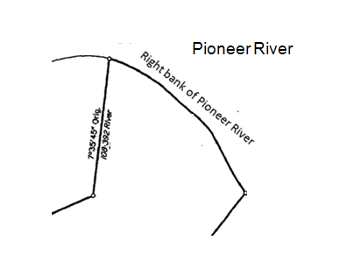

<Parcel name="H1" class="Hydrography" desc=”Pioneer Creek” state="adjoining" parcelFormat="Standard" useOfParcel="River" parcelType="Single">

Diag. Compiled IrregularLine boundary with River as adjoining parcel

## 4.11 PlanFeatures

PlanFeatures element in LandXML is used for diagrammatic features of the plan such as occupations, offsets, other features, etc. Hence, the features can be exaggerated for better visual representation, if required. The points (CgPoint) used to create the feature should have pntSurv of “sideshot” unless it is an actual boundary or reference point.

### 4.11.1 Occupations

Occupations generally have geometry (shape), description and offsets. Geometry and the description of an occupation are defined in PlanFeature element and all the points used in the geometry definition should have corresponding CgPoint elements. Offsets are generally defined using Monument element but it can also be defined using PlanFeature element in some cases.

In a special case where the occupation is a wall on the boundary the Line@desc attribute is also need to be populated with “Face of Wall” of the corresponding parcel geometry line.

In NSW, only the following five types of features can be used and these are only to differentiate the rendering style.

* Building : hatching inside a line

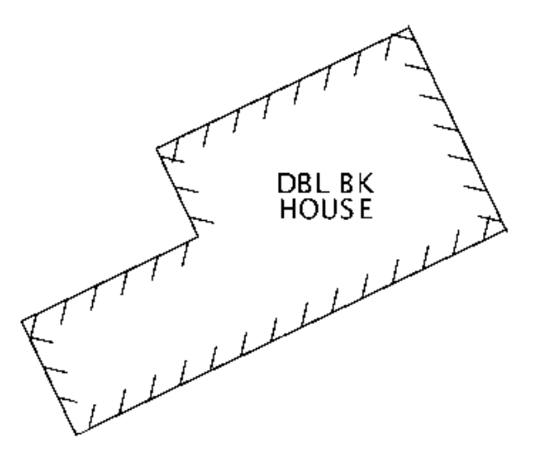

* Wall : hatching between a set of parallel lines

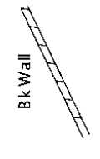 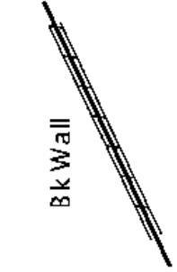 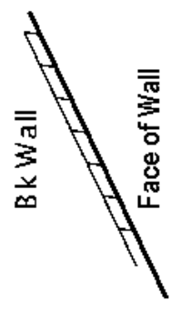

Wall only Boundary in Wall Wall on Boundary

**NB**: Boundary in Wall must indicate where the boundary is at two end points using Monuments element

* Fence : hatching between the broken line

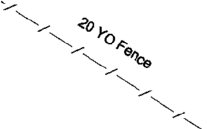 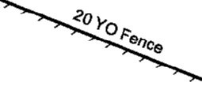

Off Boundary On Boundary

**NB**: There is slight difference in hatching between on and off boundary Fence

* Kerb : broken line

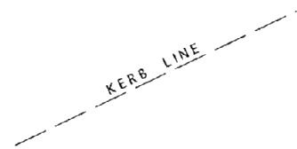

* Offset : renders only desc attribute between given two points

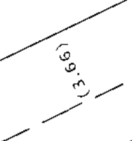

See following example for how each elements/attributes are populated in LandXML for occupations.

All points (CgPoint) used to create occupations including the occupation of a point nature such as ‘centre of a fence post’ should be in the CgPoints element.

*At CgPoints;*

<CgPoints zoneNumber="56">

…

<CgPoint name="11" state="proposed" pntSurv="boundary">1322.137070 897.047360</CgPoint>

<CgPoint name="12" state="existing" pntSurv="boundary">1268.003170 937.445250</CgPoint>

…

<CgPoint name="35" state="existing" pntSurv="boundary">1310.226980 897.991240</CgPoint>

<CgPoint name="36" state="existing" pntSurv="boundary">1188.710850 975.722460</CgPoint>

…

<CgPoint name="3" state="existing" pntSurv="sideshot">1183.368710 976.036190</CgPoint>

<CgPoint name="4" state="existing" pntSurv="sideshot">1177.116210 974.874520</CgPoint>

<CgPoint name="5" state="existing" pntSurv="sideshot">1153.054100 958.694270</CgPoint>

<CgPoint name="6" state="existing" pntSurv="sideshot">1289.443320 915.970390</CgPoint>

<CgPoint name="7" state="existing" pntSurv="sideshot">1197.135371 977.322490</CgPoint>

<CgPoint name="8" state="existing" pntSurv="sideshot">1185.846230 964.612050</CgPoint>

<CgPoint name="9" state="proposed" pntSurv="boundary">1235.561320 944.719420</CgPoint>

…

</CgPoints>

Monuments element is generally used for mark details but it can also be used for occupation offset information. When it is used for this purpose, type attribute must be “Occupation”.

*At Monuments;*

<Monuments>

…

<!--one occupation with offsets to two roads near intersection (see diagrams on next page) -->

<Monument name="30" pntRef="5" type="Occupation" state="Found" desc="1.00 Clear Smith Rd, 0.05 Clear Fred St"/>

…

<!--offsets from the occupation of a point nature (see diagrams on next page) -->

<Monument name="31" pntRef="9" type="Occupation" state=" Found " desc="Cen. Old SFP 0.24N 0.09E"/>

…

<!--offsets from the occupation of a point nature (see diagrams on page 60) -->

<Monument name="32" pntRef="3" type="Occupation" state=" Found " desc="(0.05)"/>

…

<!--offsets from the occupation of a point nature (see diagrams on page 60) -->

<Monument name="33" pntRef="6" type="Occupation" state=" Found " desc="0.04 OFF BDY"/>

…

</Monuments>

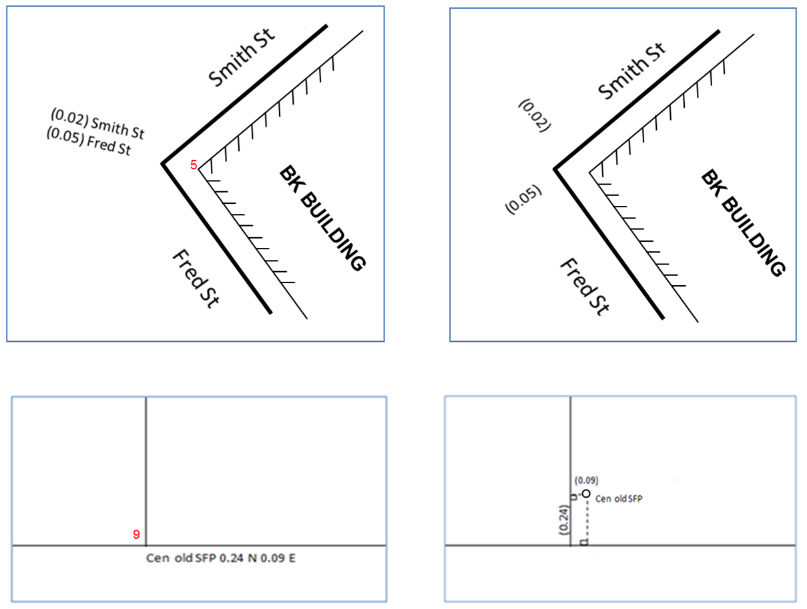

Offsets to two Roads near intersection

**How it will be rendered**

**What it means**

(0.09)

Cen old SFP

(0.24)

Cen old SFP 0.24 N 0.09 E

**9**

Occupation of point nature

PlanFeatures element is where each occupation is defined as an individual PlanFeature element with its geometry definition and the description of what the feature (occupation) is. The name attribute of a PlanFeature determines the rendering style. If there are two or more of same type features, numeric suffix must be used to give them the unique identity.

*At PlanFeatures;*

<PlanFeatures name="Occupation">

<PlanFeature name="Fence1" desc="20 YO FENCE ON BDY">

<CoordGeom name="F1">

<Line>

<Start pntRef="11"/>

<End pntRef="12"/>

</Line>

</CoordGeom>

</PlanFeature>

<PlanFeature name="Wall1" desc="Bk Wall">

<CoordGeom name="W1">

<Line>

<Start pntRef="35"/>

<End pntRef="36"/>

</Line>

</CoordGeom>

</PlanFeature>

<PlanFeature name="Kerb1" desc="Kerb Line">

<CoordGeom name="K1">

<Line>

<Start pntRef="7"/>

<End pntRef="8"/>

</Line>

</CoordGeom>

</PlanFeature>

*Cont’d to next page*

11

12

20 YO FENCE ON BDY

35

36

Bk Wall

7

8

Kerb Line

*Cont’d from last page*

<PlanFeature name="Building1" desc="DBL BK HOUSE">

<CoordGeom name="B1">

<Line>

<Start pntRef="3"/>

<End pntRef="4"/>

</Line>

<Line>

<Start pntRef="4"/>

<End pntRef="5"/>

</Line>

<Line>

<Start pntRef="5"/>

<End pntRef="6"/>

</Line>

<Line>

<Start pntRef="6"/>

<End pntRef="3"/>

</Line>

</CoordGeom>

</PlanFeature>

<PlanFeature name="Offset1" desc="(3.66)">

<!--desc can also have (KL-BDY 3.66), (3.66 CNR Bk), etc. -->

<CoordGeom name="O1">

<Line>

<Start pntRef="12"/>

<End pntRef="7"/>

</Line>

</CoordGeom>

</PlanFeature>

</PlanFeatures>

3

4

5

6

DBL BK HOUSE

7

12

(3.66)

(0.05)

0.04 OFF BDY

**NB**: To facilitate rendering of occupations within LXML file the coordinate geometry must be sequenced as if walking along the occupation feature with the hatching representing the substance of the occupation always on the right hand side of the occupation line being defined

In a case where the occupation is a wall on the boundary Line@desc attribute under Parcel element must be populated as per below example.

*At Parcel;*

<Parcel name="12" area="495.0" class="Lot" state="proposed" parcelFormat="Standard" parcelType="Single">

<Center pntRef="LC-137"/>

<CoordGeom name="XSTG12-1-1205">

…

<Line>

<Start pntRef="34"/>

<End pntRef="35"/>

</Line>

<Line desc="Face of Wall">

<Start pntRef="35"/>

<End pntRef="36"/>

</Line>

<Line>

<Start pntRef="36"/>

<End pntRef="37"/>

</Line>

…

</CoordGeom>

</Parcel>

**NB**:

* When using the PlanFeature@name of “Wall” or “Fence” the CoordGeom will represent the center line of the wall/fence.
* When using the PlanFeature@name of ”Building” or “Kerb” the CoordGeom will represent the outside face of the building’s wall or face of Kerb

### 4.11.2 Other Types of Plan Features

Other types of plan features such as “Dam”, “Cliff’, “Watercourse” etc. can be created using one of the five feature types (PlanFeature@name) from previous section. Type should be selected to match the appropriate line style for rendering and for the description of the actual feature, PlanFeature@desc attribute should be used.

Examples

1. Use Building to render a Cliff

<PlanFeature name="Building" desc="Top edge of cliff">

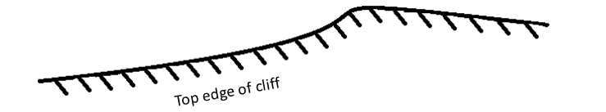

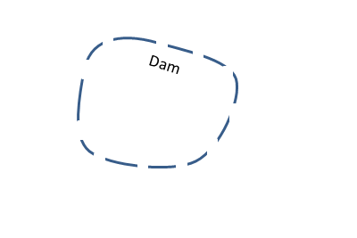

2. Use Kerb to render a Dam

<PlanFeature name="Kerb" desc="Dam">

3. Use Kerb to render a Tree

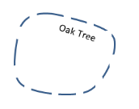<PlanFeature name="Kerb" desc="Oak Tree">

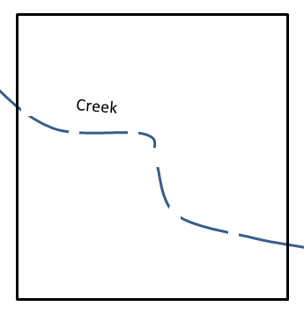

4. Use Kerb to render a Creek

<PlanFeature name="Kerb" desc="Creek">

**NB:** If there is an irregular line in the shape of the watercourse the IrregularLine element should be used in the CoordGeom of the PlanFeature

## 4.12 Easements over track in use or line of pipes (Approx. position)

These easements are defined using IrregularLine element as per section 4.10 of this document. See following example for how each elements/attributes are populated in LandXML for the easement below.

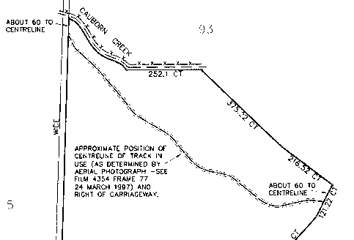

11

12

*At Parcel;*

<Parcel name="E1" class="Easement" state="proposed" parcelFormat="Standard" parcelType="Single" desc="Right of Carriageway over track in use">

<Center pntRef="LC-137"/>

<CoordGeom name="E1">

<IrregularLine desc="Approximate position of centreline of track in use" source="as determined by Aerial photograph – see film 4354 frame 77, 24 March 1997">

<Start pntRef="11"/>

<End pntRef="12"/>

<PntList2D>1322.137070 897.047360 1315.916630 896.467670 1310.226980 897.991240 1303.757680 903.401480 1294.458130 911.729520 1206.212380 967.435920 1195.584230 974.819390 1188.710850 975.722460 1183.368710 976.036190 1177.116210 974.874520 1170.836800 971.127850 1162.738330 965.201400 1157.406840 961.661120 1153.054100 958.694270 1289.443320 915.970390</PntList2D>

</IrregularLine>

</CoordGeom>

</Parcel>

*At CgPoints;*

<CgPoints zoneNumber="56">

…

<CgPoint name="11" state="proposed" pntSurv="boundary">1322.137070 897.047360</CgPoint>

<CgPoint name="12" state="proposed" pntSurv="boundary">1268.003170 937.445250</CgPoint>

…

</CgPoints>

## 4.13 Transmission line easements defined by centre line traverse

These easements have two parts and they are defined separately in the LandXML.

* The centerline traverse : This is defined as an unclosed easement parcel.
* The extremity boundaries : This is defined as a plan feature.

See following example for how each elements/attributes are populated in LandXML for the easement below.

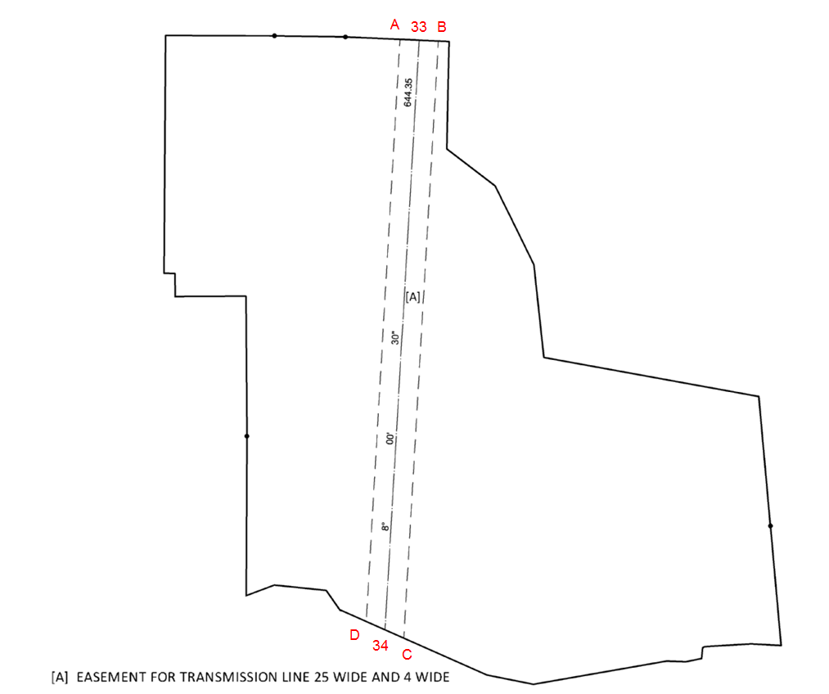

**The centreline traverse**

*At CgPoints;*

<CgPoints zoneNumber="56">

…

<CgPoint name="33" state="proposed" pntSurv="boundary">1322.137070 897.047360</CgPoint>

<CgPoint name="34" state="proposed" pntSurv="boundary">1268.003170 937.445250</CgPoint>

…

</CgPoints>

*At Parcel;*

<Parcel name="E3" class="Easement" state="proposed" parcelFormat="Standard" parcelType="Single" desc="Easement for Transmission Line 25 Wide - Defined by traverse of centreline of poles ">

<Center pntRef="LC-17"/>

<CoordGeom name="E3">

<Line>

<Start pntRef="33"/>

<End pntRef="34"/>

</Line>

</CoordGeom>

</Parcel>

*At InstrumentSetup;*

…

<InstrumentSetup id="S-33" stationName="33" instrumentHeight="0">

<InstrumentPoint pntRef="33" />

</InstrumentSetup>

<InstrumentSetup id="S-34" stationName="34" instrumentHeight="0">

<InstrumentPoint pntRef="34" />

</InstrumentSetup>

…

*At ObservationGroup;*

<ObservationGroup id="OG-1">

…

<ReducedObservation name="21" setupID="S-34" targetSetupID="S-33" azimuth="8.0030" horizDistance="644.35" desc="Boundary"></ReducedObservation>

…

</ObservationGroup>

**The extremity boundaries**

*At CgPoints;*

<CgPoints zoneNumber="56">

…

<CgPoint name="A" state="proposed" pntSurv="sideshot">1183.368710 976.036190</CgPoint>

<CgPoint name="B" state="proposed" pntSurv="sideshot">1177.116210 974.874520</CgPoint>

<CgPoint name="C" state="proposed" pntSurv="sideshot">1153.054100 958.694270</CgPoint>

<CgPoint name="D" state="proposed" pntSurv="sideshot">1289.443320 915.970390</CgPoint>

…

</CgPoints>

**N.B.**

Any description with prefix ‘DNR’ will not be rendered from Rendering Service

*At PlanFeatures;*

<PlanFeatures name="Occupation">

…

<PlanFeature name="Kerb E3" desc="DNR Transmission line easement boundary">

<CoordGeom name="E3Bdy">

<Line>

<Start pntRef="A"/>

<End pntRef="B"/>

</Line>

<Line>

<Start pntRef="B"/>

<End pntRef="C"/>

</Line>

<Line>

<Start pntRef="C"/>

<End pntRef="D"/>

</Line>

<Line>

<Start pntRef="D"/>

<End pntRef="A"/>

</Line>

</CoordGeom>

</PlanFeature>

…

</PlanFeatures>

## 4.14 Definition of easement segments

**New Easements**

Where a new easement extends over multiple lots, this easement must be segmented and defined as separate easement parcels, one for each lot that it affects.

The easement parcel names (Parcel@name) are to be E1, E2, E3, etc. but they must have same parcel description (Parcel@desc). This will ensure all the parts of the easement parcels with same descriptions to be combined within the one designation as per below diagram.

Full dimensions are required for all proposed easement parcels including all ‘(x)’ marked easement boundaries.

**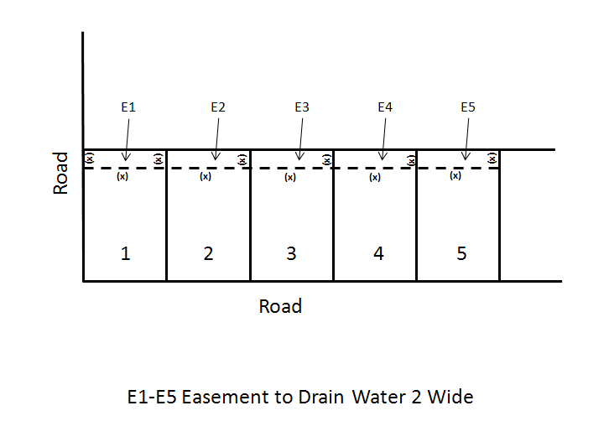****Existing Easements**

Where an existing easement extends over multiple lots it is not necessary to segment the easement parcel or show dimensions.

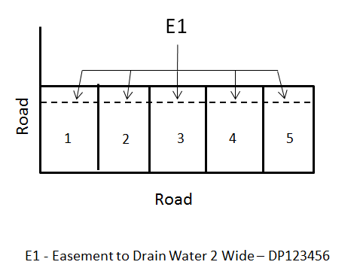

## 4.15 Administrative area boundaries

Where a plan crosses over multiple administrative areas such as LGA, Parish, etc., the administrative areas are defined as unclosed parcels. This method also applies to any partial parcel where the parcel cannot be shown in full either because of size or its extent is unknown.

Typically for administrative area boundaries there will be two Administrative Area parcels separated by a common boundary. These types of parcels need at least one line and a Center to identify on which side of the line the parcel is located.

The example shown below is where a plan covers 2 LGA’s

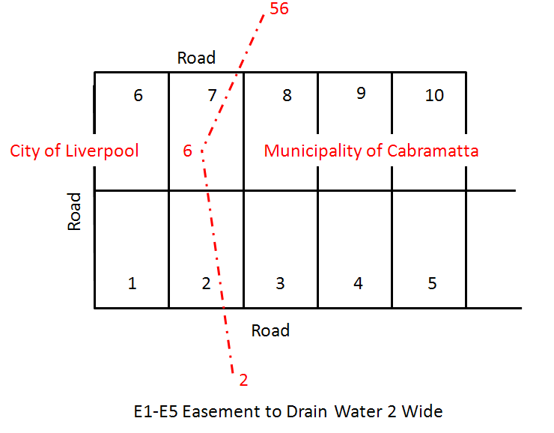Where there are multiple administrative area types that coincide with the same dividing boundary e.g. when both Locality and LGA are different on both sides, the parcel name can combine their names e.g. name =”City Of Hay - locality of Como”. The useOfParcel will be set to “Administrative Area”. However there will still be a separate Administrative Area element required for each one

*At Parcels;*

<Parcels>

…

<Parcel name="City of Liverpool" class="Administrative Area" state="existing" parcelType="Single" parcelFormat="Standard" useOfParcel="Local Government Area">

<Center pntRef="LC-13"/>

<CoordGeom name="LGA-1">

<Line>

<Start pntRef="56"/>

<End pntRef="6"/>

</Line>

<Line>

<Start pntRef="6"/>

<End pntRef="2"/>

</Line>

</CoordGeom>

</Parcel>

<Parcel name="Municipality of Cabramatta" class="Administrative Area" state="existing" parcelType="Single" parcelFormat="Standard" useOfParcel="Local Government Area">

<Center pntRef="LC-14"/>

<CoordGeom name="LGA-2">

<Line>

<Start pntRef="2"/>

<End pntRef="6"/>

</Line>

<Line>

<Start pntRef="6"/>

<End pntRef="56"/>

</Line>

</CoordGeom>

</Parcel>

…

</Parcels>

## 4.16 Defining diagrams (enlargements) in NSW LXML

The rendering service will provide the ability to self-nominate diagrams, including diagrams that render only specific information in the specified area. If there are no self-nominated diagrams, diagrams will be auto generated by the service.

The Annotation elements are used to define the self-nominated diagrams. To define the area to be shown as diagram, Annotation@desc attribute is used with reference to CgPoint@name values. The Annotation@type defines the type of diagrams which include the following “*annotationType*” enumerations

* “Diagram”

: Render all information in the area defined by the Annotation@desc

* “Diagram Lots”

: Render all information relating to lots only

* “Diagram Occupations”

: Render all information relating to occupations and line work only for lots

* “Diagram Secondary Interests”

: Render all information relating to secondary interests (e.g. easements) and line work only for lots.

See following example for how each elements/attributes are populated in LXML to define self-nominate diagrams.

*At SurveyHeader;*

<SurveyHeader …>

…

<Annotation type="Diagram" name="D1" desc="D-11, D-12, D-13, D-14"/>

<Annotation type="Diagram Secondary Interests" name="D2" desc="D-21, D-22, D-23, D-24"/>

<Annotation type="Diagram Occupations" name="D3" desc="D-31, D-32, D-33, D-34"/>

<Annotation type="Diagram" name="D4" desc="D-41, D-42, D-43, D-44"/>

<Annotation type="Diagram Lots" name="D5" desc="34, 33, 80, 83, 84, 69"/>

<Annotation type="Diagram Occupations" name="D6" desc="34, 33, 80, 83, 84, 69"/>

<Annotation type="Diagram Secondary Interests" name="D7" desc="34, 33, 80, 83, 84, 69"/>

…

</SurveyHeader>

**NB:** The CgPoint used to define the extent of the diagram can be any points that are already in the file or can be points that are created solely for the purpose of defining the diagram area. For all the CgPoint solely for extent of the diagram only should be defined as per below.

*At CgPoints;*

<CgPoints …>

…

<CgPoint name="D-11" state="proposed" pntSurv="sideshot">303.305400 980.661530</CgPoint>

<CgPoint name="D-12" state="proposed" pntSurv="sideshot">303.305400 886.032160</CgPoint>

<CgPoint name="D-13" state="proposed" pntSurv="sideshot">276.163110 886.032160</CgPoint>

<CgPoint name="D-14" state="proposed" pntSurv="sideshot">276.163110 980.661530</CgPoint>

<CgPoint name="D-21" state="proposed" pntSurv="sideshot">293.706738 991.056130</CgPoint>

…

</ CgPoints>

## 4.17 Adding Direction of Flow arrow in water course

The Direction of Flow arrow can be added in LandXML using the Annotation@type of “Direction Of Flow Tidal” or “Direction Of Flow Non Tidal”. This will allow the rendering service to render the appropriate type of arrow next to a water course. The reference (link) to the water course is done using the desc attribute, which is to be populated with the Start and End points of the corresponding IrregularLine element.

There are 2 relevant annotation types and the type of arrow will be as per below;

1. “Direction Of Flow Non Tidal” will produce a straight arrow.

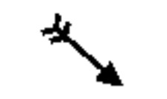

2. “Direction Of Flow Tidal” will produce an “S” shaped arrow.

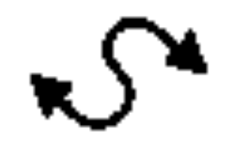

See following example for how each elements/attributes are populated in LandXML.

**NB:** The flow arrow will always render from first point to second point in the desc attribute regardless of Start and End of IrregularLine.

*At IrregularLine;*

…

<IrregularLine desc="Right Bank of Hawkesbury River" >

<Start pntRef="11"/>

<End pntRef="14"/>

<PntList2D>……</PntList2D>

</IrregularLine>

…

<IrregularLine desc=" Bank of Georges River" >

<Start pntRef="21"/>

<End pntRef="24"/>

<PntList2D>……</PntList2D>

</IrregularLine>

…

*At SurveyHeader;*

<SurveyHeader …>

…

<Annotation type="Direction Of Flow Tidal" name="F1" desc="11, 14"/>

<Annotation type="Direction Of Flow Non Tidal" name="F2" desc="21, 24"/>

…

</SurveyHeader>

## 4.18 Defining Reserved Roads

When a reserved road is excluded from a lot, it should be created in the LXML file as a separate road parcel. It must have a class of “Reserved Road”

The boundaries of the Reserved Road do not require ReducedObservation and will be rendered as broken lines. If any boundary of the reserved road coincides with another parcel boundary of any other class, the line work of other parcel class will take precedence at the rendering.

See following example for how each elements/attributes should be populated in LandXML for given example.

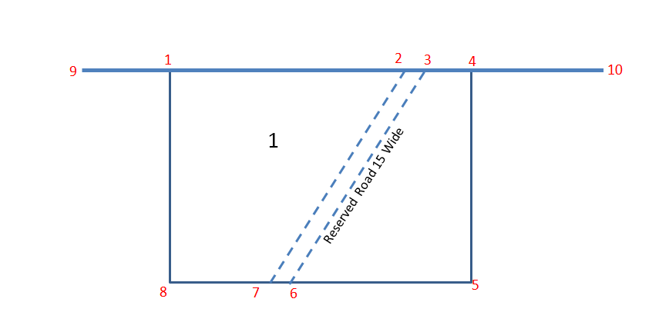

*At Parcel;*

<Parcel name="R11" desc="Reserved Road 15 Wide" class="Reserved Road" state="existing" parcelFormat="Standard" parcelType="Single">

<Center pntRef="LC-47"/>

<CoordGeom name="R11-1">

<Line>

<Start pntRef="2"/>

<End pntRef="3"/>

</Line>

<Line>

<Start pntRef="3"/>

<End pntRef="6"/>

</Line>

<Line>

<Start pntRef="6"/>

<End pntRef="7"/>

</Line>

<Line>

<Start pntRef="7"/>

<End pntRef="2"/>

</Line>

</CoordGeom>

</Parcel>

If any of the Reserved Road parcel boundaries coincide with a proposed lot boundary that has a ReducedObservation (boundary from point 8 to point 1 below), the ReducedObservation@desc should be “Boundary” and not “Road”.

### 4.19 Defining Reference Mark (RM)

Reference marks in LandXML are defined in two levels. One is using Monument element to define physical mark information and the other is to define the information in regard actual observation to referencing corner.

### 4.19.1 RM(s) referencing single corner

In most situations, there will be a double up of information in Monument and ReducedObservation elements in regard to the state of the mark and the observation (see Example 1 below). There are also cases where this information does not agree between the two elements (see Example 2 below).

Example 1: Two reference marks (points 1 & 2) were found referencing a cornet ‘L’ (point 10) and agree with DP1171493 which is also the origin of the mark. Another mark (point 3) was placed to reference corner ‘AD’ (point 11).

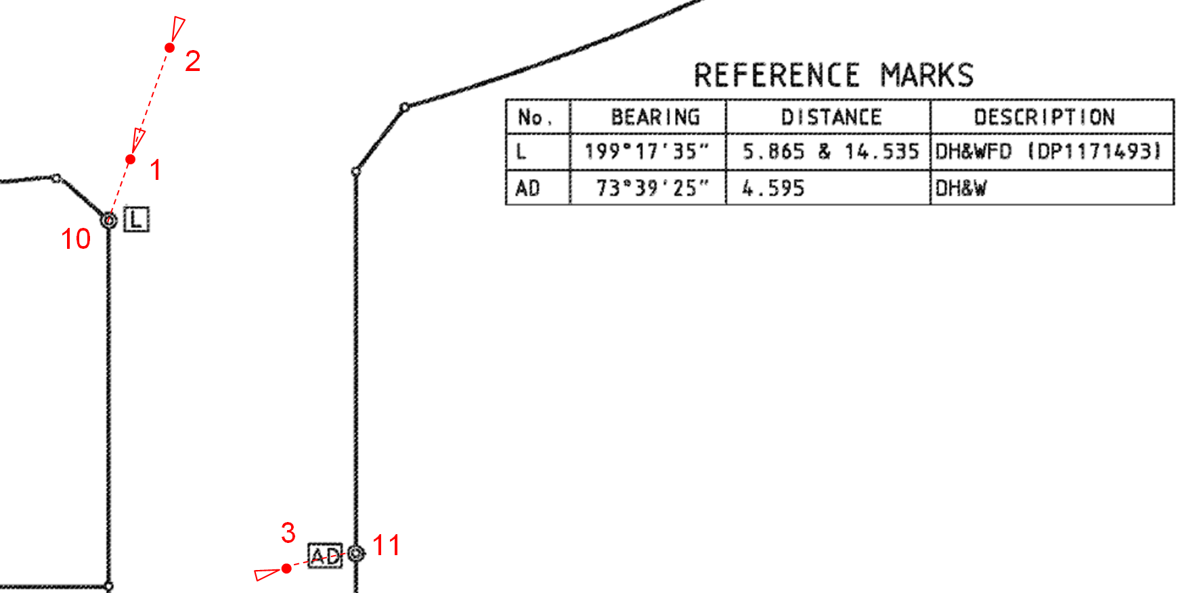

See following for how each elements/attributes should be populated in LandXML for given example.

*At CgPoints;*

<CgPoints zoneNumber="56">

…

<CgPoint name="1" state="existing" pntSurv="reference">6110676.619 534466.481</CgPoint>

<CgPoint name="2" state="existing" pntSurv="reference">6110676.317 534462.548</CgPoint>

<CgPoint name="3" state="proposed" pntSurv="reference">6110668.110 534471.312</CgPoint>

…

<CgPoint name="10" state="proposed" pntSurv="boundary">6110671.235 534463.458</CgPoint>

<CgPoint name="11" state="proposed" pntSurv="boundary">6110665.137 534452.181</CgPoint>

…

</CgPoints>

*At ObservationGroup;*

<ObservationGroup id="OG-1">

…

<ReducedObservation name="19" desc="Reference" setupID="IS1" targetSetupID="IS10" azimuth="199.1735" horizDistance="5.865" distanceAccClass="Found" adoptedDistanceSurvey="DP1171493"/>

<ReducedObservation name="20" desc="Reference" setupID="IS2" targetSetupID="IS10" azimuth="199.1735" horizDistance="14.535" distanceAccClass="Found" adoptedDistanceSurvey="DP1171493"/>

<ReducedObservation name="21" desc="Reference" setupID="IS3" targetSetupID="IS11" azimuth="73.3925" horizDistance="4.595" distanceAccClass ="Placed"/>

…

</ObservationGroup>

*At Monuments;*

<Monuments>

…

<Monument name="21" pntRef="1" type="DH&amp;W" state="Found" originSurvey ="DP1171493"/>

<Monument name="22" pntRef="2" type="DH&amp;W" state="Found" originSurvey ="DP1171493"/>

<Monument name="23" pntRef="3" type="DH&amp;W" state="Placed"/>

…

</Monuments>

Example 2: There are two reference marks (points 1 & 2) were found referencing a cornet at point 31 but has been re-referenced by the survey and does not agree with the origin (DP247735) of the mark.

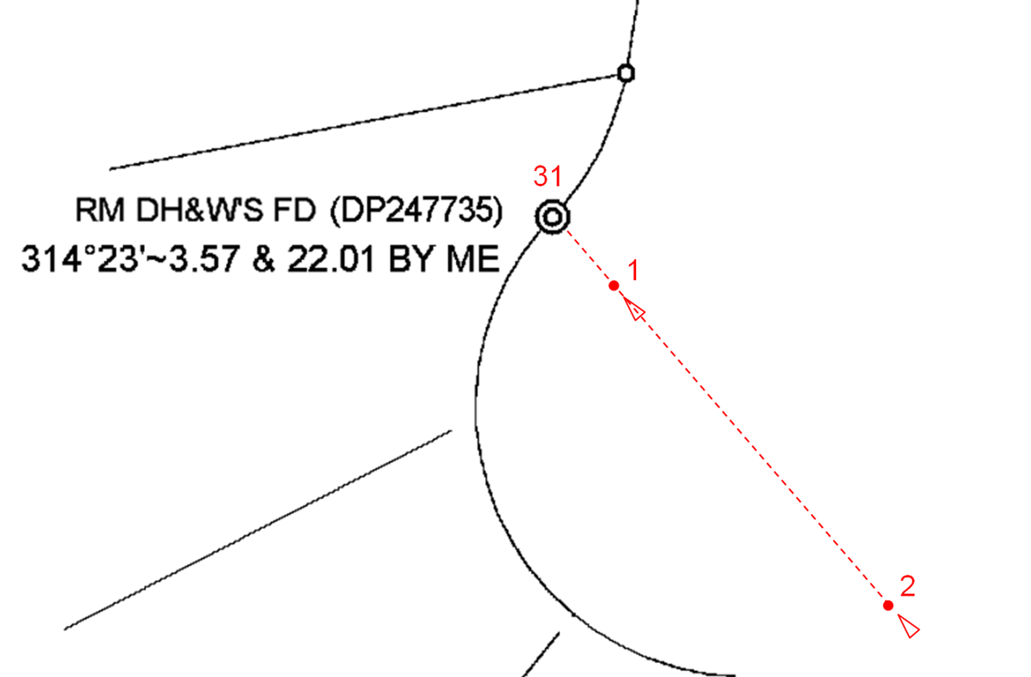

See following for how each elements/attributes should be populated in LandXML for given example.

*At Monuments;*

<Monuments>

…

<Monument name="21" pntRef="1" type="DH&amp;W" state="Found" originSurvey ="DP247735"/>

<Monument name="22" pntRef="2" type="DH&amp;W" state="Found" originSurvey ="DP247735"/>

…

</Monuments>

*At ObservationGroup;*

<ObservationGroup id="OG-1">

…

<ReducedObservation name="19" desc="Reference" setupID="IS1" targetSetupID="IS31" azimuth="314.2000" horizDistance="3.570" distanceAccClass="Found By Me" adoptedDistanceSurvey="DP247735"/>

<ReducedObservation name="20" desc="Reference" setupID="IS2" targetSetupID="IS31" azimuth="314.2000" horizDistance="22.010" distanceAccClass="Found By Me" adoptedDistanceSurvey="DP247735"/>

…

</ObservationGroup>

*At CgPoints;*

<CgPoints zoneNumber="56">

…

<CgPoint name="1" state="existing" pntSurv="reference">6110676.619 534466.481</CgPoint>

<CgPoint name="2" state="existing" pntSurv="reference">6110676.317 534462.548</CgPoint>

…

<CgPoint name="31" state="proposed" pntSurv="boundary">6110671.235 534463.458</CgPoint>

…

</CgPoints>

### 4.19.2 When one mark references multiple corners

There have been many occasions where one physical mark is used to reference multiple corners at different times of survey. When a single mark is used to define multiple corners with different attribute values, it must be defined as follow.

* + - 1. Attributes of the physical mark will be populated in the Monument element.
      2. The reference information will be populated in the ReducedObservation of each reference lines

Example: Two reference lines shown in red box below are actually connected to same reference mark, which is shown as a circle with wings. Connection to the left corner was surveyed and agrees to the found origin (DP1074678), whereas connection to the right corner is new reference using same mark.

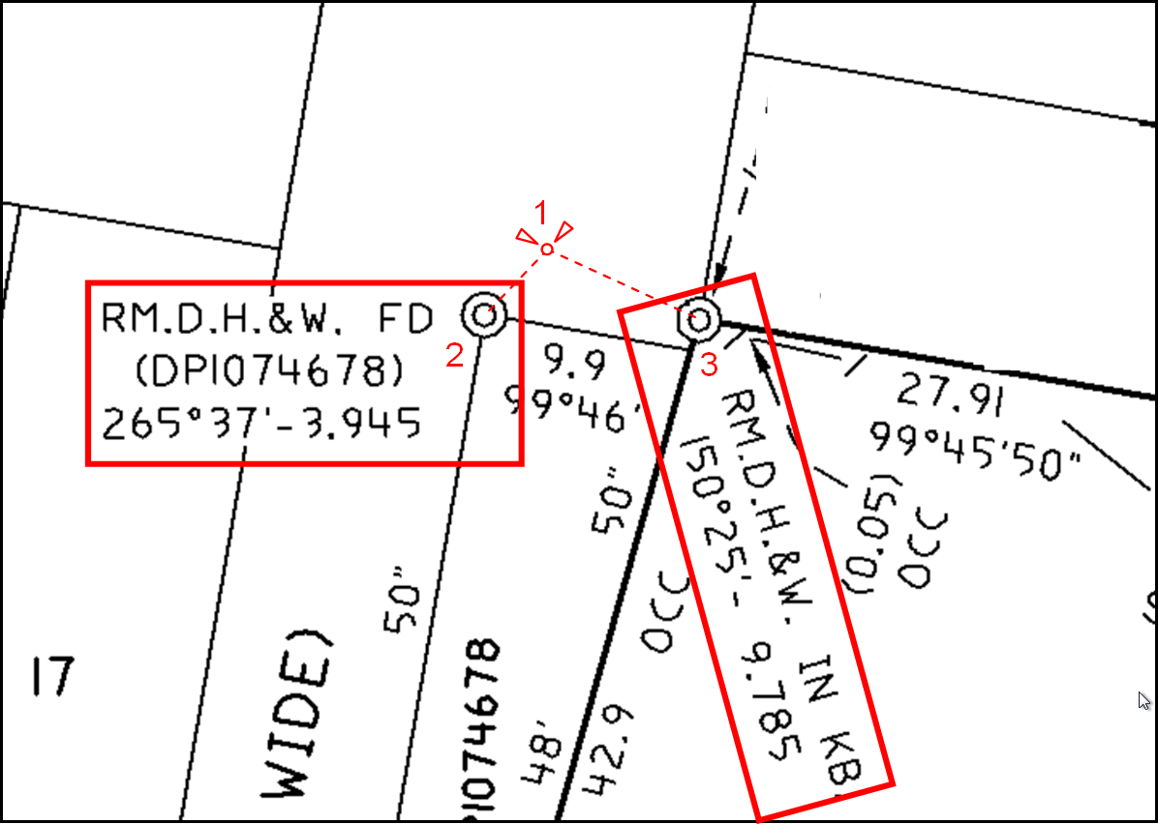

See following for how each elements/attributes should be populated in LandXML for given example.

*At CgPoints;*

<CgPoints zoneNumber="56">

…

<CgPoint name="1" state="existing" pntSurv="reference">6110676.619 534466.481</CgPoint>

<CgPoint name="2" state="existing" pntSurv="boundary">6110676.317 534462.548</CgPoint>

<CgPoint name="3" state="proposed" pntSurv="boundary">6110668.110 534471.312</CgPoint>

…

</CgPoints>

*At ObservationGroup;*

<ObservationGroup id="OG-1">

…

<ReducedObservation name="30" desc="Reference" setupID="IS1" targetSetupID="IS2" azimuth="265.3700" horizDistance="3.945" distanceAccClass="Found" adoptedDistanceSurvey="DP1074678"/>

<ReducedObservation name="31" desc="Reference" setupID="IS1" targetSetupID="IS3" azimuth="150.2500" horizDistance="9.785" distanceAccClass ="Placed">

<FieldNote>Add. Ref. By Me</FieldNote>

< ReducedObservation />

…

</ObservationGroup>

*At Monuments;*

<Monuments>

…

<Monument name="10" pntRef="1" type="DH&amp;W" state="Found" originSurvey ="DP1074678"/>

…

</Monuments>

**NB:** The state attribute under Monument element is the physical state of the mark and the distanceAccClass attribute under ReducedObservation element is the state of the individual reference line. When these attributes are either “Found” or “Found By Me”, the Monument@ originSurvey attribute and ReducedObservation@adoptedDistanceSurvey attributes should be populated accordingly.

## 4.20 Defining the area ‘Benefited to the Part’ using Designated Area

When only part of the lot is being benefited by a secondary interest such as an easement, it is required to designate the area being benefited. The area being designated must be created as a separate parcel with a Parcel@class=”Designated Area”.

See next page for how each elements/attributes should be populated in LandXML for example below.

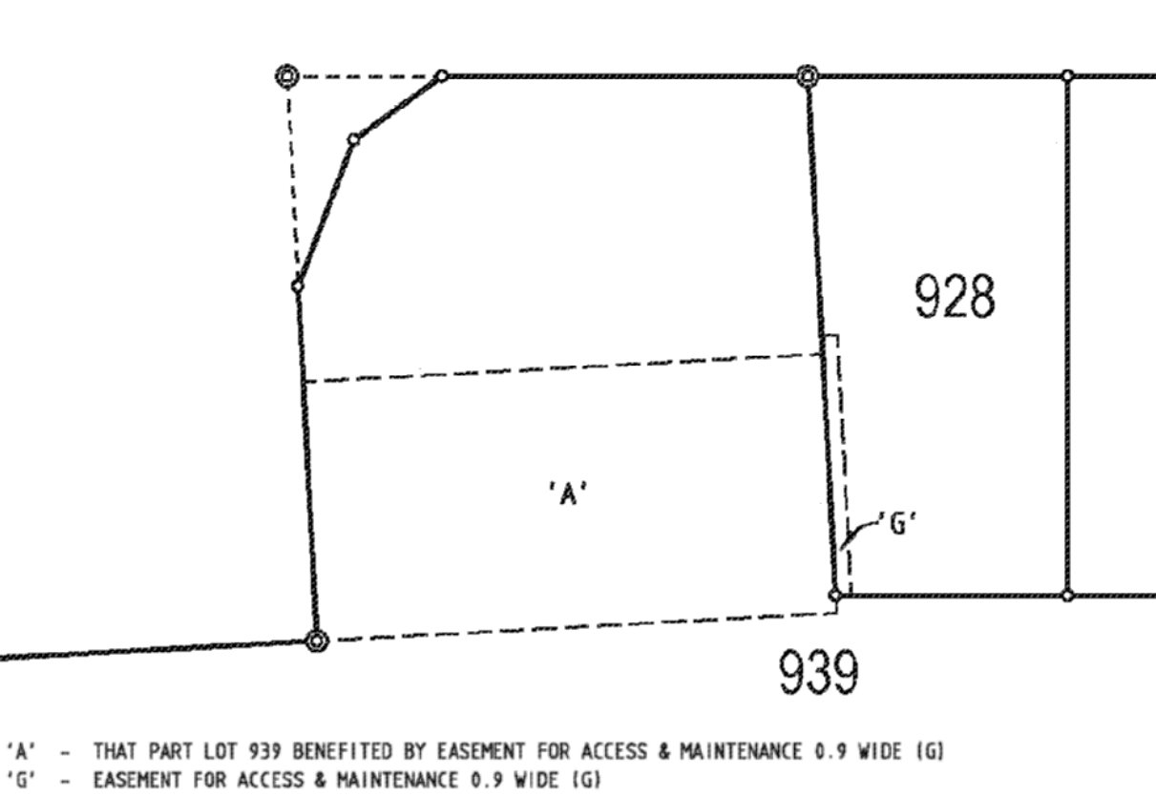

3

1

2

4

6

7

8

9

**E1**

**E2**

**E1 –** PART BENEFITED BY EASEMENT FOR ACCESS & MAINTENANCE 0.9 WIDE

**E2 –** EASEMENT FOR ACCESS & MAINTENANCE 0.9 WIDE

*At Parcels;*

<Parcels>

…

<Parcel name="E1" desc="Part Benefited by Easement for Access and Maintenance 0.9 Wide" class="Designated Area" state="proposed" parcelType="Single" parcelFormat="Standard">

<Center pntRef="LC-14"/>

<CoordGeom name="LGA-2">

<Line>

<Start pntRef="6"/>

<End pntRef="7"/>

</Line>

<Line>

<Start pntRef="7"/>

<End pntRef="8"/>

</Line>

<Line>

<Start pntRef="8"/>

<End pntRef="9"/>

</Line>

<Line>

<Start pntRef="9"/>

<End pntRef="6"/>

</Line>

</CoordGeom>

</Parcel>

<Parcel name="E2" desc="Easement for Access and Maintenance 0.9 Wide" class="Easement" state="proposed" parcelType="Single" parcelFormat="Standard">

<Center pntRef="LC-13"/>

<CoordGeom name="LGA-1">

<Line>

<Start pntRef="1"/>

<End pntRef="2"/>

</Line>

<Line>

<Start pntRef="2"/>

<End pntRef="3"/>

</Line>

<Line>

<Start pntRef="3"/>

<End pntRef="4"/>

</Line>

<Line>

<Start pntRef="4"/>

<End pntRef="1"/>

</Line>

</CoordGeom>

</Parcel>

…

</Parcels>

## 4.21 Defining the Line PEG

When there is a Line PEG on a boundary, this can be defined using Monument element as per the other types of boundary marks. The difference with the Line PEG is that this point will not be part of the Coordinate Geometry of a parcel and have a CgPoint@pntSurv=”traverse”. Instead there should be a connection to the Line PEG in the ReducedObservation element.

See following for how each elements/attributes should be populated in LandXML for example below.

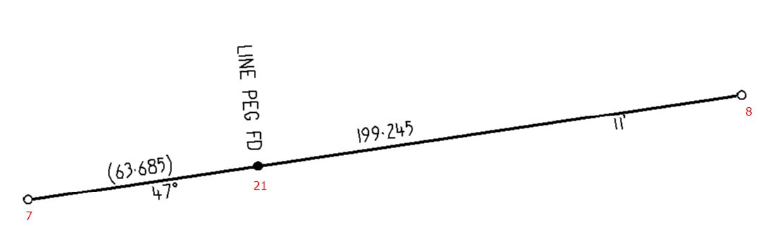

*At Monuments;*

<Monuments>

…

<Monument name="18" pntRef="21" type="PEG" desc="LINE PEG" state="Found"/>

…

</Monuments>

*At ObservationGroup;*

<ObservationGroup id="OG-1">

…

<ReducedObservation name="3" desc="Boundary" setupID="IS7" targetSetupID="IS8" azimuth="47.1100" horizDistance="199.245"/>

…

<ReducedObservation name="31" desc="Connection" setupID="IS7" targetSetupID="IS21" azimuth="47.1100" horizDistance="63.685"/>

…

</ObservationGroup>

*At CgPoints;*

<CgPoints zoneNumber="56">

…

<CgPoint name="7" state="existing" pntSurv="boundary">6110676.619 534466.481</CgPoint>

<CgPoint name="8" state="existing" pntSurv="boundary">6110696.317 534659.548</CgPoint>

…

<CgPoint name="21" state="existing" pntSurv="traverse">6110683.110 534521.312</CgPoint>

…

</CgPoints>

## 4.22 Defining Obstructed Boundary Corner

If a corner that cannot be marked is within the material of a structure that does not have a surface accessible for marking, the corner may instead be shown by the obstructed boundary corner symbol (i.e.solid circle), in this case the placement of an RM is not required. See Cl28(3)(b) SSI Reg 2017.

This is recorded by adding a Monument element for the relevant CgPoint with a Monument@state=”Not Marked Obstructed” and Monument@type=”Not Marked” see example below



This will generate a solid circle on the corner point when rendered in the Rendering service.

## 4.23 New road parcels abutting existing or other new road parcels

See diagrams below:

Road Widening and Splays: R3, R4 and R5 are existing adjoining road parcels

R1 and R2 are new (Proposed) Road parcels

The boundary lines of new lots 1 and 2 that abut existing road parcels R3 and R5 and new road widening parcels R1 and R2 get a ReducedObservation@desc=”Road” –This will flag the marking requirements of the Regs and render the line as a solid line

The boundary lines of the new road widening parcels R1 and R2 that abut existing road parcels (shown as dashed red lines) are defined as ReducedObservation@desc=”Road Extent”

New Road Parcels abutting: the common boundary line of R1 and R2 (shown as dashed red line) is defined as ReducedObservation@desc=”Road Extent”

This method will negate the marking requirements and enable the rendering service to render the Road Extent lines as dashed lines

This will apply for plans that dedicate the new road on registration.

For plans that show the road widening as a lot for future acquisition. The normal rules will apply treating the new (future road) lot as a standard lot in a DP

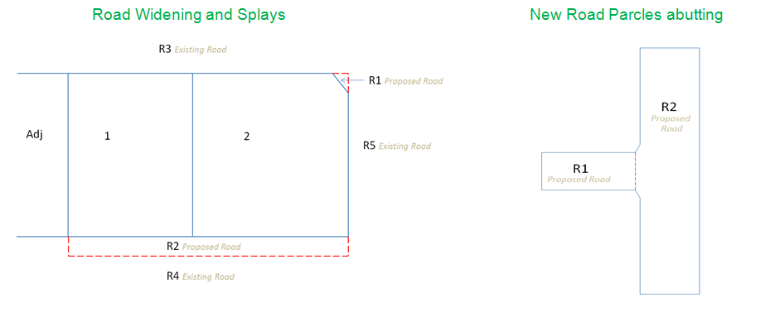

## 4.24 Height Schedule and Height Difference Schedule

See diagram following for additional attributes used to construct the Height Schedule and Height Difference Schedule required under Cl’s 69 and 71 SSI Reg 2017.

All additional data required to construct the tables is already recorded in the LXML file

See also the relevant attribute information in ReducedObservation and RedVerticalObservation Sections in this document

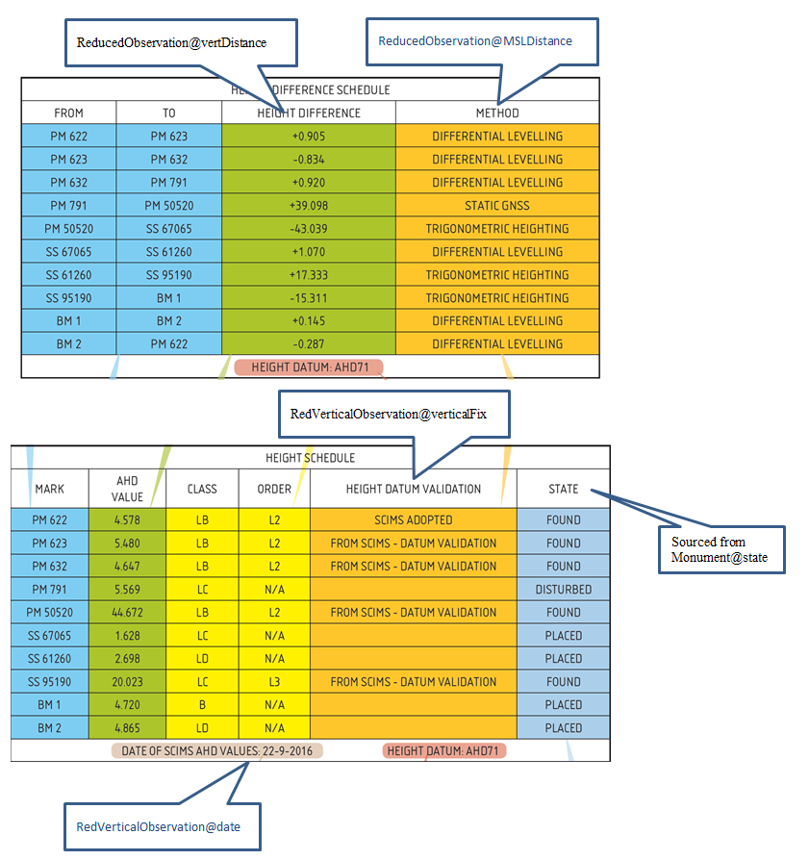

Reduced observations that are specific to Height Difference Schedule only can be entered with or without corresponding horizontal observation as per below.

With corresponding horizontal observation:

*At ObservationGroup;*

<ObservationGroup id="OG-1">

…

<ReducedObservation name="15" desc="Connection" setupID="IS7" targetSetupID="IS8" azimuth="59.3032" horizDistance="324.525" distanceType="Measured" azimuthType="Measured" distanceAdoptionFactor="1.00024000" > <ReducedObservation />

…

<ReducedObservation name="23" desc="Height Difference" setupID="IS7" targetSetupID="IS8" vertDistance="1.255" MSLDistance=" Differential Levelling"/>

…

</ObservationGroup>

**OR**

Without any corresponding horizontal observation:

*At ObservationGroup;*

<ObservationGroup id="OG-1">

…

<ReducedObservation name="23" desc="Height Difference" setupID="IS7" targetSetupID="IS8" vertDistance="1.255" MSLDistance=" Differential Levelling"/>

…

</ObservationGroup>

## 4.25 GNSS Schedule

The GNSS Validation Schedule is required by Cl 66 SSI Reg 2017 where the orientation of the survey is adopted from a grid bearing derived from MGA co-ordinates, determined using an approved GNSS method, of 2 permanent survey marks or reference marks.

The Schedule compares multiple measurements bewteen the same Marks and is constructed using multiple ReducedObservations between the two Marks. To do this there needs to be multiple (2) InstrumentSetup elements for each of the 2 points used in the ReducedObservation

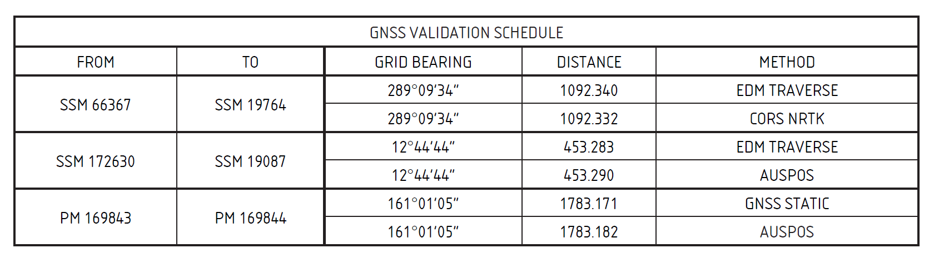The structure of the LXML elements for the multiple ReducedObservations from SSM66367 to SSM19764 in the example Validation Schedule below is following:

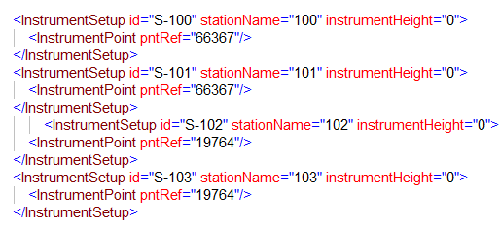

The “METHOD” is recorded using the ReducedObservation@distanceType/azimuthType which is an enumerated list see Appendix A3

**5. Strata Plan specific scenarios**

Only the plan drawing information contained in the Location and Floor Plans is included in the LXML file. All of the other data that is currently recorded on the Administration Sheets will remain on the Administration Sheets with some of it being replicated in the LXML file, as is done with Deposited Plans.

**5.01 Structural Requirements**

**5.01.1 Lot boundary definition Structural and Non Structural**

Designate structural lines with wall rendering information.

Coordinate Geometry of external and internal parcels do not share common CgPoints with a gap for wall.

Construct geometry using:

Internal points for internal parcels and external points for external parcels

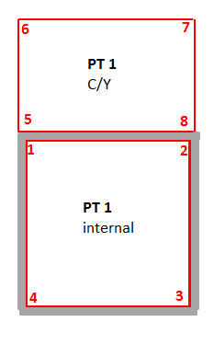

**Structural Boundaries**

The CoordGeom/Line@desc attribute will define the type of line work for a structure and the location of the boundary in relation to the structure.

For Lot boundaries defined buy a structure the CoordGeom/Line@desc attribute will identify whether the boundary is on the Left, Right or Centre of the structure going clockwise

Values will be “SR”, “SL” and “SC”

The thick line representing the structure (e.g. Wall) will be rendered on the relative side of the boundary accordingly.

For non-boundary structural lines such as the building line work on the location Plan. The CoordGeom/Line@desc attribute will be “SR”

**Non Structural boundaries**

The CoordGeom/Line@desc attribute will = “NS” and will be rendered as a thin line

**See example below**

Internal parts are defined by inside face of wall (see redline and points). Line@desc=”SR”. Rendering will draw thick line on left hand side of the boundary going clockwise. In other words the boundary is on the right side of the structure.

External parts of lots are define by external face of wall (see external redline and points). Line@desc will be SR/L or NS accordingly. Rendering will draw thin line for Non Structural and thick line for Structural ( again on left hand side going clockwise, hence thick line for line 8 to 5 will overlap line from 1 to 2

This method could be used regardless of actual wall thickness.

Scale of the plan will be defined by the surveyor by using the annotation element (Annotation@type=”Scale”) in the LXML. The LPI rendering service will use the scale information to ensure the line thickness for structural line is rendered at 1mm. The surveyor should ensure that the points have appropriate coordinates so that structural lines render at 1mm in the scale defined in the file at A3 on a SP plan form.

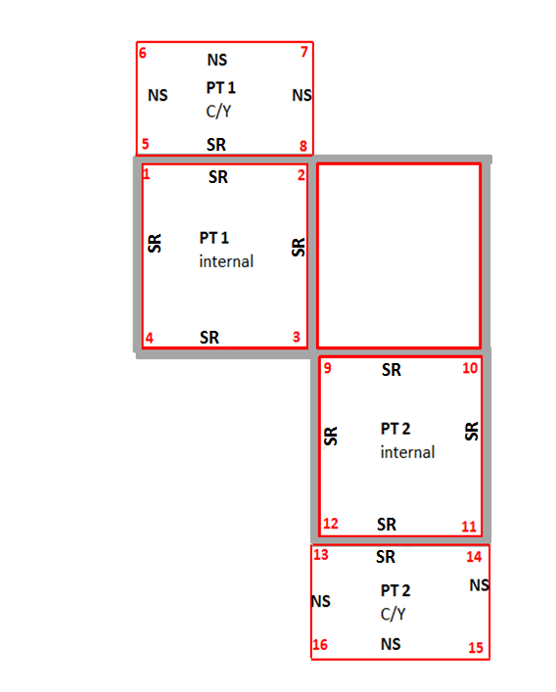

<Parcel name="1" class="Lot" state="proposed" parcelType="Multipart" area="156">

    <Parcels>

         <Parcel name="1A" pclRef="1A"/>

         <Parcel name="1B" pclRef="1B"/>

<Parcel name="1A" class="Lot" state="proposed" parcelType="Part" parcelFormat="Strata" buildingLevelNo="Ground Floor Plan">

  <CoordGeom name="1A">

  <Line desc="SR">

     <Start pntRef="1"/>

          <End pntRef="2"/>

          </Line>

          <Line desc="SR">

                   <Start pntRef="2"/>

                   <End pntRef="3"/>

           </Line>

           <Line desc="SR">

                  <Start pntRef="3"/>

                   <End pntRef="4"/>

             </Line>

             <Line desc="SR ">

                     <Start pntRef="4"/>

                     <End pntRef="1"/>

               </Line>

           </CoordGeom>

      </Parcel>

<Parcel name="1B" desc="CY" class="Lot" state="proposed" parcelType="Part" parcelFormat="Strata" buildingLevelNo="Ground Floor Plan">

            <CoordGeom name="1B">

                 <Line desc="NS">

                        <Start pntRef="5"/>

                        <End pntRef="6"/>

                   </Line>

                   <Line desc="NS ">

                         <Start pntRef="6"/>

                         <End pntRef="7"/>

                    </Line>

                    <Line desc="NS ">

                           <Start pntRef="7"/>

                            <End pntRef="8"/>

                      </Line>

                      <Line desc=”SR ">

                           <Start pntRef="8"/>

                           <End pntRef="5"/>

                        </Line>

**Example for Columns – option 2**

           <CoordGeom name="X">

                                                            <Line desc="NS ">

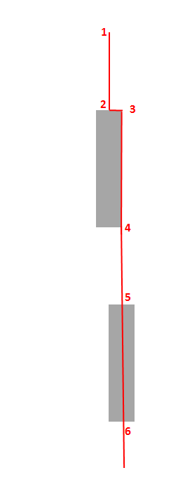                                                                    <Start pntRef="1"/>

                                                                    <End pntRef="2"/>

                                                            </Line>

                                                            <Line desc="NS ">

                                                                    <Start pntRef="2"/>

                                                                    <End pntRef="3"/>

                                                            </Line>

                                                            <Line desc="SL">

                                                                    <Start pntRef="3"/>

                                                                    <End pntRef="4"/>

                                                            </Line>

                                                            <Line desc="NS ">

                                                                    <Start pntRef="4"/>

                                                                    <End pntRef="5"/>

                                                          </Line>

                                                            <Line desc="SC ">

                                                                    <Start pntRef="5"/>

                                                                    <End pntRef="6"/>

                                                          </Line>

                                                        </CoordGeom>

**Lot boundary definition Structural Dashed**

If the structure forms part of the lot (i.e. cubic space strata scheme the relevant CordGeom/Line@desc will be “SD” any structural boundary that is not forming part of the lot will be defined as per a normal SP.

Note: “SD” means Structural dashed and will render as a thick dashed line

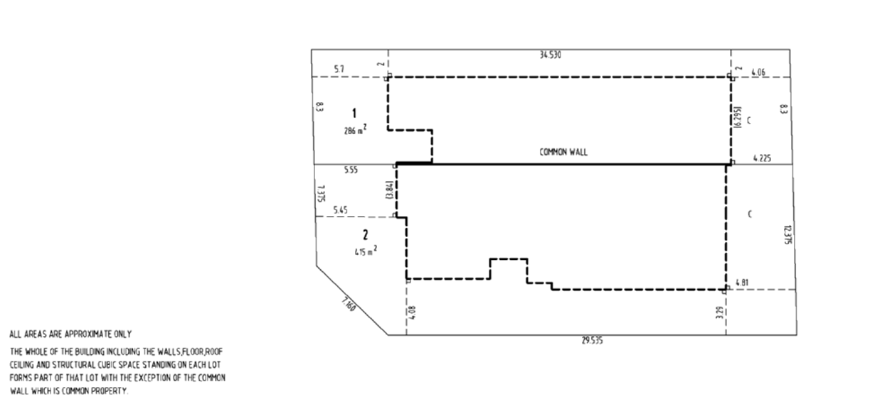

**5.01.2 Separating Levels**

In order to ensure information is only recorded on the relevant building level, there needs to be a way of separating the Location Plan and each Floor Plan so each point only exists on only one Floor Plan /Location Plan.

**Separation is done using the CgPoint@code attribute**

To facilitate separation and rendering of individual Location and Floor Plans, every point in the file will have a CgPoint@code attribute that corresponds the relevant Parcel@buildingLevelNo that it belongs to.

Coincident points at different levels of the building will have the same coordinates but a different CgPoint@code value

The value for the code attribute must have an numeric prefix starting at “0” for Location Plan and “1” for the lowest level of the building (eg lowest basement level) and increase by one for each level of the building going upwards including Mezzanine levels etc. For example a 3 storey building with 2 basement levels will have Cgpoint@code values as follows:

Location Plan = 0, Location Plan

Basement Level 2 = 1, Basement Level 2

Basement Level 1 = 2, Basement Level 1

Ground Floor = 3, GroundFloor

Level 1= 4, Level 1

Level 2 = 5, Level 2

Level 3 = 6, Level 3

Note the name of the building level can be a free text field ( e.g. Level 1, First Floor, Level A etc), but must be separated from the numeric prefix by a comma (i.e. comma delimited)

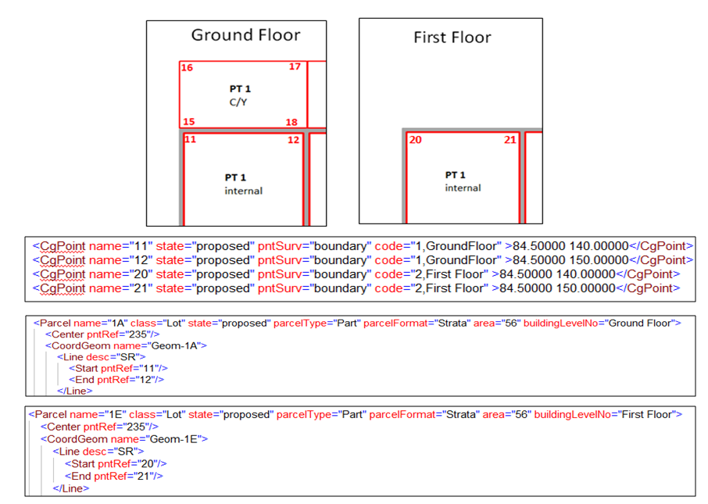

**5.02 Location Plan**

The following sections use sample Strata Plan drawing sheets to identify relevant data and describes how this data is recorded in the LXML file in the related tables.

Each table is followed by an image of the relevant plan sheet identifying the mapped data.

| **Data field** | **Display Item** | **LandXML Mapping** |
| --- | --- | --- |
| 1 | Base Parcel | <Parcel name="55/1206312" class="Lot" state="affected" parcelType="Single" parcelFormat="Standard" buildingLevelNo=”Location Plan”>  <Center pntRef="200"/>  <CoordGeom name="2">  <Line desc="NS"> <Start pntRef="198"/>  <End pntRef="199"/>  </Line>  ……  </CoordGeom>  </Parcel>  <ReducedObservation name="33" desc="Boundary" setupID="IS198" targetSetupID="IS199" horizDistance="72.085"/>  …….. |
| 2 | Adjoining parcels and roads | As per DP’s add following attribute to Parcel element" buildingLevelNo=”Location Plan” |
| 3 | Buildings  and street No | <Parcel name="Building 1" class="Building" desc="Two Story Brick Units" state="proposed" parcelType="Single" parcelFormat="Strata" buildingLevelNo=”Location Plan” buildingNo="No99" >  <Center pntRef="210"/>  <CoordGeom name="2">  <Line desc="SR ">  <Start pntRef="220"/>  <End pntRef="221"/>  </Line>  ……  </CoordGeom>  </Parcel>  <Parcel name="Building 2" class="Building" desc…… etc  No Reduced Observations |
| 4 | Strata lot boundaries external from building | <Parcel name="PK2" desc="PK" parcelType="Single" class="Lot" state="proposed" parcelFormat="strata" buildingLevelNo=”Location Plan” >  <Center pntRef="137"/>  <CoordGeom name="PK-2">  <Line desc="NS">  <Start pntRef="23"/>  <End pntRef="22"/>  </Line>….No Reduced Observations |
| 5 | Structural features such as walls and offsets that are not on lot boundary  If structure defines lot boundary and offset is required | As per occupations in DP’s: Use PlanFeatures to define position and description of structure and use Monument element to show offsets. Feature name to be followed by “Location Plan. E.g. Wall Location Plan  Offsets can also be defined using the PlanFeature = “Offset “ and selecting 2 points to show an offset value anywhere along a structure to the parcel boundary  Use PlanFeature = “Offset “ and selecting 2 points to show an offset value anywhere along a structure to the parcel boundary |
| 6 | Notes and designations | <SurveyHeader….>  <Annotation type="Plan Note" name="1" desc="CY-Courtyard- Stratum statement "/>  <Annotation type="Plan Note" name="2" desc="P-Porch Covered or stratum statement"/>  <Annotation type="Plan Note" name="3" desc="PW- Prolongation of wall"/>  <Annotation type="Plan Note" name="4" desc="PK –Parking Space Stratum statement"/>  ……  Note: Only one annotation for each area that will apply to all location and floor plans |
| 7 | Location Plan label | <Parcel buildingLevelNo=”Location Plan” |
| N/A | All other data | As per DP’s |

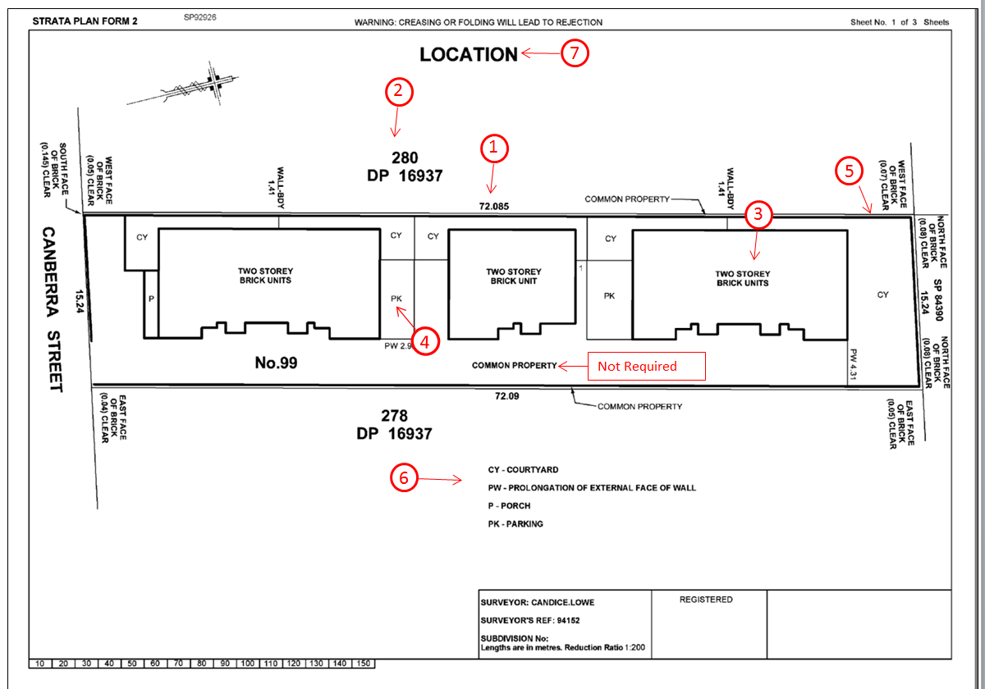

**5.02 Floor Plans**

|  |  |  |
| --- | --- | --- |
| Data field | Display Item | LandXML Mapping |
| 8  9  10 | Strata lot | <Parcel name="1" class="Lot " state="proposed" parcelType="Multipart" area="196">  <Parcels>  <Parcel name="1A" pclRef="1A"/>  <Parcel name="1B" pclRef="1B"/>  <Continue for all parts  </Parcels>  <Parcel name="1A" class="Lot " state="proposed" parcelType="Part" parcelFormat=" Strata " area="114" buildingLevelNo=”Ground Floor” >  <Center pntRef="209"/>  <CoordGeom name="1A">  <Line desc="SR">  <Start pntRef="73"/>  <End pntRef="43"/>  </Line>……  <Parcel name="1B" class="Lot" state="proposed" parcelType="Part" parcelFormat=" Strata " area="15" desc="P" buildingLevelNo=”Ground Floor" >  <Center pntRef="209"/>  <CoordGeom name="1B">  <Line desc="SR">  <Start pntRef="11"/>  <End pntRef="18"/>  </Line>………..  <Parcel name="1C" class="Lot" state="proposed" parcelType="Part" parcelFormat=" Strata " area="8” desc="P" buildingLevelNo=”Ground Floor ” >  <Center pntRef="210"/>  <CoordGeom name="1C">  <Line desc="SR">  <Start pntRef="29"/>  <End pntRef="30"/>  </Line>……..  <Parcel name="1D" class="Lot" state="proposed" parcelType="Part" parcelFormat=" Strata" area="55" desc="CY" buildingLevelNo=”Ground Floor” >  <Center pntRef="299"/>  <CoordGeom name="1D">  <Line desc="NS">  <Start pntRef="35"/>  <End pntRef="36"/>  </Line>……..  <Continue for all parts  Parts of lots define by measured lines will have ReducedObservations using the FieldNote element to add descriptions to the line e.g. PW ( Prolongation of wall)  ReducedObservation name="33" desc=" Boundary" setupID="IS170" targetSetupID="IS171" horizDistance="2.965">  <FieldNote> PW</FieldNote><ReducedObservation/>  parts of lots defined by structures only are defined using the CoordGeom Element@attributes only as there are no dimensions  If needed the Line@note attribute can be used to designate what structure is used to define the boundary e.g. “EDGE OF CONCRETE”  Would usually be noted with an designation such as E with an Annotation@type=”Plan Note” to identify what the designation represents e.g. “E-EDGE OF CONCRETE” |
| 11 | Connections along walls | <ReducedObservation name="45" desc="Connection" setupID="IS198" targetSetupID="IS197" horizDistance="2.73"/>  …….. |
| 12 | Designations | See item 6 in Location Plan Section 5.01 |
| 13 | Floor Plan and Level label | <Parcel buildingLevelNo=”Ground Floor” |
| N/A | Structural features such as walls and offsets. That are shown within the cubic space of a lot  If structure defines boundary and offset is required | As per occupations in DP’s: Use PlanFeatures to define position and description of structure and use Monument element to show offsets if any. Feature name to be followed by “Ground Floor” E.g. Wall Ground Floor  Offsets can also be defined using the PlanFeature = “Offset “ and selecting 2 points to show an offset value anywhere along a structure to the parcel boundary  Use PlanFeature = “Offset “ and selecting 2 points to show an offset value anywhere along a structure to the parcel boundary |
| N/A | All other data | As per DP’s |

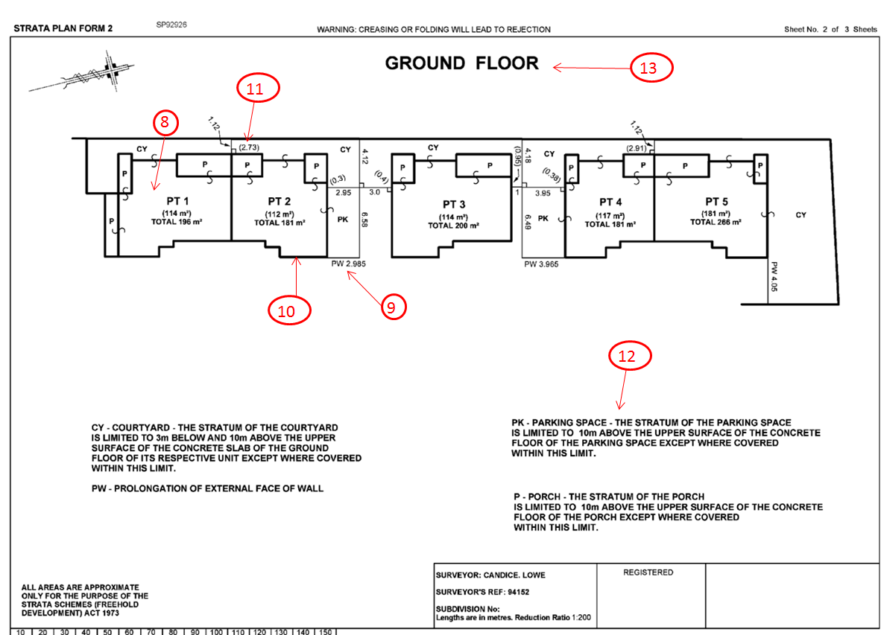

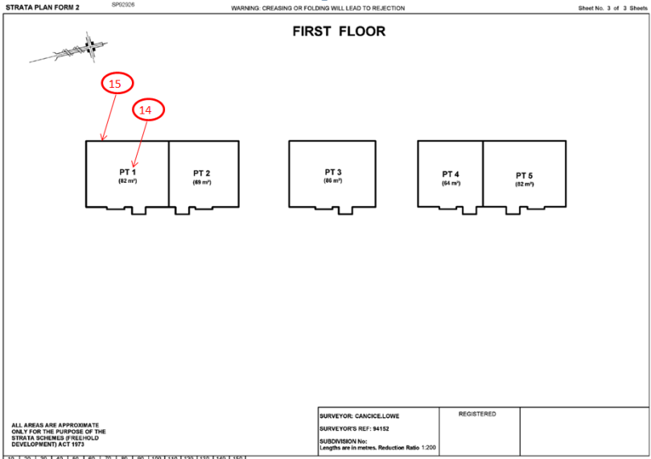

|  |  |  |
| --- | --- | --- |
|  |  |  |
| Data field | Display Item | LandXML Mapping |
| 14 | Strata lot | <Parcel name="1E" class="Lot" state="proposed" parcelType="Part" parcelFormat=" Strata " area="82" buildingLevelNo=”First Floor” >  <Center pntRef="209"/>  <CoordGeom name="1E">  <Line desc="SR">  <Start pntRef="73"/>  <End pntRef="43"/>  </Line>……….. |
| 15 | Structural Boundaries | Internal parts of lots are defined using the CoordGeom Element@attributes only as there are no dimensions  Note: any line boundaries are defined as describe in Ground Floor |
| N/A | All other data | As per DP’s |

|  |  |  |
| --- | --- | --- |
|  | | |
| Data field | Display Item | LandXML Mapping |
| 16 | Common Property parcels   * Unique areas * Multiple common areas with same label | <Parcel name="CP" class="Common Property" state="proposed" parcelType="Multipart"">  <Parcels>  <Parcel name="CPA" pclRef="CPA"/>  <Parcel name="CPB" pclRef="CPB"/>  <Parcel name="C" pclRef="CPC"/>  <Continue for all parts  …..  </Parcels>  <Parcel name="CPA" class="Common Property" state="proposed" parcelType="Part" parcelFormat="Strata" desc="Bin Storage" buildingLevelNo=” Basement”>  <Center pntRef="300"/>  <CoordGeom name="CPA">  <Line desc="NS">  <Start pntRef="173"/>  <End pntRef="143"/>  </Line>……  <Parcel name="CPB" class="Common Property" state="proposed" parcelType="Part" parcelFormat=" Strata " desc="Lift” buildingLevelNo=” Basement”" >  <Center pntRef="350"/>  <CoordGeom name="CPB">  <Line desc="SR">  <Start pntRef="311"/>  <End pntRef="318"/>  </Line>………..  <Parcel name="CPC" class="Common Property" state="proposed" parcelType="Part" parcelFormat=" Strata " desc="Lift" buildingLevelNo=”Ground Floor” >  <Center pntRef="610"/>  <CoordGeom name="CPC L">  <Line desc="SR">  <Start pntRef="429"/>  <End pntRef="430"/> |

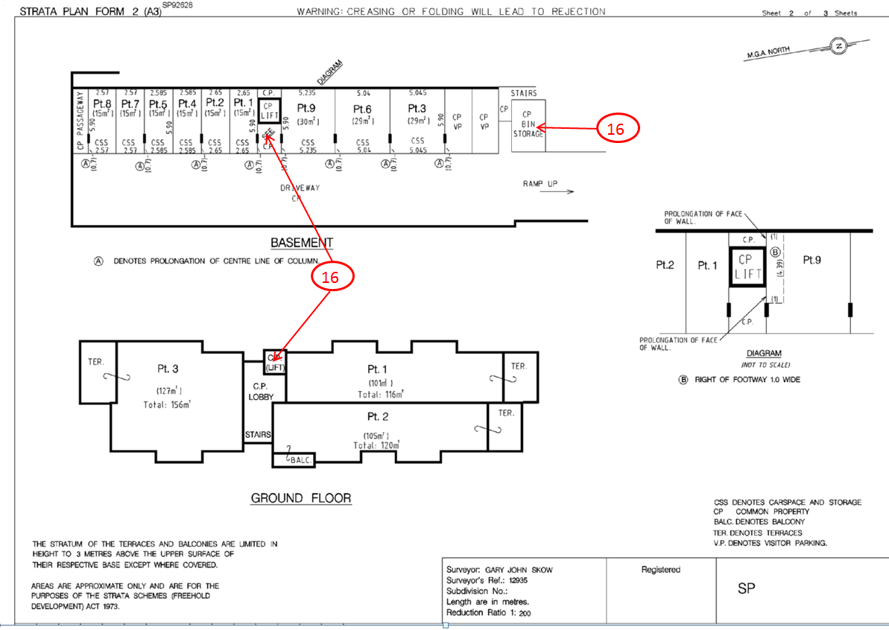

|  |  |  |
| --- | --- | --- |
| Data field | Display Item | LandXML Mapping |
| 17 | Lot boundaries | The perimeter boundaries of each lot are defines as in a normal SP with a series of Line@“desc” of “S” or “NS” as required.  To add note on Common Wall use the Annotation@type=”Plan Note”  <Annotation type="Plan Note" name="n1" desc="the common wall between lots 1 and 2 is common property"/>  or  <Annotation type="Plan Note" name="n1" desc=" Where there is a common wall on the boundary between lots 1 and 2 the boundary is the centreline of the common wall"/>  … |
| 18 | Structure form part of lot | If the structure forms part of the lot the relevant CoordGeom/Line@desc will be “SD” any structural boundary that is not forming part of the lot will be “SR” etc.  Note: “SD” means Structural dashed and will render as a thick dashed line |
| 19 | Connection lines | <ReducedObservation name="33" desc="Connection" setupID="IS170" targetSetupID="IS171" horizDistance="2.965">  If there is a note on the connection (e.g. PW) use FieldNote  <ReducedObservation ………..<FieldNote> PW</FieldNote><ReducedObservation/>  Use Annotation@type=”Plan Note” to identify any abbreviated Field Note values  <Annotation type="Plan Note" name="n2" desc="PW- Prolongation of wall"/> |
| N/A | All other data | As per normal SP’s |

**5.03 Cubic Space Floor Plan**

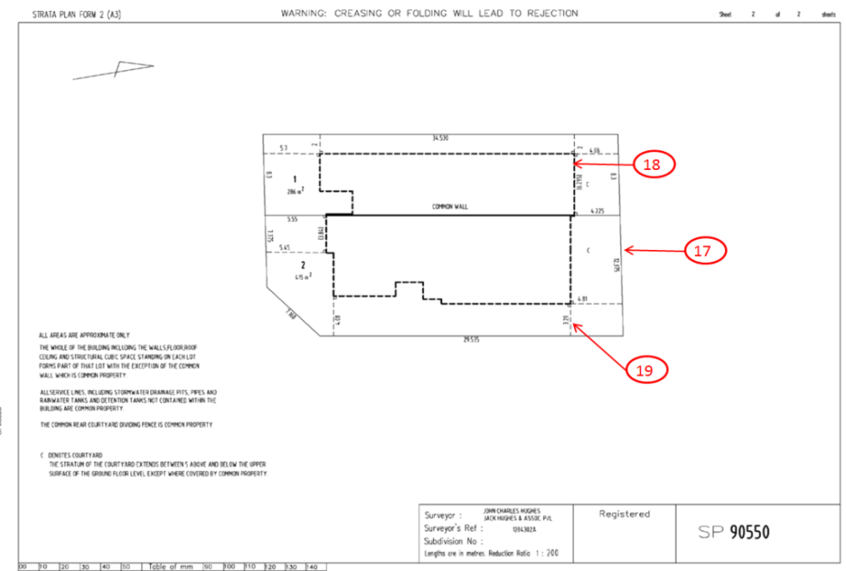

# Appendix A – Enumeration lists

The following appendix outlines all the LandXML type definitions used by the ePlan Protocol in NSW implementation. This includes the enumerated types.

## A1. Primitive Data Types

The following are primitive data type definitions used by the CIF. They are defined by the XML standard (see <http://www.w3.org/TR/xmlschema-0/#CreatDt>).

|  |  |
| --- | --- |
| Type | Description |
| anySimpleType | Highest level of simple type and can store any simple type. |
| anyURI | Uniform Resource Identifier |
| boolean | True of False |
| date | ISO8601 date format: YYYY-MM-DD |
| double | A double precision floating point number |
| IDREF | A reference to the ID of another element |
| int | An integer |
| positiveInteger | A positive integer value |
| string | An extended sequence of characters |
| time | ISO8601 time format: hh:mm:ss |

## A2. LandXML Enumerated Types

The following types are defined in LandXML with an enumerated list of valid values. NSW will be using a subset of the LandXML values available.

See LandXML 1.2 schema for full list <http://www.landxml.org/schema/LandXML-1.2/LandXML-1.2.xsd>

The attributes are listed under the element to which they belong and are listed in the order, in which the elements appear in this document.

| **Attribute** | **Type** | **Description** | **Enumerations** |
| --- | --- | --- | --- |
| **Metric** | | | |
| directionUnit | angularType | Angular values in numeric format.  E.g. 45° 3’ 5” should be entered as “45.0305”.  Minutes and seconds must be within the numeric range between 00 and 60. | Set to:  decimal dd.mm.ss |
| areaUnit | metArea | Valid metric units of measure for area. | Set to:  squareMeter |
| linearUnit | metLinear | Valid metric units of measure for length | Set to:  meter |
| pressureUnit | metPressure | Valid metric units of measure for pressure | Set to:  milliBars |
| temperatureUnit | metTemperature | Valid metric units of measure for temperature. | Set to:  celsius |
| volumeUnit | metVolume | Valid metric units of measure for area volume. | Set to:  cubicMeter |
| **CgPoint** | | | |
| state | stateType | The state of the point. Either proposed (new) or existing | * proposed * existing |
| pntSurv | survPntType | The type/purpose of the point | * boundary * control * natural boundary * reference * sideshot * traverse |
| **Parcel** | | | |
| state | parcelStateType | The state of the parcel in context of other parcels in the plan | * adjoining * existing * proposed * affected |
| **Curve** | | | |
| rot | clockwise | The direction of the curve either clockwise (cc) or counter clockwise (ccw) | * cw * ccw |
| **SurveyHeader** | | | |
| type | surveyType | Whether the plan was surveyed or compiled | * compiled * surveyed |
| **ReducedArcObservation** | | | |
| rot | clockwise | The direction of the curve either clockwise (cc) or counter clockwise (ccw) | * cw * ccw |

## A3. NSW Enumerated Types

The following enumerated types in LandXML are defined as jurisdictional enumeration types to meet each jurisdictional requirement. NSW enumeration schema file is available at the following link: <http://www.nswlrs.com.au/__data/assets/file/0011/146981/xml-gov-au-nsw-icsm-eplan-cif-enumerated-types-1.0.xsd>

The attributes are listed under the element to which they belong and are listed in the order, in which the elements appear in this document.

| **Attribute** | **Type** | **Description** | **Enumerations** |
| --- | --- | --- | --- |
| **CoordinateSystem** | | | |
| datum | surveyBgDatumType | Horizontal Datum of the plan | * ISG * Local * MGA94 * MGA2020 * MM * TM |
| horizontalDatum | horzDatumType | Datum of CgPoint coordinates | Set to:  Local |
| verticalDatum | vertDatumType | Vertical datum for the plan | Set to:  AHD |
| **CgPoints** | | | |
| zoneNumber | zoneNumberType | The MGA zone for the plan and NSW zones should be one of the following | * 54 * 55 * 56 * 57 * 58 |
| **Monument** | | | |
| state | monumentState | This is a list of states for a monument (mark or occupation). | * Found * Gone * Not Found * ~~Found Now Gone~~ * Placed * Not Marked * Found By Me * Not Marked Obstructed |
| Type | monumentType | This is a survey mark types, also includes “Not Marked” and “Occupation” to accommodate complex scenarios as described in Section 4 of this document.  **N.B.**  “Approved Mark” together with desc attribute can be used if the used mark type is not in the list | * DH&amp;W * GIP * Wing * Reference Tree * Tree * Approved Mark * Broad Arrow * Conc Block * DH * Bottle * Lockspit * Metal Spike * GIN * Nail * Peg * PM * Pipe * Post * PVC Pipe * Rod * Specified Point * Spike * Star Picket * SSM * Reference Mark Token * TS * Not Marked * Occupation * MM * GB * CP * CR * Witness Mark * BM * Steel Fence Post * Chiselled Triangle * Non Corrodible Bolt * Non Corrodible Spike * Non Corrodible Nail * Bench Mark Token * Boundary Mark Token * Non Corrodible Nail And Wing * PVC Star Picket |
| condition | monumentCondition | This is a list of mark conditions that may be applied to a Control Mark. | * Destroyed * Not Found * Uncertain * Subsidence Area * Found Intact * Restricted Access |
| **Parcel** | | | |
| class | parcelClass | This is a list of parcel classes in NSW.  **N.B.**  Classes that are in blue text are secondary interest parcels and require desc attribute to be populated. | * Administrative Area * Association Property * Building * Caveat * Common Property * Covenant * Designated Area * Easement * Exclusive Use Area * Footprint * Hydrography * Lease * License * Lot * Permit * Positive Covenant * Profit A Prende * Restriction On Use Of Land * Restriction On User * Railway * Reserved Road * Road |
| parcelFormat | parcelFormat | Parcel Format describes how the parcel is described | * Standard * Strata * Stratum |
| parcelType | parcelTypeType | The parcel structure type | * Single * Multipart * Part |
| UseOfParcel | useOfParcelType | Describes how the parcel is used for | * Access Channel * Administrative Area * Artificial Water Way * Association Property * Balcony * Bay * Boat Ramps * Canal * Car Parking * Car Space * Carport * Cemetery * Coastal Management Zone * Common Property * County * Courtyard * Creek * Deck * Drainage Reserve * Entry * Garage * Garbage * Garden * Garden Area * Garden Space * Landing * Letter Box * Lift * Loading Bay * Local Government Area * Locality * Main * Ocean * Parish * Parking * Parking Area * Patio * Permit * Permit To Occupy * Planter * Planter Box * Plunge Pool * Pool * Porch * Portico * Private Yard * Public Reserve * Public Use Land * Remainder * River * Roof Garden * Stairs * Storage * Store * Swimming Pool * Temporary Road * Terrace * Travelling Stock Route * Tree Clearing * Unit * Verandah * Visitor Parking * Void * Water Feature * Yard * Yard Area |
| **Location Address** | | | |
| addressType | addressTypeType | This Type is to define a specific list of address types | * Alias * Historical * Primary * Secondary |
| flatType | flatTypeType | To define a specific list of living unit types for addressing | * Apartment * Berth * Cottage * Dock * Duplex * Factory * Flat * House * Kiosk * Office * Penthouse * Premises * Room * Shed * Shop * Stall * Studio * Suite * Townhouse * Unit * Villa * Ward * Warehouse |
| floorLevelType | floorLevelTypeType | To define a specific list of floor level types | * Basement * Floor * Ground * Level * Lobby * Lower Ground Floor * Lower Level * Mezzanine * Observation Deck * Parking * Platform * Podium * Rooftop * Sub-Basement * Upper Ground Floor |
| **RoadName** | | | |
| roadName | roadNameTypeType | To define a specific list of Road name types | * Access * Accessway * Alley * Alleyway * Amble * Anchorage * Approach * Arcade * Artery * Avenue * Basin * Beach * Bend * Block * Boardwalk * Boulevard * Boulevarde * Brace * Brae * Branch * Break * Bridge * Broadway * Brow * Bypass * Byway * Causeway * Centre * Centreway * Chase * Circle * Circlet * Circuit * Circus * Close * Colonnade * Common * Concourse * Copse * Corner * Corso * Court * Courtyard * Cove * Crescent * Crest * Cross * Crossing * Crossroad * Crossway * Cruiseway * Cul-de-Sac * Cutting * Dale * Dell * Deviation * Dip * Distributor * Drive * Driveway * Edge * Elbow * End * Entrance * Esplanade * Estate * Expressway * Extension * Fairway * Fire Track * Firetrail * Flat * Follow * Footway * Foreshore * Formation * Freeway * Front * Frontage * Gap * Garden(s) * Gate(s) * Glade * Glen * Grange * Green * Ground * Grove * Gully * Heights * Highroad * Highway * Hill * Interchange * Intersection * Island * Junction * Key * Landing * Lane * Laneway * Lees * Line * Link * Little * Lookout * Loop * Lower * Mall * Meander * Mew * Mews * Motorway * Mount * Nook * Outlook * Parade * Park * Parklands * Parkway * Part * Pass * Passage * Path * Pathway * Piazza * PKW * Place * Plateau * Plaza * Pocket * Point * Port * Promenade * Quad * Quadrangle * Quadrant * Quay(s) * Ramble * Ramp * Range * Reach * Reserve * Rest * Retreat * Ride * Ridge * Ridgeway * Right Of Way * Ring * Rise * River * Riverway * Riviera * Road * Roads * Roadside * Roadway * Ronde * Rosebowl * Rotary * Round * Route * Row * Rue * Run * Service Way * Siding * Slope * Sound * Spur * Square * Stairs * State Highway * Steps * Strait * Strand * Street * Strip * Subway * Tarn * Terrace * Thoroughfare * Tollway * Top * Tor * Towers * Track * Trail * Trailer * Triangle * Trunkway * Turn * Underpass * Upper * Vale * Viaduct * View * Villas * Vista * Wade * Walk * Walkway * Way * Wharf * Wynd * Yard |
| roadNameSuffix | roadNameSuffixType | To allow a list of specific road suffixes | * Central * East * Extension * Lower * North * North East * North West * South * South East * South West * Upper * West |
| roadType | roadTypeType | To define if the road is a public, private or temporary road | * Public * Private * Temporary |
| **AddressPoint** | | | |
| addressPointType | addressPointTypeType | This is to define the type of Geocode what the address point is for. | * Access Point * Centroid of Parcel |
| **Survey Header** | | | |
| jurisdiction | jurisdictionType | This is the name of the jurisdiction (i.e. state) and should be  Set to:  New South Wales  for all plans lodged at LRS | * Australian Capital Territory * New South Wales * Northern Territory * Queensland * South Australia * Tasmania * Western Australia * Victoria |
| surveyFormat | surveyFormatType | Describes the format of the survey | * [Community Schemes](http://rgdirections.lands.nsw.gov.au/plans/plantypes/communityschemes) * [Examination Survey](http://rgdirections.lands.nsw.gov.au/plans/plantypes/examinationsurvey) * Standard * Stratum * [Strata Schemes](http://rgdirections.lands.nsw.gov.au/plans/plantypes/strataschemes) * [Survey Information Only](http://rgdirections.lands.nsw.gov.au/plans/plantypes/surveyinformationonly) |
| **AdministrativeArea** | | | |
| adminAreaType | adminAreaTypeType | Type of Admin Area | * County * Locality * Local Government Area * Parish * Survey Region * Terrain |
| **PurposeOfSurvey** | | | |
| purposeOfSurvey @name | purpSurvType | Purpose of the plan | * Additional Sheet For Community Title Plan * Boundary Adjustment Plan For Community Title Plan * Building Alteration Plan * Building Alteration Plan – Leasehold * Building Stratum Subdivision * Coal Definition * Community Plan * Community Plan Of Consolidation * Community Plan Of Subdivision * Consolidation * Crown Folio Creation * Delimitation * Departmental * Easement * Ex-Survey Plan * Lease * Limited Folio Creation * Neighbourhood Plan * Neighbourhood Plan Of Consolidation * Neighbourhood Plan Of Subdivision * Oyster Lease * Part Strata * Pipelines Act, 1967 * Precinct Plan * Precinct Plan Of Consolidation * Precinct Plan Of Subdivision * Primary Application * Redefinition * Replacement Sheet For Community Title Plan * Resumption Or Acquisition * Road Or Motorway * Roads Act, 1993 * Strata Plan * Strata Plan – Leasehold * Strata Plan Of Consolidation * Strata Plan Of Consolidation – Leasehold * Strata Plan Of Subdivision * Strata Plan Of Subdivision – Leasehold * Staged Strata Plan * Staged Strata Plan Of Subdivision * Subdivision * Surrender * Survey Information Only |
| **AdministrativeDate** | | | |
| adminDateType | adminDateTypeType | The administrative purpose of the date | * Date Of Survey * Date Of Compilation * Date Of Survey Certificate * Date Of Subdivision Certificate * Date Of Strata Certificate |
| **Personnel** | | | |
| regType | registrationType | Surveyor’s registration state | Set to:  Registered |
| role | surveyorRoleType | Surveyor’s role | Set to:  Signing Surveyor |
| **Annotation** | | | |
| type | annotationType | The type of annotation | * Parcel Note * Plan Note * Plans Used * Subdivision Number * Diagram * Diagram Lots * Diagram Occupations * Diagram Secondary Interests * Direction Of Flow Tidal * Direction Of Flow Non Tidal * Combined Scale Factor * LRS File Ref * Scale |
| **ReducedObservation** | | | |
| desc | purposeType | This is the equivalent of the line type | * Boundary * Road * Connection * Road Extent * Reference * Height Difference |
| distanceType/  azimuthType | observationType | This is a list of defined observation types. | * Adopted * Calculated * Deducted * Measured * Scaled * Compiled * ~~GNSS~~ * LRSCalculated * Cadastral Traverse * AUSPOS * Static GNSS * RTK GNSS * CORS NRTK GNSS * CORS RTK GNSS * CORS Static GNSS |
| distanceAccClass | distanceAccType | This is a list of states for a monument. | * Found * Placed * Found By Me |
| MSLDistance | heightMethodType | This is a list of methods used for height measurement | * Differential Levelling * Trigonometric Heighting * Static GNSS * RTK GNSS * CORS NRTK GNSS * CORS RTK GNSS * CORS Static GNSS |
| **ReducedArcObservation** | | | |
| desc | purposeType | This is the equivalent of the line type | * Boundary * Road * Connection * Road Extent * Reference |
| arcType | observationType | This is a list of defined observation types. | * Adopted * Calculated * Deducted * Measured * Scaled * Compiled * GNSS * LRSCalculated |
| **RedHorizontalPosition** | | | |
| horizontalDatum | horzDatumType | Horizontal datum of SCIMS marks | * ISG * Local * MGA94 * MGA2020 * MM * TM |
| horizontalFix | horzFixType | Method used to determine the coordinates of the SCIMS marks | * ~~SCIMS~~ * ~~Traverse~~ * Scaled From Map * ~~Astro~~ * Policy 3 * ~~GNSS~~ * From SCIMS * Cadastral Traverse * AUSPOS * Static GNSS * RTK GNSS * CORS NRTK GNSS * CORS RTK GNSS * CORS STATIC GNSS * Autonomous GNSS * Policy 4 * Policy 5 |
| Class | horzClassType | SCIMS horizontal class | * 3A * 2A * A * B * C * D * E * U |
| order | horzOrderType | SCIMS horizontal order | * 00 * 0 * 1 * 2 * 3 * 4 * 5 * U * NA |

|  |  |  |  |
| --- | --- | --- | --- |
| **RedVerticalObservation** | | | |
| verticalDatum | vertDatumType | Vertical datum of SCIMS marks | Set to:  AHD |
| Class | vertClassType | SCIMS vertical class | * L2A * LA * LB * LC * LD * LE * 2A * A * B * C * D * E * U |
| order | vertOrderType | SCIMS vertical order | * L0 * L1 * L2 * L3 * L4 * L5 * 0 * 1 * 2 * 3 * 4 * 5 * U * NA |
| Vertical Fix | vertFixType | This is a list of methods used for height datum validation | * SCIMS Adopted * From SCIMS – Datum Validation * Null |

**END OF DOCUMENT**